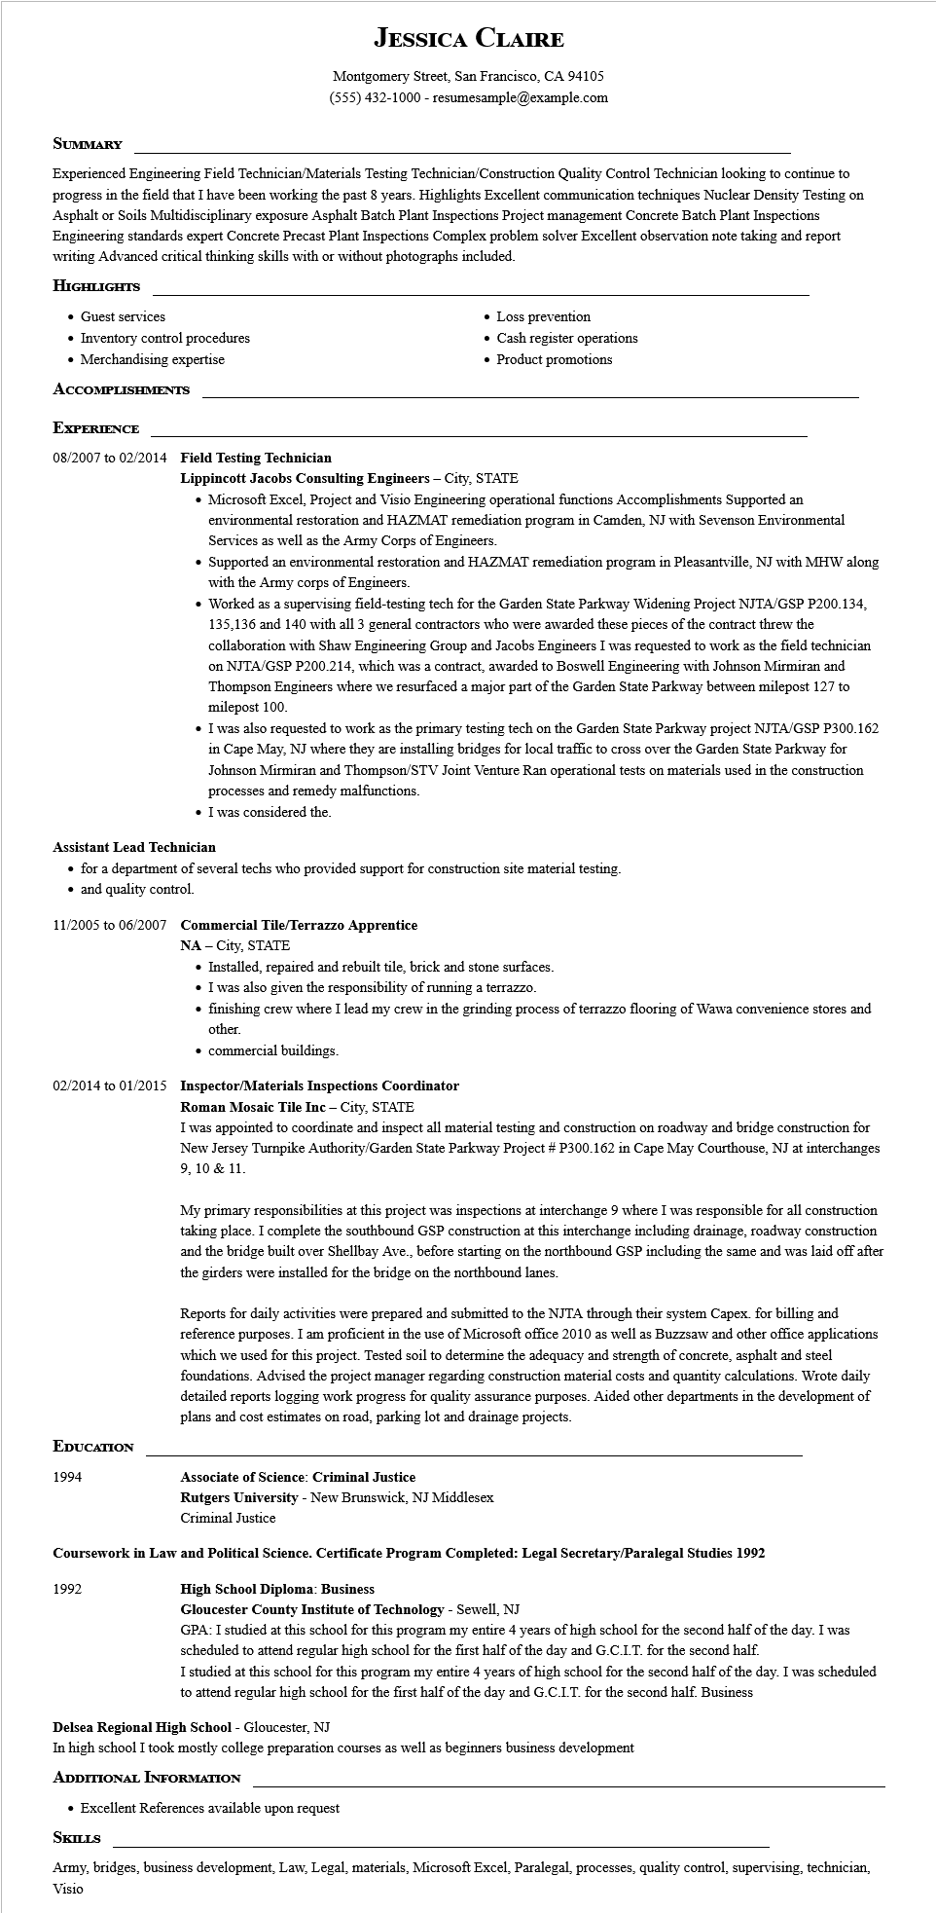

**JESSICA CLAIRE**

Montgomery Street, San Francisco, CA 94105 (555) 432-1000 - resumesample@example.com

**SUMMARY**

Experienced Engineering Field Technician/Materials Testing Technician/Construction Quality Control Technician looking to continue to progress in the field that I have been working the past 8 years. Highlights Excellent communication techniques Nuclear Density Testing on Asphalt or Soils Multidisciplinary exposure Asphalt Batch Plant Inspections Project management Concrete Batch Plant Inspections Engineering standards expert Concrete Precast Plant Inspections Complex problem solver Excellent observation note taking and report writing Advanced critical thinking skills with or without photographs included.

**HIGHLIGHTS**

• Guest services

• Inventory control procedures

• Merchandising expertise

**ACCOMPLISHMENTS**

**EXPERIENCE**

**08/2007 to 02/2014 Field Testing Technician**

• Loss prevention

• Cash register operations

• Product promotions

**Lippincott Jacobs Consulting Engineers - City, STATE**

• Microsoft Excel, Project and Visio Engineering operational functions Accomplishments Supported an environmental restoration and HAZMAT remediation program in Camden, NJ with Sevenson Environmental Services as well as the Army Corps of Engineers.

• Supported an environmental restoration and HAZMAT remediation program in Pleasantville, NJ with MHW along with the Army corps of Engineers.

• Worked as a supervising field-testing tech for the Garden State Parkway Widening Project NJTA/GSP P200.134, 135,136 and 140 with all 3 general contractors who were awarded these pieces of the contract threw the collaboration with Shaw Engineering Group and Jacobs Engineers I was requested to work as the field technician on NJTA/GSP P200.214, which was a contract, awarded to Boswell Engineering with Johnson Mirmiran and Thompson Engineers where we resurfaced a major part of the Garden State Parkway between milepost 127 to milepost 100.

• I was also requested to work as the primary testing tech on the Garden State Parkway project NJTA/GSP P300.162 in Cape May, NJ where they are installing bridges for local traffic to cross over the Garden State Parkway for Johnson Mirmiran and Thompson/STV Joint Venture Ran operational tests on materials used in the construction processes and remedy malfunctions.

⚫ I was considered the.

**Assistant Lead Technician**

⚫ for a department of several techs who provided support for construction site material testing.

⚫ and quality control.

**11/2005 to 06/2007 Commercial Tile/Terrazzo Apprentice**

NA-City, STATE

• Installed, repaired and rebuilt tile, brick and stone surfaces.

• I was also given the responsibility of running a terrazzo.

⚫ finishing crew where I lead my crew in the grinding process of terrazzo flooring of Wawa convenience stores and other.

⚫ commercial buildings.

**02/2014 to 01/2015 Inspector/Materials Inspections Coordinator**

**Roman Mosaic Tile Inc - City, STATE**

I was appointed to coordinate and inspect all material testing and construction on roadway and bridge construction for New Jersey Turnpike Authority/Garden State Parkway Project # P300.162 in Cape May Courthouse, NJ at interchanges 9, 10 & 11.

My primary responsibilities at this project was inspections at interchange 9 where I was responsible for all construction taking place. I complete the southbound GSP construction at this interchange including drainage, roadway construction and the bridge built over Shellbay Ave., before starting on the northbound GSP including the same and was laid off after the girders were installed for the bridge on the northbound lanes.

Reports for daily activities were prepared and submitted to the NJTA through their system Capex. for billing and reference purposes. I am proficient in the use of Microsoft office 2010 as well as Buzzsaw and other office applications which we used for this project. Tested soil to determine the adequacy and strength of concrete, asphalt and steel foundations. Advised the project manager regarding construction material costs and quantity calculations. Wrote daily detailed reports logging work progress for quality assurance purposes. Aided other departments in the development of plans and cost estimates on road, parking lot and drainage projects.

**EDUCATION**

1994

**Associate of Science: Criminal Justice**

**Rutgers University - New Brunswick, NJ Middlesex**

Criminal Justice

**Coursework in Law and Political Science. Certificate Program Completed: Legal Secretary/Paralegal Studies 1992**

1992

**High School Diploma: Business**

**Gloucester County Institute of Technology - Sewell, NJ**

GPA: I studied at this school for this program my entire 4 years of high school for the second half of the day. I was scheduled to attend regular high school for the first half of the day and G.C.I.T. for the second half.

I studied at this school for this program my entire 4 years of high school for the second half of the day. I was scheduled

to attend regular high school for the first half of the day and G.C.I.T. for the second half. Business

**Delsea Regional High School - Gloucester, NJ**

In high school I took mostly college preparation courses as well as beginners business development ADDITIONAL INFORMATION

• Excellent References available upon request

**SKILLS**

Army, bridges, business development, Law, Legal, materials, Microsoft Excel, Paralegal, processes, quality control, supervising, technician, Visio