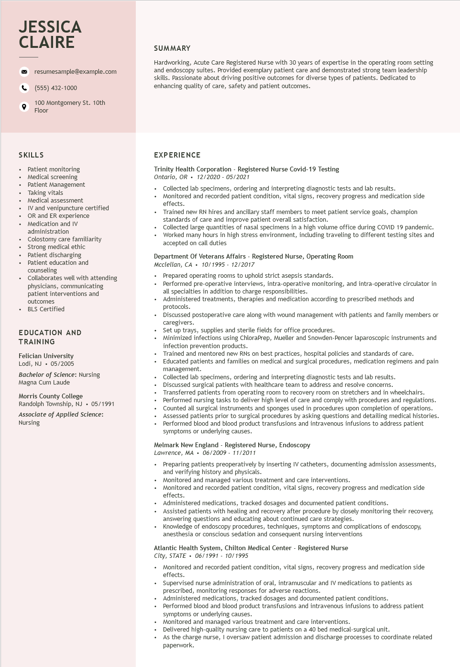

**JESSICA CLAIRE**

resumesample@example.com

(555) 432-1000

100 Montgomery St. 10th Floor

**SUMMARY**

Hardworking, Acute Care Registered Nurse with 30 years of expertise in the operating room setting and endoscopy suites. Provided exemplary patient care and demonstrated strong team leadership skills. Passionate about driving positive outcomes for diverse types of patients. Dedicated to enhancing quality of care, safety and patient outcomes.

SKILLS

• Patient monitoring

•

Medical screening

•

Patient Management

•

Taking vitals

•

•

Medical assessment

IV and venipuncture certified

• OR and ER experience

Medication and IV administration

Colostomy care familiarity Strong medical ethic

• Patient discharging

• Patient education and

counseling

• Collaborates well with attending

physicians, communicating

patient interventions and

outcomes

• BLS Certified

EDUCATION AND TRAINING

Felician University Lodi, NJ⚫ 05/2005

Bachelor of Science: Nursing Magna Cum Laude

Morris County College

Randolph Township, NJ ⚫ 05/1991 Associate of Applied Science: Nursing

**EXPERIENCE**

Trinity Health Corporation - Registered Nurse Covid-19 Testing Ontario, OR⚫ 12/2020- 05/2021

• Collected lab specimens, ordering and interpreting diagnostic tests and lab results.

• Monitored and recorded patient condition, vital signs, recovery progress and medication side effects.

• Trained new RN hires and ancillary staff members to meet patient service goals, champion standards of care and improve patient overall satisfaction.

• Collected large quantities of nasal specimens in a high volume office during COVID 19 pandemic. Worked many hours in high stress environment, including traveling to different testing sites and accepted on call duties

Department Of Veterans Affairs - Registered Nurse, Operating Room

*Mcclellan, CA. 10/1995 - 12/2017*

Prepared operating rooms to uphold strict asepsis standards.

• Performed pre-operative interviews, intra-operative monitoring, and intra-operative circulator in all specialties in addition to charge responsibilities.

•

Administered treatments, therapies and medication according to prescribed methods and protocols.

Discussed postoperative care along with wound management with patients and family members or caregivers.

• Set up trays, supplies and sterile fields for office procedures.

Minimized infections using ChloraPrep, Mueller and Snowden-Pencer laparoscopic instruments and infection prevention products.

• Trained and mentored new RNs on best practices, hospital policies and standards of care. Educated patients and families on medical and surgical procedures, medication regimens and pain management.

• Collected lab specimens, ordering and interpreting diagnostic tests and lab results. Discussed surgical patients with healthcare team to address and resolve concerns.

Transferred patients from operating room to recovery room on stretchers and in wheelchairs. Performed nursing tasks to deliver high level of care and comply with procedures and regulations. Counted all surgical instruments and sponges used in procedures upon completion of operations.

• Assessed patients prior to surgical procedures by asking questions and detailing medical histories. Performed blood and blood product transfusions and intravenous infusions to address patient symptoms or underlying causes.

Melmark New England - Registered Nurse, Endoscopy

Lawrence, MA. 06/2009- 11/2011

Preparing patients preoperatively by inserting IV catheters, documenting admission assessments, and verifying history and physicals.

• Monitored and managed various treatment and care interventions.

• Monitored and recorded patient condition, vital signs, recovery progress and medication side effects.

• Administered medications, tracked dosages and documented patient conditions.

• Assisted patients with healing and recovery after procedure by closely monitoring their recovery, answering questions and educating about continued care strategies.

Knowledge of endoscopy procedures, techniques, symptoms and complications of endoscopy, anesthesia or conscious sedation and consequent nursing interventions

Atlantic Health System, Chilton Medical Center - Registered Nurse

*City, STATE⚫ 06/1991 - 10/1995*

• Monitored and recorded patient condition, vital signs, recovery progress and medication side effects.

•

Supervised nurse administration of oral, intramuscular and IV medications to patients as prescribed, monitoring responses for adverse reactions.

• Administered medications, tracked dosages and documented patient conditions.

• Performed blood and blood product transfusions and intravenous infusions to address patient symptoms or underlying causes.

• Monitored and managed various treatment and care interventions.

• Delivered high-quality nursing care to patients on a 40 bed medical-surgical unit.

As the charge nurse, I oversaw patient admission and discharge processes to coordinate related paperwork.