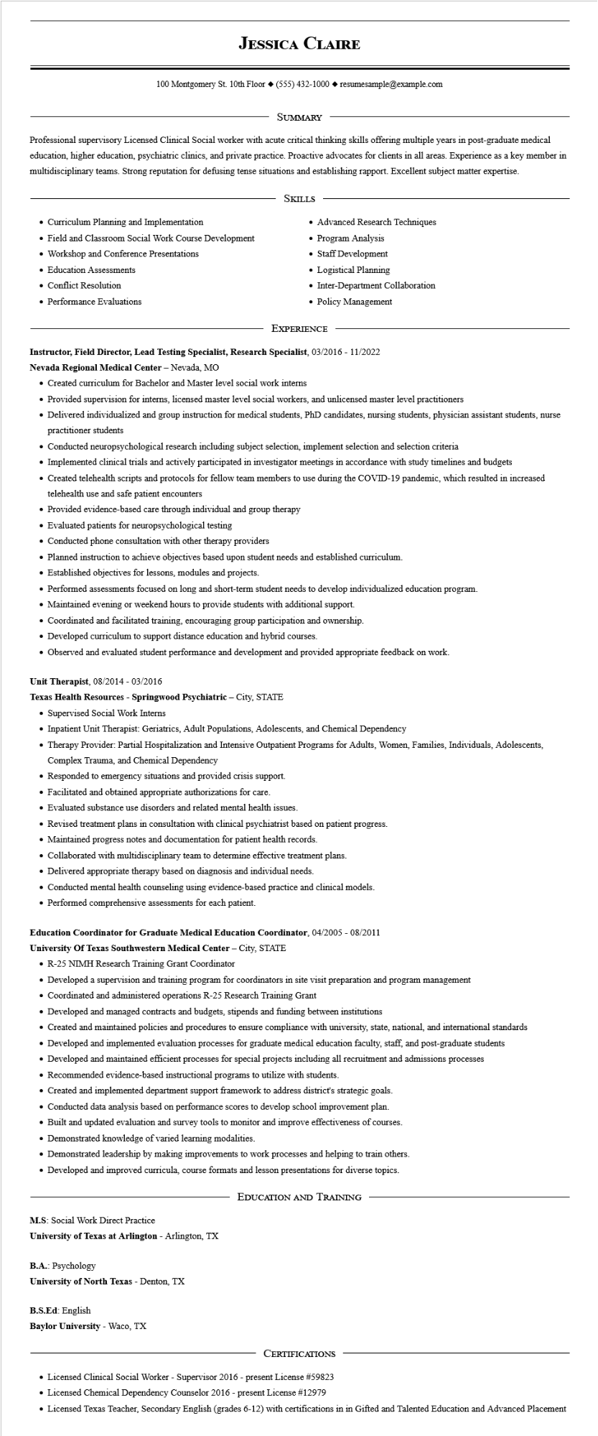

**JESSICA CLAIRE**

100 Montgomery St. 10th Floor◆ (555) 432-1000◆ resumesample@example.com

SUMMARY

Professional supervisory Licensed Clinical Social worker with acute critical thinking skills offering multiple years in post-graduate medical education, higher education, psychiatric clinics, and private practice. Proactive advocates for clients in all areas. Experience as a key member in multidisciplinary teams. Strong reputation for defusing tense situations and establishing rapport. Excellent subject matter expertise.

• Curriculum Planning and Implementation

• Field and Classroom Social Work Course Development

• Workshop and Conference Presentations

• Education Assessments

• Conflict Resolution

• Performance Evaluations

SKILLS

• Advanced Research Techniques

Program Analysis

• Staff Development

• Logistical Planning

• Inter-Department Collaboration

• Policy Management

EXPERIENCE

**Instructor, Field Director, Lead Testing Specialist, Research Specialist, 03/2016 - 11/2022**

**Nevada Regional Medical Center - Nevada, MO**

• Created curriculum for Bachelor and Master level social work interns

• Provided supervision for interns, licensed master level social workers, and unlicensed master level practitioners

• Delivered individualized and group instruction for medical students, PhD candidates, nursing students, physician assistant students, nurse practitioner students

• Conducted neuropsychological research including subject selection, implement selection and selection criteria

• Implemented clinical trials and actively participated in investigator meetings in accordance with study timelines and budgets

• Created telehealth scripts and protocols for fellow team members to use during the COVID-19 pandemic, which resulted in increased telehealth use and safe patient encounters

• Provided evidence-based care through individual and group therapy

• Evaluated patients for neuropsychological testing

• Conducted phone consultation with other therapy providers

• Planned instruction to achieve objectives based upon student needs and established curriculum.

• Established objectives for lessons, modules and projects.

• Performed assessments focused on long and short-term student needs to develop individualized education program.

• Maintained evening or weekend hours to provide students with additional support.

• Coordinated and facilitated training, encouraging group participation and ownership.

• Developed curriculum to support distance education and hybrid courses.

• Observed and evaluated student performance and development and provided appropriate feedback on work.

Unit Therapist, 08/2014 - 03/2016

**Texas Health Resources - Springwood Psychiatric - City, STATE**

• Supervised Social Work Interns

• Inpatient Unit Therapist: Geriatrics, Adult Populations, Adolescents, and Chemical Dependency

• Therapy Provider: Partial Hospitalization and Intensive Outpatient Programs for Adults, Women, Families, Individuals, Adolescents, Complex Trauma, and Chemical Dependency

• Responded to emergency situations and provided crisis support.

• Facilitated and obtained appropriate authorizations for care.

• Evaluated substance use disorders and related mental health issues.

• Revised treatment plans in consultation with clinical psychiatrist based on patient progress.

• Maintained progress notes and documentation for patient health records.

• Collaborated with multidisciplinary team to determine effective treatment plans.

• Delivered appropriate therapy based on diagnosis and individual needs.

• Conducted mental health counseling using evidence-based practice and clinical models.

• Performed comprehensive assessments for each patient.

**Education Coordinator for Graduate Medical Education Coordinator, 04/2005 - 08/2011**

**University of Texas Southwestern Medical Center - City, STATE**

• R-25 NIMH Research Training Grant Coordinator

• Developed a supervision and training program for coordinators in site visit preparation and program management

• Coordinated and administered operations R-25 Research Training Grant

• Developed and managed contracts and budgets, stipends and funding between institutions

• Created and maintained policies and procedures to ensure compliance with university, state, national, and international standards

• Developed and implemented evaluation processes for graduate medical education faculty, staff, and post-graduate students

• Developed and maintained efficient processes for special projects including all recruitment and admissions processes

• Recommended evidence-based instructional programs to utilize with students.

• Created and implemented department support framework to address district's strategic goals.

• Conducted data analysis based on performance scores to develop school improvement plan.

• Built and updated evaluation and survey tools to monitor and improve effectiveness of courses.

• Demonstrated knowledge of varied learning modalities.

• Demonstrated leadership by making improvements to work processes and helping to train others.

• Developed and improved curricula, course formats and lesson presentations for diverse topics.

M.S: Social Work Direct Practice

**University of Texas at Arlington - Arlington, TX**

B.A.: Psychology

**University of North Texas - Denton, TX**

B.S.Ed: English

**Baylor University - Waco, TX**

**EDUCATION AND TRAINING**

CERTIFICATIONS

• Licensed Clinical Social Worker - Supervisor 2016 - present License #59823

• Licensed Chemical Dependency Counselor 2016 - present License #12979

• Licensed Texas Teacher, Secondary English (grades 6-12) with certifications in in Gifted and Talented Education and Advanced Placement