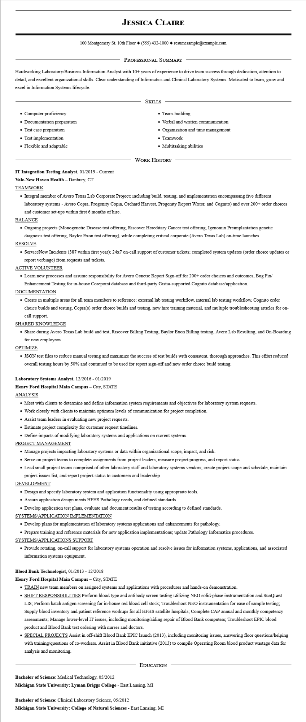

**JESSICA CLAIRE**

100 Montgomery St. 10th Floor (555) 432-1000◆ resumesample@example.com

PROFESSIONAL SUMMARY

Hardworking Laboratory/Business Information Analyst with 10+ years of experience to drive team success through dedication, attention to detail, and excellent organizational skills. Clear understanding of Informatics and Clinical Laboratory Systems. Motivated to learn, grow and excel in Information Systems lifecycle.

• Computer proficiency

• Documentation preparation

• Test case preparation

• Test implementation

• Flexible and adaptable

SKILLS

• Team-building

• Verbal and written communication

• Organization and time management Teamwork

• Multitasking abilities

WORK HISTORY

**IT Integration Testing Analyst, 01/2019 - Current**

**Yale-New Haven Health - Danbury, CT**

TEAMWORK

• Integral member of Avero Texas Lab Corporate Project: including build, testing, and implementation encompassing five different laboratory systems - Avero Copia, Progenity Copia, Orchard Harvest, Progenity Report Writer, and Cognito) and over 200+ order choices and customer set-ups within first 6 months of hire.

BALANCE

• Ongoing projects (Monogenetic Disease test offering, Riscover Hereditary Cancer test offering, Igenomix Preimplantation genetic diagnosis test offering, Baylor Exon test offering), while completing critical corporate (Avero Texas Lab) on-time launches.

RESOLVE

• ServiceNow Incidents (387 within first year); 24x7 on-call support of customer tickets; completed system updates (order choice updates or report verbiage) from requests and tickets.

ACTIVE VOLUNTEER

• Learn new processes and assume responsibility for Avero Genetic Report Sign-off for 200+ order choices and outcomes, Bug Fix/ Enhancement Testing for in-house Corepoint database and third-party Gistia-supported Cognito database/application.

DOCUMENTATION

• Create in multiple areas for all team members to reference: external lab testing workflow, internal lab testing workflow, Cognito order choice builds and testing, Copia(s) order choice builds and testing, new hire training material, and multiple troubleshooting articles for on- call support.

SHARED KNOWLEDGE

• Share during Avero Texas Lab build and test, Riscover Billing Testing, Baylor Exon Billing testing, Avero Lab Resulting, and On-Boarding for new employees.

OPTIMIZE

• JSON test files to reduce manual testing and maximize the success of test builds with consistent, thorough approaches. This effort reduced overall testing hours by 50% and continued to be used for report sign-off and new order choice build testing.

Laboratory Systems Analyst, 12/2016 - 01/2019

**Henry Ford Hospital Main Campus - City, STATE**

ANALYSIS

• Meet with clients to determine and define information system requirements and objectives for laboratory system requests.

• Work closely with clients to maintain optimum levels of communication for project completion.

• Assist team leaders in evaluating new project requests.

• Estimate project complexity for customer request timelines.

• Define impacts of modifying laboratory systems and applications on current systems.

PROJECT MANAGEMENT

• Manage projects impacting laboratory systems or data within organizational scope, impact, and risk.

• Serve on project teams to complete assignments from project leaders, measure project progress, and report status.

• Lead small project teams comprised of other laboratory staff and laboratory systems vendors; create project scope and schedule, maintain project issues list, and report project status to customers and leadership.

DEVELOPMENT

• Design and specify laboratory system and application functionality using appropriate tools.

• Assure application design meets HFHS Pathology needs, and defined standards.

• Develop application test plans, evaluate and document results of testing according to defined standards.

SYSTEMS/APPLICATION IMPLEMENTATION

• Develop plans for implementation of laboratory systems applications and enhancements for pathology.

• Prepare training and reference materials for new application implementations; update Pathology Informatics procedures.

SYSTEMS/APPLICATIONS SUPPORT

• Provide rotating, on-call support for laboratory systems operation and resolve issues for information systems, applications, and associated information systems equipment.

**Blood Bank Technologist, 01/2013 - 12/2018**

**Henry Ford Hospital Main Campus - City, STATE**

• TRAIN new team members on assigned systems and applications with procedures and hands-on demonstration.

• SHIFT RESPONSIBILITIES Perform blood type and antibody screen testing utilizing NEO solid-phase instrumentation and SunQuest LIS; Perform batch antigen screening for in-house red blood cell stock; Troubleshoot NEO instrumentation for ease of sample testing: Supply blood inventory and patient reference workups for all HFHS satellite hospitals; Complete CAP annual and monthly competency assessments; Manage lower-level IT issues, including monitoring/aiding repair of Blood Bank computers; Troubleshoot EPIC blood product and Blood Bank test ordering with nurses and doctors.

• SPECIAL PROJECTS Assist in off-shift Blood Bank EPIC launch (2013), including monitoring issues, answering floor questions/helping with training/questions of co-workers. Assist in Blood Bank initiative (2013) to compile Operating Room blood product wastage data for analysis and monitoring.

**EDUCATION**

Bachelor of Science: Medical Technology, 05/2012

**Michigan State University: Lyman Briggs College - East Lansing, MI**

Bachelor of Science: Clinical Laboratory Science, 05/2012

**Michigan State University: College of Natural Sciences - East Lansing, MI**