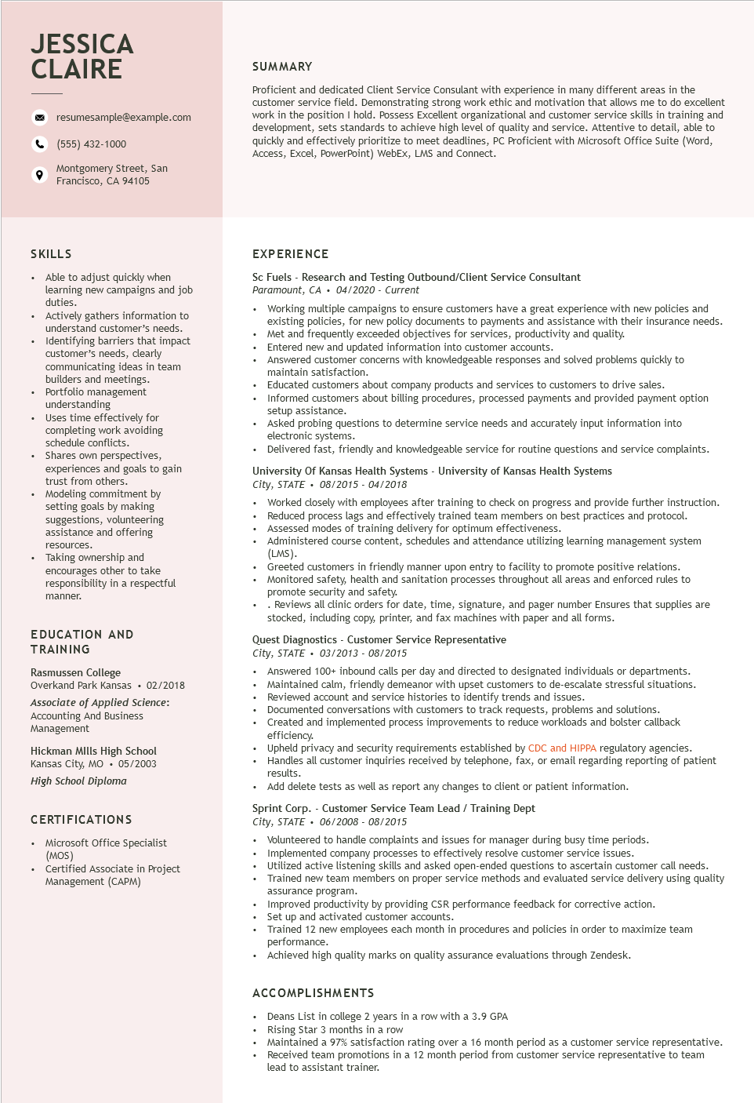

**JESSICA CLAIRE**

resumesample@example.com

(555) 432-1000

Montgomery Street, San Francisco, CA 94105

SUMMARY

Proficient and dedicated Client Service Consulant with experience in many different areas in the customer service field. Demonstrating strong work ethic and motivation that allows me to do excellent work in the position I hold. Possess Excellent organizational and customer service skills in training and development, sets standards to achieve high level of quality and service. Attentive to detail, able to quickly and effectively prioritize to meet deadlines, PC Proficient with Microsoft Office Suite (Word, Access, Excel, PowerPoint) WebEx, LMS and Connect.

SKILLS

• Able to adjust quickly when learning new campaigns and job duties.

• Actively gathers information to understand customer's needs.

•

Identifying barriers that impact customer's needs, clearly communicating ideas in team builders and meetings. Portfolio management understanding

• Uses time effectively for completing work avoiding schedule conflicts.

• Shares own perspectives, experiences and goals to gain trust from others.

• Modeling commitment by setting goals by making suggestions, volunteering assistance and offering

resources.

Taking ownership and

encourages other to take responsibility in a respectful

manner.

EDUCATION AND

TRAINING

Rasmussen College

Overkand Park Kansas ⚫ 02/2018

Associate of Applied Science: Accounting And Business Management

Hickman Mills High School

Kansas City, MO ⚫ 05/2003

*High School Diploma*

**CERTIFICATIONS**

.

Microsoft Office Specialist (MOS)

Certified Associate in Project Management (CAPM)

EXPERIENCE

Sc Fuels - Research and Testing Outbound/Client Service Consultant Paramount, CA⚫ 04/2020 - Current

•

• Working multiple campaigns to ensure customers have a great experience with new policies and existing policies, for new policy documents to payments and assistance with their insurance needs. Met and frequently exceeded objectives for services, productivity and quality.

•

Entered new and updated information into customer accounts.

Answered customer concerns with knowledgeable responses and solved problems quickly to maintain satisfaction.

• Educated customers about company products and services to customers to drive sales.

Informed customers about billing procedures, processed payments and provided payment option setup assistance.

• Asked probing questions to determine service needs and accurately input information into electronic systems.

• Delivered fast, friendly and knowledgeable service for routine questions and service complaints. University of Kansas Health Systems - University of Kansas Health Systems

*City, STATE 08/2015 - 04/2018*

Worked closely with employees after training to check on progress and provide further instruction. • Reduced process lags and effectively trained team members on best practices and protocol. • Assessed modes of training delivery for optimum effectiveness.

•

•

Administered course content, schedules and attendance utilizing learning management system (LMS).

Greeted customers in friendly manner upon entry to facility to promote positive relations.

Monitored safety, health and sanitation processes throughout all areas and enforced rules to promote security and safety.

⚫. Reviews all clinic orders for date, time, signature, and pager number Ensures that supplies are stocked, including copy, printer, and fax machines with paper and all forms.

Quest Diagnostics - Customer Service Representative

*City, STATE 03/2013 - 08/2015*

• Answered 100+ inbound calls per day and directed to designated individuals or departments.

• Maintained calm, friendly demeanor with upset customers to de-escalate stressful situations.

• Reviewed account and service histories to identify trends and issues.

• Documented conversations with customers to track requests, problems and solutions.

·

Created and implemented process improvements to reduce workloads and bolster callback efficiency.

Upheld privacy and security requirements established by CDC and HIPPA regulatory agencies.

• Handles all customer inquiries received by telephone, fax, or email regarding reporting of patient results.

• Add delete tests as well as report any changes to client or patient information.

Sprint Corp. - Customer Service Team Lead / Training Dept

City, STATE. 06/2008 - 08/2015

• Volunteered to handle complaints and issues for manager during busy time periods.

• Implemented company processes to effectively resolve customer service issues.

• Utilized active listening skills and asked open-ended questions to ascertain customer call needs.

Trained new team members on proper service methods and evaluated service delivery using quality assurance program.

Improved productivity by providing CSR performance feedback for corrective action.

• Set up and activated customer accounts.

Trained 12 new employees each month in procedures and policies in order to maximize team performance.

• Achieved high quality marks on quality assurance evaluations through Zendesk.

**ACCOMPLISHMENTS**

Deans List in college 2 years in a row with a 3.9 GPA

• Rising Star 3 months in a row

• Maintained a 97% satisfaction rating over a 16 month period as a customer service representative. Received team promotions in a 12 month period from customer service representative to team lead to assistant trainer.