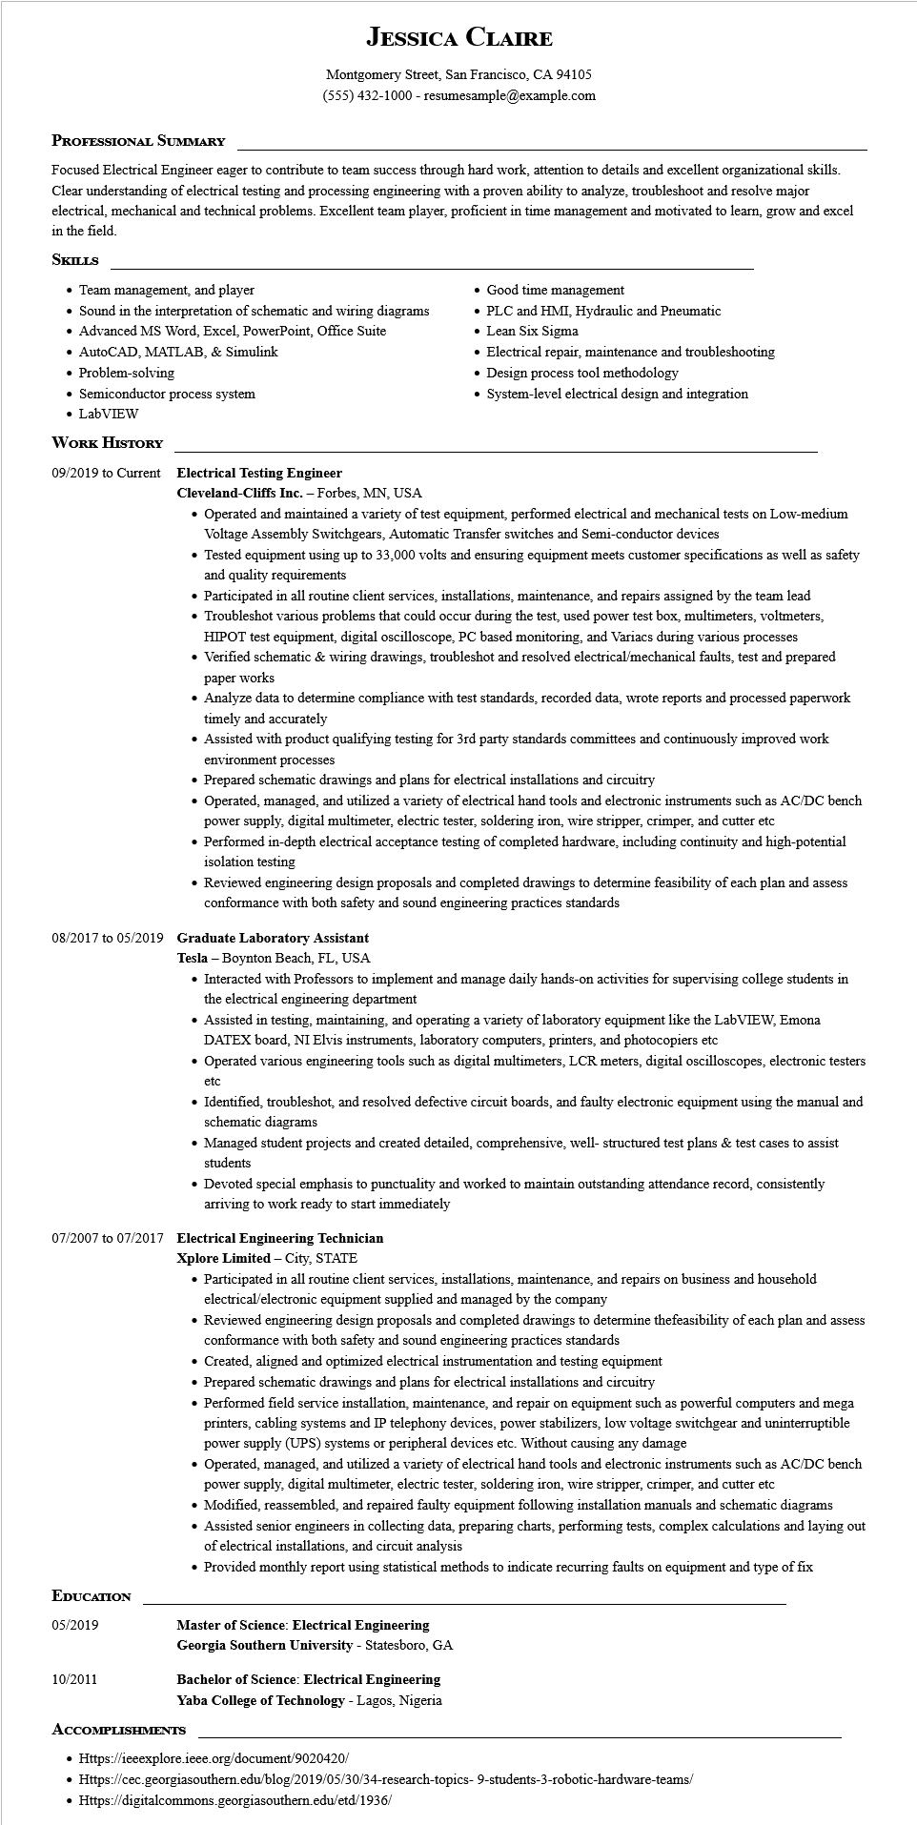

**JESSICA CLAIRE**

Montgomery Street, San Francisco, CA 94105

(555) 432-1000 - resumesample@example.com

**PROFESSIONAL SUMMARY**

Focused Electrical Engineer eager to contribute to team success through hard work, attention to details and excellent organizational skills. Clear understanding of electrical testing and processing engineering with a proven ability to analyze, troubleshoot and resolve major electrical, mechanical and technical problems. Excellent team player, proficient in time management and motivated to learn, grow and excel in the field.

**SKILLS**

Team management, and player

• Sound in the interpretation of schematic and wiring diagrams

• Advanced MS Word, Excel, PowerPoint, Office Suite

• AutoCAD, MATLAB, & Simulink

• Problem-solving

• Semiconductor process system

• LabVIEW

**WORK HISTORY**

**09/2019 to Current Electrical Testing Engineer**

**Cleveland-Cliffs Inc. - Forbes, MN, USA**

• Good time management

• PLC and HMI, Hydraulic and Pneumatic

• Lean Six Sigma

• Electrical repair, maintenance and troubleshooting

• Design process tool methodology

System-level electrical design and integration

• Operated and maintained a variety of test equipment, performed electrical and mechanical tests on Low-medium Voltage Assembly Switchgears, Automatic Transfer switches and Semi-conductor devices

• Tested equipment using up to 33,000 volts and ensuring equipment meets customer specifications as well as safety and quality requirements

• Participated in all routine client services, installations, maintenance, and repairs assigned by the team lead

• Troubleshot various problems that could occur during the test, used power test box, multimeters, voltmeters, HIPOT test equipment, digital oscilloscope, PC based monitoring, and Variacs during various processes

• Verified schematic & wiring drawings, troubleshot and resolved electrical/mechanical faults, test and prepared paper works

• Analyze data to determine compliance with test standards, recorded data, wrote reports and processed paperwork timely and accurately

• Assisted with product qualifying testing for 3rd party standards committees and continuously improved work environment processes

• Prepared schematic drawings and plans for electrical installations and circuitry

• Operated, managed, and utilized a variety of electrical hand tools and electronic instruments such as AC/DC bench power supply, digital multimeter, electric tester, soldering iron, wire stripper, crimper, and cutter etc

• Performed in-depth electrical acceptance testing of completed hardware, including continuity and high-potential isolation testing

• Reviewed engineering design proposals and completed drawings to determine feasibility of each plan and assess conformance with both safety and sound engineering practices standards

**08/2017 to 05/2019 Graduate Laboratory Assistant**

Tesla - Boynton Beach, FL, USA

• Interacted with Professors to implement and manage daily hands-on activities for supervising college students in the electrical engineering department

• Assisted in testing, maintaining, and operating a variety of laboratory equipment like the LabVIEW, Emona DATEX board, NI Elvis instruments, laboratory computers, printers, and photocopiers etc

• Operated various engineering tools such as digital multimeters, LCR meters, digital oscilloscopes, electronic testers

etc

• Identified, troubleshot, and resolved defective circuit boards, and faulty electronic equipment using the manual and schematic diagrams

• Managed student projects and created detailed, comprehensive, well-structured test plans & test cases to assist students

• Devoted special emphasis to punctuality and worked to maintain outstanding attendance record, consistently arriving to work ready to start immediately

**07/2007 to 07/2017 Electrical Engineering Technician**

**Xplore Limited - City, STATE**

• Participated in all routine client services, installations, maintenance, and repairs on business and household electrical/electronic equipment supplied and managed by the company

• Reviewed engineering design proposals and completed drawings to determine thefeasibility of each plan and assess conformance with both safety and sound engineering practices standards

• Created, aligned and optimized electrical instrumentation and testing equipment

• Prepared schematic drawings and plans for electrical installations and circuitry

• Performed field service installation, maintenance, and repair on equipment such as powerful computers and mega printers, cabling systems and IP telephony devices, power stabilizers, low voltage switchgear and uninterruptible power supply (UPS) systems or peripheral devices etc. Without causing any damage

• Operated, managed, and utilized a variety of electrical hand tools and electronic instruments such as AC/DC bench power supply, digital multimeter, electric tester, soldering iron, wire stripper, crimper, and cutter etc

• Modified, reassembled, and repaired faulty equipment following installation manuals and schematic diagrams

• Assisted senior engineers in collecting data, preparing charts, performing tests, complex calculations and laying out of electrical installations, and circuit analysis

• Provided monthly report using statistical methods to indicate recurring faults on equipment and type of fix

**EDUCATION**

05/2019

**Master of Science: Electrical Engineering**

**Georgia Southern University - Statesboro, GA**

10/2011

Bachelor of Science: Electrical Engineering

Yaba College of Technology - Lagos, Nigeria

**ACCOMPLISHMENTS**

• Https://ieeexplore.ieee.org/document/9020420/

• Https://cec.georgiasouthern.edu/blog/2019/05/30/34-research-topics- 9-students-3-robotic-hardware-teams/

• Https://digitalcommons.georgiasouthern.edu/etd/1936/