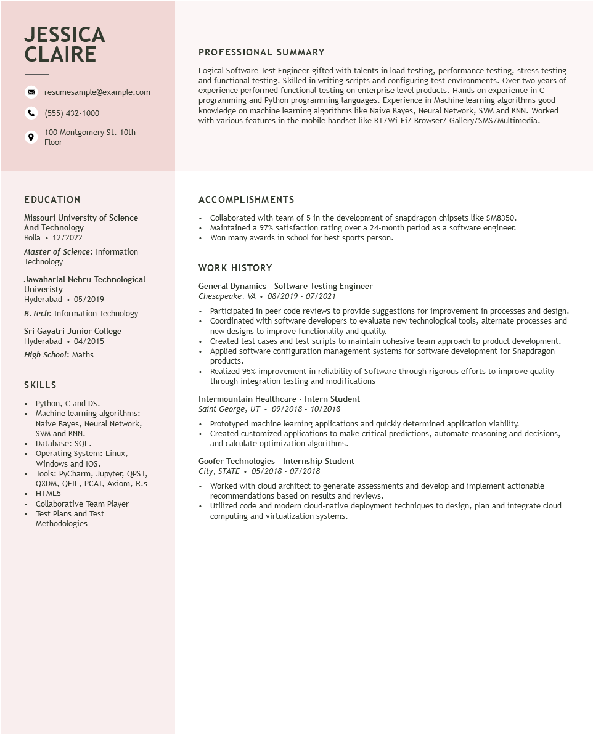

**JESSICA CLAIRE**

resumesample@example.com

(555) 432-1000

100 Montgomery St. 10th Floor

PROFESSIONAL SUMMARY

Logical Software Test Engineer gifted with talents in load testing, performance testing, stress testing and functional testing. Skilled in writing scripts and configuring test environments. Over two years of experience performed functional testing on enterprise level products. Hands on experience in C programming and Python programming languages. Experience in Machine learning algorithms good knowledge on machine learning algorithms like Naive Bayes, Neural Network, SVM and KNN. Worked with various features in the mobile handset like BT/Wi-Fi/ Browser/Gallery/SMS/Multimedia.

**EDUCATION**

Missouri University of Science And Technology

Rolla⚫ 12/2022

Master of Science: Information Technology

Jawaharlal Nehru Technological Univeristy

Hyderabad⚫ 05/2019

B.Tech: Information Technology

Sri Gayatri Junior College

Hyderabad 04/2015

High School: Maths

**SKILLS**

•

Python, C and DS.

Machine learning algorithms:

Naive Bayes, Neural Network,

SVM and KNN.

• Database: SQL.

·

•

Operating System: Linux,

Windows and IOS.

Tools: PyCharm, Jupyter, QPST,

QXDM, QFIL, PCAT, Axiom, R.s HTML5

• Collaborative Team Player

• Test Plans and Test

Methodologies

**ACCOMPLISHMENTS**

• Collaborated with team of 5 in the development of snapdragon chipsets like SM8350. Maintained a 97% satisfaction rating over a 24-month period as a software engineer.

•

• Won many awards in school for best sports person.

**WORK HISTORY**

General Dynamics - Software Testing Engineer Chesapeake, VA 08/2019-07/2021

• Participated in peer code reviews to provide suggestions for improvement in processes and design.

• Coordinated with software developers to evaluate new technological tools, alternate processes and new designs to improve functionality and quality.

• Created test cases and test scripts to maintain cohesive team approach to product development. Applied software configuration management systems for software development for Snapdragon products.

• Realized 95% improvement in reliability of Software through rigorous efforts to improve quality through integration testing and modifications

Intermountain Healthcare - Intern Student

*Saint George, UT⚫ 09/2018 - 10/2018*

• Prototyped machine learning applications and quickly determined application viability.

• Created customized applications to make critical predictions, automate reasoning and decisions, and calculate optimization algorithms.

**Goofer Technologies - Internship Student**

*City, STATE 05/2018 - 07/2018*

• Worked with cloud architect to generate assessments and develop and implement actionable recommendations based on results and reviews.

Utilized code and modern cloud-native deployment techniques to design, plan and integrate cloud computing and virtualization systems.