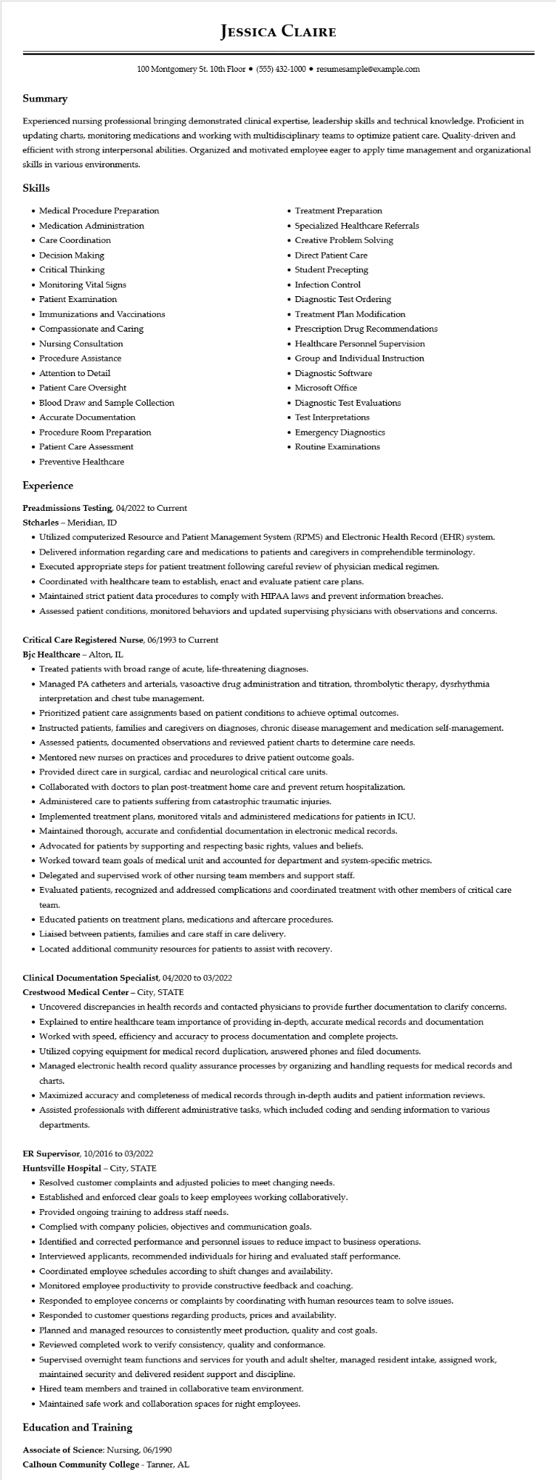

**JESSICA CLAIRE**

100 Montgomery St. 10th Floor⚫ (555) 432-1000⚫ resumesample@example.com

**Summary**

Experienced nursing professional bringing demonstrated clinical expertise, leadership skills and technical knowledge. Proficient in updating charts, monitoring medications and working with multidisciplinary teams to optimize patient care. Quality-driven and efficient with strong interpersonal abilities. Organized and motivated employee eager to apply time management and organizational skills in various environments.

**Skills**

• Medical Procedure Preparation

• Medication Administration

• Care Coordination

• Decision Making

• Critical Thinking

• Monitoring Vital Signs

• Patient Examination

• Immunizations and Vaccinations

• Compassionate and Caring

• Nursing Consultation

• Procedure Assistance

• Attention to Detail

• Patient Care Oversight

• Blood Draw and Sample Collection

• Accurate Documentation

• Procedure Room Preparation

• Patient Care Assessment

• Preventive Healthcare

**Experience**

**Preadmissions Testing, 04/2022 to Current**

**Stcharles - Meridian, ID**

• Treatment Preparation Specialized Healthcare Referrals

• Creative Problem Solving

• Direct Patient Care

• Student Precepting

• Infection Control

• Diagnostic Test Ordering

• Treatment Plan Modification

• Prescription Drug Recommendations

• Healthcare Personnel Supervision

• Group and Individual Instruction

• Diagnostic Software

• Microsoft Office

• Diagnostic Test Evaluations

• Test Interpretations

• Emergency Diagnostics

• Routine Examinations

• Utilized computerized Resource and Patient Management System (RPMS) and Electronic Health Record (EHR) system.

• Delivered information regarding care and medications to patients and caregivers in comprehendible terminology.

• Executed appropriate steps for patient treatment following careful review of physician medical regimen.

• Coordinated with healthcare team to establish, enact and evaluate patient care plans.

• Maintained strict patient data procedures to comply with HIPAA laws and prevent information breaches.

• Assessed patient conditions, monitored behaviors and updated supervising physicians with observations and concerns.

**Critical Care Registered Nurse, 06/1993 to Current**

**Bjc Healthcare - Alton, IL**

• Treated patients with broad range of acute, life-threatening diagnoses.

• Managed PA catheters and arterials, vasoactive drug administration and titration, thrombolytic therapy, dysrhythmia interpretation and chest tube management.

• Prioritized patient care assignments based on patient conditions to achieve optimal outcomes.

• Instructed patients, families and caregivers on diagnoses, chronic disease management and medication self-management.

• Assessed patients, documented observations and reviewed patient charts to determine care needs.

• Mentored new nurses on practices and procedures to drive patient outcome goals.

• Provided direct care in surgical, cardiac and neurological critical care units.

• Collaborated with doctors to plan post-treatment home care and prevent return hospitalization.

• Administered care to patients suffering from catastrophic traumatic injuries.

• Implemented treatment plans, monitored vitals and administered medications for patients in ICU.

• Maintained thorough, accurate and confidential documentation in electronic medical records.

• Advocated for patients by supporting and respecting basic rights, values and beliefs.

• Worked toward team goals of medical unit and accounted for department and system-specific metrics.

• Delegated and supervised work of other nursing team members and support staff.

• Evaluated patients, recognized and addressed complications and coordinated treatment with other members of critical care

team.

• Educated patients on treatment plans, medications and aftercare procedures.

• Liaised between patients, families and care staff in care delivery.

• Located additional community resources for patients to assist with recovery.

Clinical Documentation Specialist, 04/2020 to 03/2022

Crestwood Medical Center - City, STATE

• Uncovered discrepancies in health records and contacted physicians to provide further documentation to clarify concerns.

• Explained to entire healthcare team importance of providing in-depth, accurate medical records and documentation

• Worked with speed, efficiency and accuracy to process documentation and complete projects.

• Utilized copying equipment for medical record duplication, answered phones and filed documents.

• Managed electronic health record quality assurance processes by organizing and handling requests for medical records and charts.

• Maximized accuracy and completeness of medical records through in-depth audits and patient information reviews.

• Assisted professionals with different administrative tasks, which included coding and sending information to various departments.

ER Supervisor, 10/2016 to 03/2022

Huntsville Hospital - City, STATE

• Resolved customer complaints and adjusted policies to meet changing needs.

• Established and enforced clear goals to keep employees working collaboratively.

• Provided ongoing training to address staff needs.

• Complied with company policies, objectives and communication goals.

• Identified and corrected performance and personnel issues to reduce impact to business operations.

• Interviewed applicants, recommended individuals for hiring and evaluated staff performance.

• Coordinated employee schedules according to shift changes and availability.

• Monitored employee productivity to provide constructive feedback and coaching.

• Responded to employee concerns or complaints by coordinating with human resources team to solve issues.

• Responded to customer questions regarding products, prices and availability.

• Planned and managed resources to consistently meet production, quality and cost goals.

• Reviewed completed work to verify consistency, quality and conformance.

·

Supervised overnight team functions and services for youth and adult shelter, managed resident intake, assigned work,

maintained security and delivered resident support and discipline.

• Hired team members and trained in collaborative team environment.

• Maintained safe work and collaboration spaces for night employees.

**Education and Training**

Associate of Science: Nursing, 06/1990

**Calhoun Community College - Tanner, AL**