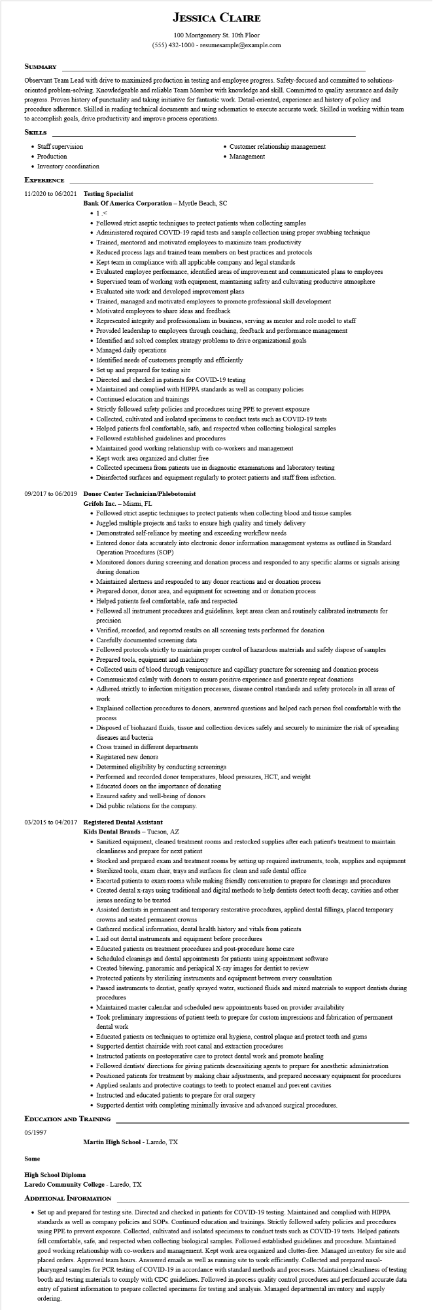

**JESSICA CLAIRE**

100 Montgomery St. 10th Floor

(555) 432-1000 - resumesample@example.com

**SUMMARY**

Observant Team Lead with drive to maximized production in testing and employee progress. Safety-focused and committed to solutions- oriented problem-solving. Knowledgeable and reliable Team Member with knowledge and skill. Committed to quality assurance and daily progress. Proven history of punctuality and taking initiative for fantastic work. Detail-oriented, experience and history of policy and procedure adherence. Skilled in reading technical documents and using schematics to execute accurate work. Skilled in working within team to accomplish goals, drive productivity and improve process operations.

**SKILLS**

• Staff supervision

• Production

• Inventory coordination

**EXPERIENCE**

**11/2020 to 06/2021 Testing Specialist**

• Customer relationship management

• Management

**Bank of America Corporation - Myrtle Beach, SC •1.<**

• Followed strict aseptic techniques to protect patients when collecting samples

• Administered required COVID-19 rapid tests and sample collection using proper swabbing technique

• Trained, mentored and motivated employees to maximize team productivity

• Reduced process lags and trained team members on best practices and protocols

• Kept team in compliance with all applicable company and legal standards

• Evaluated employee performance, identified areas of improvement and communicated plans to employees

• Supervised team of working with equipment, maintaining safety and cultivating productive atmosphere

• Evaluated site work and developed improvement plans

• Trained, managed and motivated employees to promote professional skill development

• Motivated employees to share ideas and feedback

• Represented integrity and professionalism in business, serving as mentor and role model to staff

• Provided leadership to employees through coaching, feedback and performance management

• Identified and solved complex strategy problems to drive organizational goals

• Managed daily operations

• Identified needs of customers promptly and efficiently

• Set up and prepared for testing site

• Directed and checked in patients for COVID-19 testing

• Maintained and complied with HIPPA standards as well as company policies

• Continued education and trainings

• Strictly followed safety policies and procedures using PPE to prevent exposure

• Collected, cultivated and isolated specimens to conduct tests such as COVID-19 tests

• Helped patients feel comfortable, safe, and respected when collecting biological samples

• Followed established guidelines and procedures

• Maintained good working relationship with co-workers and management

• Kept work area organized and clutter free

• Collected specimens from patients use in diagnostic examinations and laboratory testing

• Disinfected surfaces and equipment regularly to protect patients and staff from infection.

**09/2017 to 06/2019 Donor Center Technician/Phlebotomist**

**Grifols Inc. - Miami, FL**

• Followed strict aseptic techniques to protect patients when collecting blood and tissue samples

• Juggled multiple projects and tasks to ensure high quality and timely delivery

• Demonstrated self-reliance by meeting and exceeding workflow needs

• Entered donor data accurately into electronic donor information management systems as outlined in Standard Operation Procedures (SOP)

• Monitored donors during screening and donation process and responded to any specific alarms or signals arising during donation

• Maintained alertness and responded to any donor reactions and or donation process

• Prepared donor, donor area, and equipment for screening and or donation process

• Helped patients feel comfortable, safe and respected

• Followed all instrument procedures and guidelines, kept areas clean and routinely calibrated instruments for precision

• Verified, recorded, and reported results on all screening tests performed for donation

• Carefully documented screening data

• Followed protocols strictly to maintain proper control of hazardous materials and safely dispose of samples

• Prepared tools, equipment and machinery

• Collected units of blood through venipuncture and capillary puncture for screening and donation process

• Communicated calmly with donors to ensure positive experience and generate repeat donations

• Adhered strictly to infection mitigation processes, disease control standards and safety protocols in all areas of work

• Explained collection procedures to donors, answered questions and helped each person feel comfortable with the process

• Disposed of biohazard fluids, tissue and collection devices safely and securely to minimize the risk of spreading diseases and bacteria.

• Cross trained in different departments

• Registered new donors

• Determined eligibility by conducting screenings

• Performed and recorded donor temperatures, blood pressures, HCT, and weight

• Educated doors on the importance of donating

• Ensured safety and well-being of donors

• Did public relations for the company.

**03/2015 to 04/2017 Registered Dental Assistant**

**Kids Dental Brands - Tucson, AZ**

• Sanitized equipment, cleaned treatment rooms and restocked supplies after each patient's treatment to maintain cleanliness and prepare for next patient

• Stocked and prepared exam and treatment rooms by setting up required instruments, tools, supplies and equipment

• Sterilized tools, exam chair, trays and surfaces for clean and safe dental office

• Escorted patients to exam rooms while making friendly conversation to prepare for cleanings and procedures

• Created dental x-rays using traditional and digital methods to help dentists detect tooth decay, cavities and other issues needing to be treated

• Assisted dentists in permanent and temporary restorative procedures, applied dental fillings, placed temporary crowns and seated permanent crowns

• Gathered medical information, dental health history and vitals from patients

• Laid out dental instruments and equipment before procedures

• Educated patients on treatment procedures and post-procedure home care

• Scheduled cleanings and dental appointments for patients using appointment software

• Created bitewing, panoramic and periapical X-ray images for dentist to review

• Protected patients by sterilizing instruments and equipment between every consultation

• Passed instruments to dentist, gently sprayed water, suctioned fluids and mixed materials to support dentists during procedures

• Maintained master calendar and scheduled new appointments based on provider availability

• Took preliminary impressions of patient teeth to prepare for custom impressions and fabrication of permanent dental work

• Educated patients on techniques to optimize oral hygiene, control plaque and protect teeth and gums

• Supported dentist chairside with root canal and extraction procedures

• Instructed patients on postoperative care to protect dental work and promote healing

• Followed dentists' directions for giving patients desensitizing agents to prepare for anesthetic administration

• Positioned patients for treatment by making chair adjustments, and prepared necessary equipment for procedures

• Applied sealants and protective coatings to teeth to protect enamel and prevent cavities

• Instructed and educated patients to prepare for oral surgery

• Supported dentist with completing minimally invasive and advanced surgical procedures.

**EDUCATION AND TRAINING**

05/1997

**Martin High School - Laredo, TX**

**Some**

**High School Diploma**

**Laredo Community College - Laredo, TX**

**ADDITIONAL INFORMATION**

• Set up and prepared for testing site. Directed and checked in patients for COVID-19 testing. Maintained and complied with HIPPA standards as well as company policies and SOPs. Continued education and trainings. Strictly followed safety policies and procedures using PPE to prevent exposure. Collected, cultivated and isolated specimens to conduct tests such as COVID-19 tests. Helped patients fell comfortable, safe, and respected when collecting biological samples. Followed established guidelines and procedure. Maintained good working relationship with co-workers and management. Kept work area organized and clutter-free. Managed inventory for site and placed orders. Approved team hours. Answered emails as well as running site to work efficiently. Collected and prepared nasal- pharyngeal samples for PCR testing of COVID-19 in accordance with standard methods and processes. Maintained cleanliness of testing booth and testing materials to comply with CDC guidelines. Followed in-process quality control procedures and performed accurate data entry of patient information to prepare collected specimens for testing and analysis. Managed departmental inventory and supply ordering.