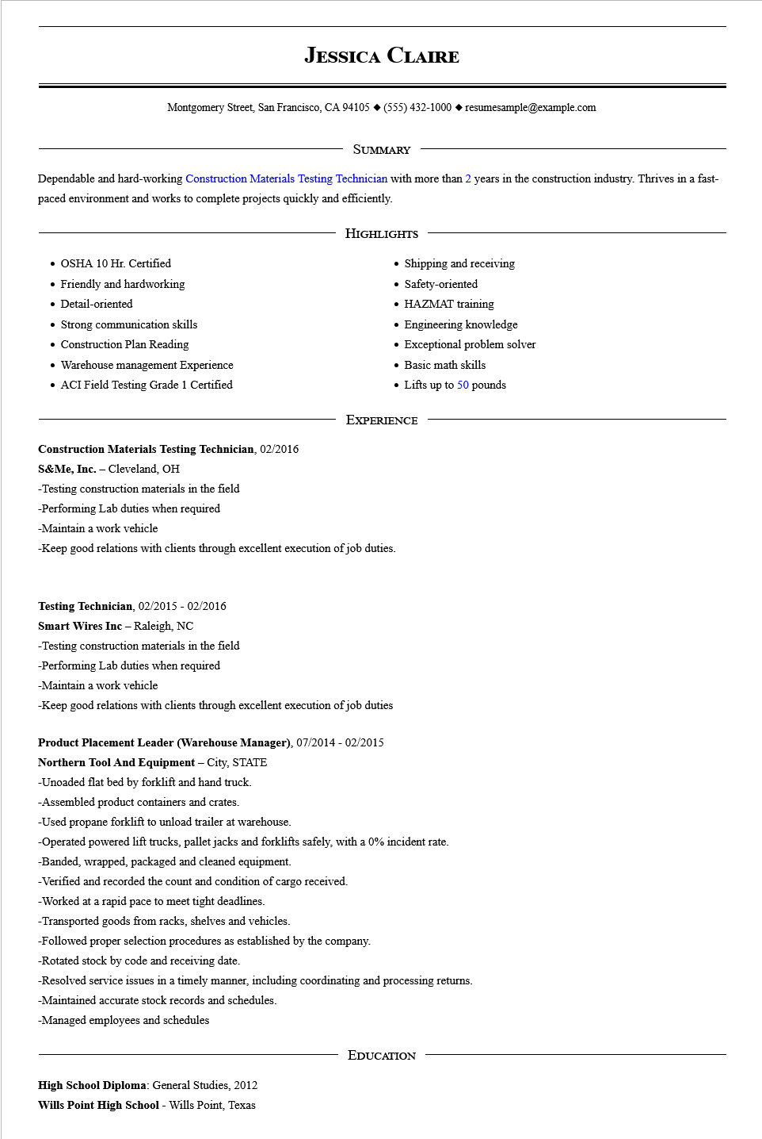

**JESSICA CLAIRE**

Montgomery Street, San Francisco, CA 94105 ♦ (555) 432-1000 resumesample@example.com

SUMMARY

Dependable and hard-working Construction Materials Testing Technician with more than 2 years in the construction industry. Thrives in a fast- paced environment and works to complete projects quickly and efficiently.

• OSHA 10 Hr. Certified

• Friendly and hardworking

• Detail-oriented

• Strong communication skills

• Construction Plan Reading

Warehouse management Experience

• ACI Field Testing Grade 1 Certified

HIGHLIGHTS

• Shipping and receiving

• Safety-oriented

• HAZMAT training

• Engineering knowledge

• Exceptional problem solver

• Basic math skills

• Lifts up to 50 pounds

EXPERIENCE

**Construction Materials Testing Technician, 02/2016**

S&Me, Inc. - Cleveland, OH

-Testing construction materials in the field

-Performing Lab duties when required

-Maintain a work vehicle

-Keep good relations with clients through excellent execution of job duties.

**Testing Technician, 02/2015 - 02/2016**

**Smart Wires Inc - Raleigh, NC**

-Testing construction materials in the field

-Performing Lab duties when required

-Maintain a work vehicle

-Keep good relations with clients through excellent execution of job duties

**Product Placement Leader (Warehouse Manager), 07/2014 - 02/2015**

**Northern Tool And Equipment - City, STATE**

-Unoaded flat bed by forklift and hand truck.

-Assembled product containers and crates.

-Used propane forklift to unload trailer at warehouse.

-Operated powered lift trucks, pallet jacks and forklifts safely, with a 0% incident rate.

-Banded, wrapped, packaged and cleaned equipment.

-Verified and recorded the count and condition of cargo received.

-Worked at a rapid pace to meet tight deadlines.

-Transported goods from racks, shelves and vehicles.

-Followed proper selection procedures as established by the company.

-Rotated stock by code and receiving date.

-Resolved service issues in a timely manner, including coordinating and processing returns.

-Maintained accurate stock records and schedules.

-Managed employees and schedules

**High School Diploma: General Studies, 2012**

**Wills Point High School - Wills Point, Texas**

EDUCATION