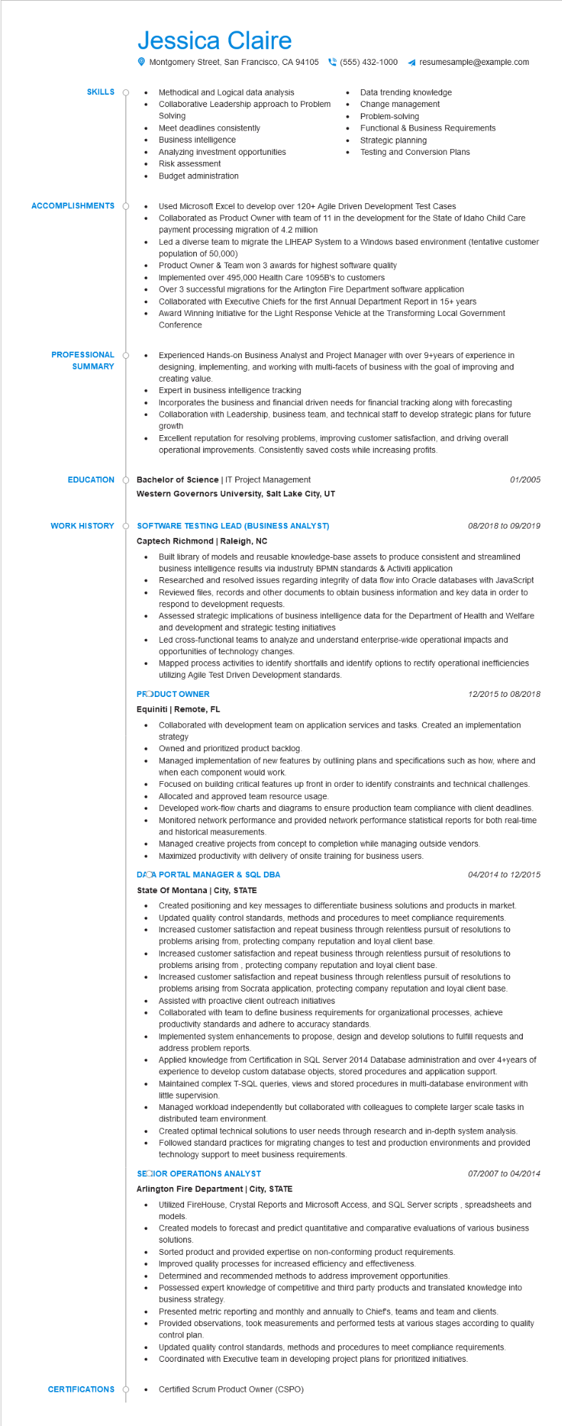

**SKILLS**

Jessica Claire

•

•

•

Montgomery Street, San Francisco, CA 94105

Methodical and Logical data analysis

Collaborative Leadership approach to Problem Solving

Meet deadlines consistently

Business intelligence

Analyzing investment opportunities

Risk assessment

•

Budget administration

(555) 432-1000

resumesample@example.com

Data trending knowledge

Change management Problem-solving

• Functional & Business Requirements

Strategic planning

Testing and Conversion Plans

**ACCOMPLISHMENTS**

•

•

.

•

Used Microsoft Excel to develop over 120+ Agile Driven Development Test Cases

Collaborated as Product Owner with team of 11 in the development for the State of Idaho Child Care payment processing migration of 4.2 million

Led a diverse team to migrate the LIHEAP System to a Windows based environment (tentative customer population of 50,000)

Product Owner & Team won 3 awards for highest software quality

Implemented over 495,000 Health Care 1095B's to customers

Over 3 successful migrations for the Arlington Fire Department software application

Collaborated with Executive Chiefs for the first Annual Department Report in 15+ years

Award Winning Initiative for the Light Response Vehicle at the Transforming Local Government Conference

**PROFESSIONAL**

**SUMMARY**

**EDUCATION**

•

Experienced Hands-on Business Analyst and Project Manager with over 9+years of experience in designing, implementing, and working with multi-facets of business with the goal of improving and creating value.

Expert in business intelligence tracking

Incorporates the business and financial driven needs for financial tracking along with forecasting Collaboration with Leadership, business team, and technical staff to develop strategic plans for future growth

Excellent reputation for resolving problems, improving customer satisfaction, and driving overall operational improvements. Consistently saved costs while increasing profits.

**Bachelor of Science | IT Project Management**

01/2005

**Western Governors University, Salt Lake City, UT**

**WORK HISTORY**

**O SOFTWARE TESTING LEAD (BUSINESS ANALYST) Captech Richmond | Raleigh, NC**

•

08/2018 to 09/2019

•

•

Built library of models and reusable knowledge-base assets to produce consistent and streamlined business intelligence results via industruty BPMN standards & Activiti application

Researched and resolved issues regarding integrity of data flow into Oracle databases with JavaScript Reviewed files, records and other documents to obtain business information and key data in order to respond to development requests.

Assessed strategic implications of business intelligence data for the Department of Health and Welfare and development and strategic testing initiatives

Led cross-functional teams to analyze and understand enterprise-wide operational impacts and opportunities of technology changes.

Mapped process activities to identify shortfalls and identify options to rectify operational inefficiencies utilizing Agile Test Driven Development standards.

**PRODUCT OWNER**

**Equiniti | Remote, FL**

12/2015 to 08/2018

Collaborated with development team on application services and tasks. Created an implementation strategy

•

Owned and prioritized product backlog.

•

Managed implementation of new features by outlining plans and specifications such as how, where and when each component would work.

Focused on building critical features up front in order to identify constraints and technical challenges. Allocated and approved team resource usage.

•

•

Developed work-flow charts and diagrams to ensure production team compliance with client deadlines. Monitored network performance and provided network performance statistical reports for both real-time and historical measurements.

Managed creative projects from concept to completion while managing outside vendors.

• Maximized productivity with delivery of onsite training for business users.

**DACA PORTAL MANAGER & SQL DBA**

**State Of Montana | City, STATE**

04/2014 to 12/2015

Created positioning and key messages to differentiate business solutions and products in market. • Updated quality control standards, methods and procedures to meet compliance requirements. Increased customer satisfaction and repeat business through relentless pursuit of resolutions to problems arising from, protecting company reputation and loyal client base. Increased customer satisfaction and repeat business through relentless pursuit of resolutions to problems arising from, protecting company reputation and loyal client base.

Increased customer satisfaction and repeat business through relentless pursuit of resolutions to problems arising from Socrata application, protecting company reputation and loyal client base. Assisted with proactive client outreach initiatives

•

Collaborated with team to define business requirements for organizational processes, achieve productivity standards and adhere to accuracy standards.

•

Implemented system enhancements to propose, design and develop solutions to fulfill requests and address problem reports.

•

Applied knowledge from Certification in SQL Server 2014 Database administration and over 4+years of experience to develop custom database objects, stored procedures and application support.

Maintained complex T-SQL queries, views and stored procedures in multi-database environment with little supervision.

•

Managed workload independently but collaborated with colleagues to complete larger scale tasks in distributed team environment.

Created optimal technical solutions to user needs through research and in-depth system analysis. Followed standard practices for migrating changes to test and production environments and provided technology support to meet business requirements.

**SECIOR OPERATIONS ANALYST**

07/2007 to 04/2014

**Arlington Fire Department | City, STATE**

• Utilized FireHouse, Crystal Reports and Microsoft Access, and SQL Server scripts, spreadsheets and models.

Created models to forecast and predict quantitative and comparative evaluations of various business solutions.

Sorted product and provided expertise on non-conforming product requirements.

Improved quality processes for increased efficiency and effectiveness.

Determined and recommended methods to address improvement opportunities.

•

Possessed expert knowledge of competitive and third party products and translated knowledge into business strategy.

Presented metric reporting and monthly and annually to Chief's, teams and team and clients.

Provided observations, took measurements and performed tests at various stages according to quality control plan.

Updated quality control standards, methods and procedures to meet compliance requirements. Coordinated with Executive team in developing project plans for prioritized initiatives.

**CERTIFICATIONS**

Certified Scrum Product Owner (CSPO)