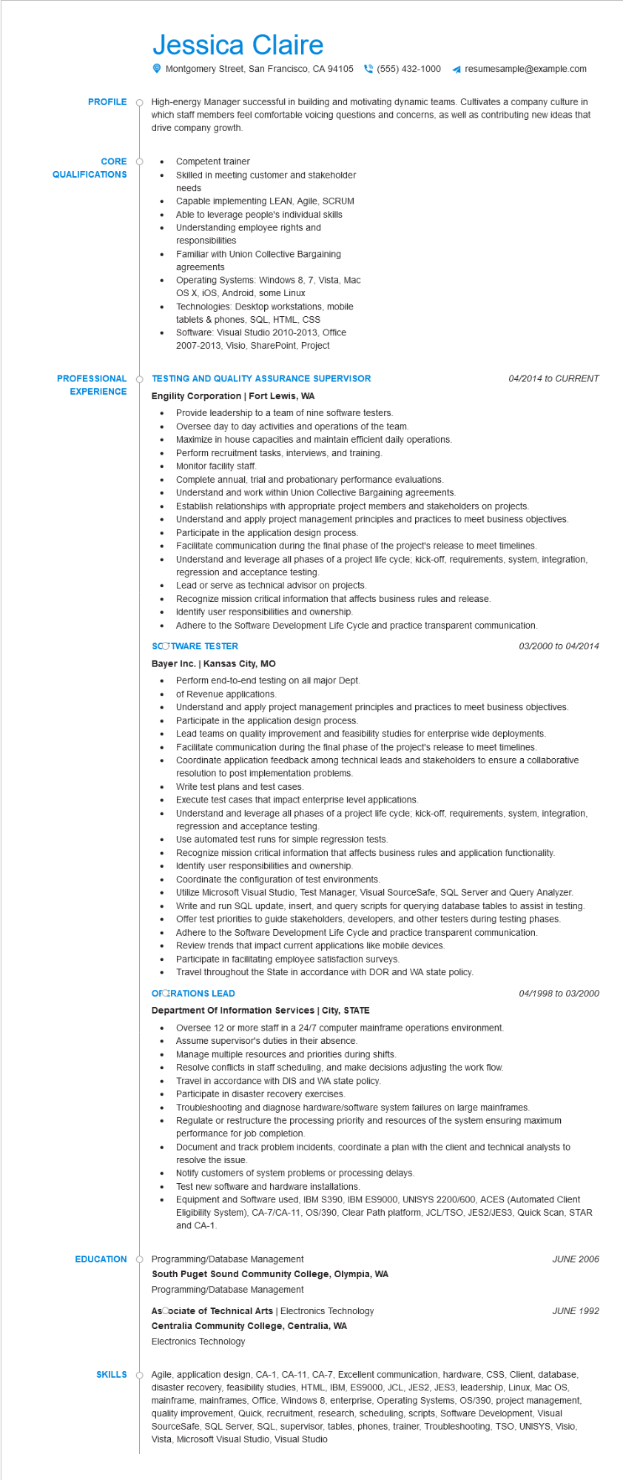

**PROFILE**

CORE

**QUALIFICATIONS**

Jessica Claire

Montgomery Street, San Francisco, CA 94105 (555) 432-1000 ◄ resumesample@example.com

High-energy Manager successful in building and motivating dynamic teams. Cultivates a company culture in which staff members feel comfortable voicing questions and concerns, as well as contributing new ideas that drive company growth.

•

•

Competent trainer

Skilled in meeting customer and stakeholder needs

Capable implementing LEAN, Agile, SCRUM

Able to leverage people's individual skills Understanding employee rights and

responsibilities

Familiar with Union Collective Bargaining agreements

Operating Systems: Windows 8, 7, Vista, Mac OS X, iOS, Android, some Linux

Technologies: Desktop workstations, mobile tablets & phones, SQL, HTML, CSS

Software: Visual Studio 2010-2013, Office 2007-2013, Visio, SharePoint, Project

**PROFESSIONAL TESTING AND QUALITY ASSURANCE SUPERVISOR EXPERIENCE**

**Engility Corporation | Fort Lewis, WA**

• Provide leadership to a team of nine software testers.

•

Oversee day to day activities and operations of the team.

•

Maximize in house capacities and maintain efficient daily operations. Perform recruitment tasks, interviews, and training.

Monitor facility staff.

•

Complete annual, trial and probationary performance evaluations.

Understand and work within Union Collective Bargaining agreements.

04/2014 to CURRENT

•

•

Establish relationships with appropriate project members and stakeholders on projects.

Understand and apply project management principles and practices to meet business objectives. Participate in the application design process.

•

Facilitate communication during the final phase of the project's release to meet timelines.

•

Understand and leverage all phases of a project life cycle; kick-off, requirements, system, integration, regression and acceptance testing.

Lead or serve as technical advisor on projects.

Recognize mission critical information that affects business rules and release.

•

Identify user responsibilities and ownership.

• Adhere to the Software Development Life Cycle and practice transparent communication.

**SCOTWARE TESTER**

**Bayer Inc. | Kansas City, MO**

03/2000 to 04/2014

•

Perform end-to-end testing on all major Dept.

of Revenue applications.

Understand and apply project management principles and practices to meet business objectives. Participate in the application design process.

•

•

Lead teams on quality improvement and feasibility studies for enterprise wide deployments. Facilitate communication during the final phase of the project's release to meet timelines.

•

Coordinate application feedback among technical leads and stakeholders to ensure a collaborative resolution to post implementation problems.

Write test plans and test cases.

Execute test cases that impact enterprise level applications.

•

•

Understand and leverage all phases of a project life cycle; kick-off, requirements, system, integration, regression and acceptance testing.

Use automated test runs for simple regression tests.

Recognize mission critical information that affects business rules and application functionality. Identify user responsibilities and ownership.

•

Coordinate the configuration of test environments.

Utilize Microsoft Visual Studio, Test Manager, Visual SourceSafe, SQL Server and Query Analyzer.

•

Write and run SQL update, insert, and query scripts for querying database tables to assist in testing.

Offer test priorities to guide stakeholders, developers, and other testers during testing phases. Adhere to the Software Development Life Cycle and practice transparent communication. Review trends that impact current applications like mobile devices.

Participate in facilitating employee satisfaction surveys.

• Travel throughout the State in accordance with DOR and WA state policy.

**OFORATIONS LEAD**

**Department Of Information Services | City, STATE**

• Oversee 12 or more staff in a 24/7 computer mainframe operations environment. Assume supervisor's duties in their absence.

04/1998 to 03/2000

•

Manage multiple resources and priorities during shifts.

Resolve conflicts in staff scheduling, and make decisions adjusting the work flow. Travel in accordance with DIS and WA state policy.

Participate in disaster recovery exercises.

Troubleshooting and diagnose hardware/software system failures on large mainframes.

Regulate or restructure the processing priority and resources of the system ensuring maximum performance for job completion.

•

Document and track problem incidents, coordinate a plan with the client and technical analysts to resolve the issue.

Notify customers of system problems or processing delays.

Test new software and hardware installations.

•

Equipment and Software used, IBM S390, IBM ES9000, UNISYS 2200/600, ACES (Automated Client Eligibility System), CA-7/CA-11, OS/390, Clear Path platform, JCL/TSO, JES2/JES3, Quick Scan, STAR and CA-1

EDUCATION Programming/Database Management

**South Puget Sound Community College, Olympia, WA**

Programming/Database Management

AsCociate of Technical Arts | Electronics Technology

**Centralia Community College, Centralia, WA**

Electronics Technology

*JUNE 2006*

JUNE 1992

SKILLS Agile, application design, CA-1, CA-11, CA-7, Excellent communication, hardware, CSS, Client, database, disaster recovery, feasibility studies, HTML, IBM, ES9000, JCL, JES2, JES3, leadership, Linux, Mac OS, mainframe, mainframes, Office, Windows 8, enterprise, Operating Systems, OS/390, project management, quality improvement, Quick, recruitment, research, scheduling, scripts, Software Development, Visual SourceSafe, SQL Server, SQL, supervisor, tables, phones, trainer, Troubleshooting, TSO, UNISYS, Visio, Vista, Microsoft Visual Studio, Visual Studio