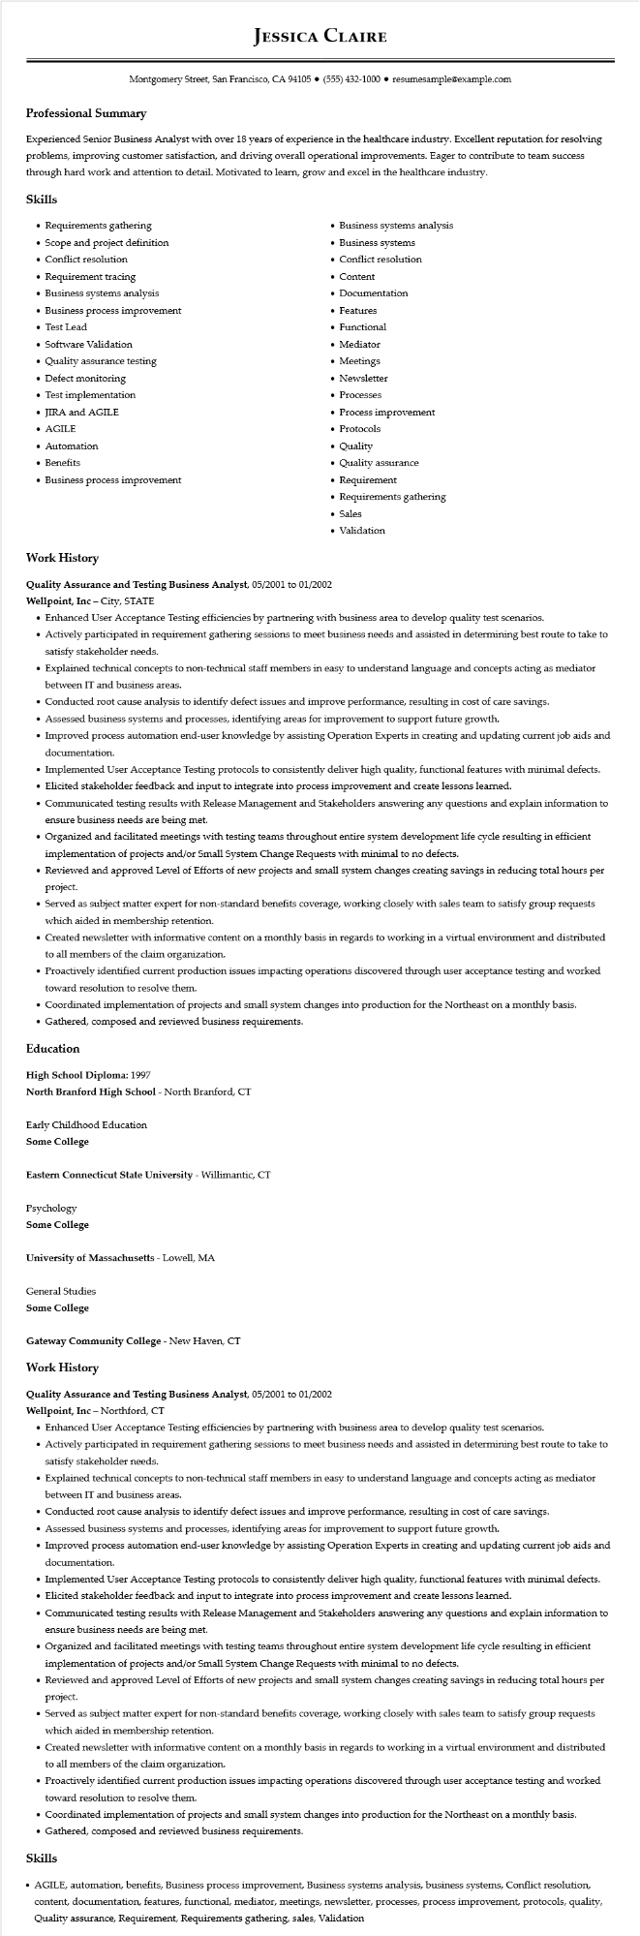

**JESSICA CLAIRE**

Montgomery Street, San Francisco, CA 94105 ⚫ (555) 432-1000⚫ resumesample@example.com

**Professional Summary**

Experienced Senior Business Analyst with over 18 years of experience in the healthcare industry. Excellent reputation for resolving problems, improving customer satisfaction, and driving overall operational improvements. Eager to contribute to team success through hard work and attention to detail. Motivated to learn, grow and excel in the healthcare industry.

**Skills**

• Requirements gathering

·

Scope and project definition

• Conflict resolution

• Requirement tracing

• Business systems analysis

• Business process improvement

• Test Lead

• Software Validation

•

Quality assurance testing

• Defect monitoring

• Test implementation

• JIRA and AGILE

• AGILE

• Automation

• Benefits

• Business process improvement

• Business systems analysis

• Business systems

• Conflict resolution

• Content

• Documentation

• Features

• Functional

• Mediator

• Meetings

• Newsletter

• Processes

• Process improvement

• Protocols

• Quality

• Quality assurance

• Requirement

• Requirements gathering • Sales

• Validation

**Work History**

**Quality Assurance and Testing Business Analyst, 05/2001 to 01/2002**

Wellpoint, Inc - City, STATE

• Enhanced User Acceptance Testing efficiencies by partnering with business area to develop quality test scenarios.

• Actively participated in requirement gathering sessions to meet business needs and assisted in determining best route to take to satisfy stakeholder needs.

• Explained technical concepts to non-technical staff members in easy to understand language and concepts acting as mediator between IT and business areas.

• Conducted root cause analysis to identify defect issues and improve performance, resulting in cost of care savings.

• Assessed business systems and processes, identifying areas for improvement to support future growth.

• Improved process automation end-user knowledge by assisting Operation Experts in creating and updating current job aids and documentation.

• Implemented User Acceptance Testing protocols to consistently deliver high quality, functional features with minimal defects.

• Elicited stakeholder feedback and input to integrate into process improvement and create lessons learned.

• Communicated testing results with Release Management and Stakeholders answering any questions and explain information to ensure business needs are being met.

• Organized and facilitated meetings with testing teams throughout entire system development life cycle resulting in efficient implementation of projects and/or Small System Change Requests with minimal to no defects.

• Reviewed and approved Level of Efforts of new projects and small system changes creating savings in reducing total hours per project.

• Served as subject matter expert for non-standard benefits coverage, working closely with sales team to satisfy group requests which aided in membership retention.

• Created newsletter with informative content on a monthly basis in regards to working in a virtual environment and distributed to all members of the claim organization.

• Proactively identified current production issues impacting operations discovered through user acceptance testing and worked toward resolution to resolve them.

• Coordinated implementation of projects and small system changes into production for the Northeast on a monthly basis.

• Gathered, composed and reviewed business requirements.

**Education**

**High School Diploma: 1997**

**North Branford High School - North Branford, CT**

Early Childhood Education

Some College

Eastern Connecticut State University - Willimantic, CT

Psychology

**Some College**

University of Massachusetts - Lowell, MA

General Studies

Some College

**Gateway Community College - New Haven, CT**

**Work History**

Quality Assurance and Testing Business Analyst, 05/2001 to 01/2002

**Wellpoint, Inc - Northford, CT**

• Enhanced User Acceptance Testing efficiencies by partnering with business area to develop quality test scenarios.

• Actively participated in requirement gathering sessions to meet business needs and assisted in determining best route to take to satisfy stakeholder needs.

• Explained technical concepts to non-technical staff members in easy to understand language and concepts acting as mediator between IT and business areas.

• Conducted root cause analysis to identify defect issues and improve performance, resulting in cost of care savings.

• Assessed business systems and processes, identifying areas for improvement to support future growth.

• Improved process automation end-user knowledge by assisting Operation Experts in creating and updating current job aids and documentation.

• Implemented User Acceptance Testing protocols to consistently deliver high quality, functional features with minimal defects.

• Elicited stakeholder feedback and input to integrate into process improvement and create lessons learned.

• Communicated testing results with Release Management and Stakeholders answering any questions and explain information to ensure business needs are being met.

• Organized and facilitated meetings with testing teams throughout entire system development life cycle resulting in efficient implementation of projects and/or Small System Change Requests with minimal to no defects.

• Reviewed and approved Level of Efforts of new projects and small system changes creating savings in reducing total hours per project.

• Served as subject matter expert for non-standard benefits coverage, working closely with sales team to satisfy group requests which aided in membership retention.

• Created newsletter with informative content on a monthly basis in regards to working in a virtual environment and distributed to all members of the claim organization.

• Proactively identified current production issues impacting operations discovered through user acceptance testing and worked toward resolution to resolve them.

• Coordinated implementation of projects and small system changes into production for the Northeast on a monthly basis. • Gathered, composed and reviewed business requirements.

**Skills**

• AGILE, automation, benefits, Business process improvement, Business systems analysis, business systems, Conflict resolution, content, documentation, features, functional, mediator, meetings, newsletter, processes, process improvement, protocols, quality, Quality assurance, Requirement, Requirements gathering, sales, Validation