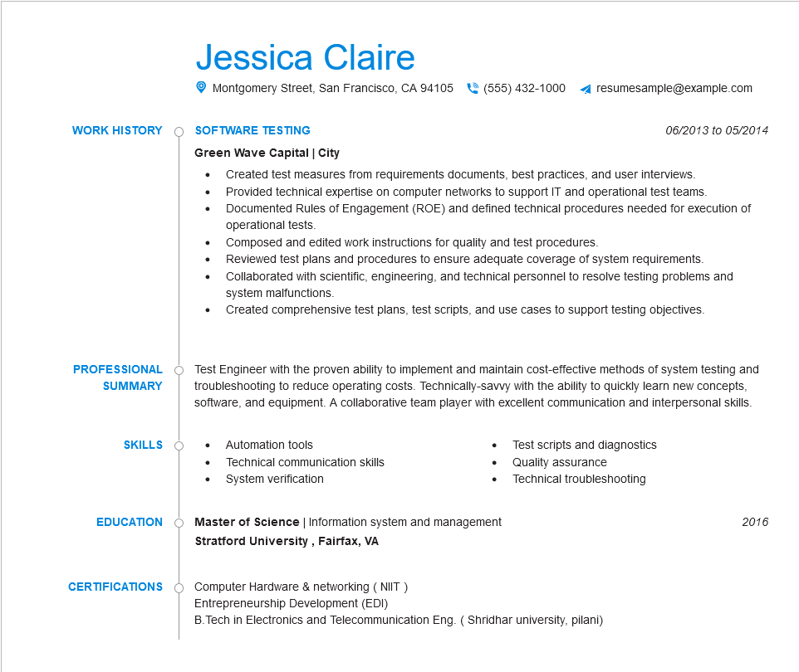

**WORK HISTORY**

Jessica Claire

Montgomery Street, San Francisco, CA 94105 (555) 432-1000

resumesample@example.com

**SOFTWARE TESTING**

Green Wave Capital | City

*06/2013 to 05/2014*

• Created test measures from requirements documents, best practices, and user interviews.

·

• Provided technical expertise on computer networks to support IT and operational test teams. Documented Rules of Engagement (ROE) and defined technical procedures needed for execution of operational tests.

•

Composed and edited work instructions for quality and test procedures.

Reviewed test plans and procedures to ensure adequate coverage of system requirements. Collaborated with scientific, engineering, and technical personnel to resolve testing problems and system malfunctions.

• Created comprehensive test plans, test scripts, and use cases to support testing objectives.

**PROFESSIONAL SUMMARY**

Test Engineer with the proven ability to implement and maintain cost-effective methods of system testing and troubleshooting to reduce operating costs. Technically-savvy with the ability to quickly learn new concepts, software, and equipment. A collaborative team player with excellent communication and interpersonal skills.

**SKILLS**

• Automation tools

Technical communication skills

• System verification

**EDUCATION**

Test scripts and diagnostics

•

Quality assurance

•

Technical troubleshooting

Master of Science | Information system and management

**Stratford University, Fairfax, VA**

**CERTIFICATIONS**

Computer Hardware & networking (NIIT)

Entrepreneurship Development (EDI)

B.Tech in Electronics and Telecommunication Eng. (Shridhar university, pilani)

2016