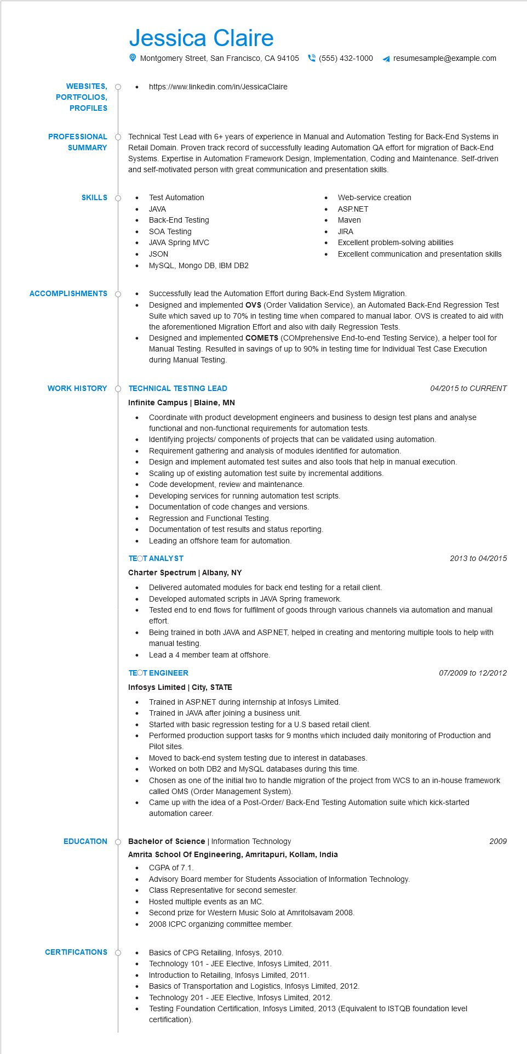

**WEBSITES, PORTFOLIOS,**

**PROFILES**

Jessica Claire

Montgomery Street, San Francisco, CA 94105(555) 432-1000

https://www.linkedin.com/in/JessicaClaire

resumesample@example.com

**PROFESSIONAL SUMMARY**

Technical Test Lead with 6+ years of experience in Manual and Automation Testing for Back-End Systems in Retail Domain. Proven track record of successfully leading Automation QA effort for migration of Back-End Systems. Expertise in Automation Framework Design, Implementation, Coding and Maintenance. Self-driven and self-motivated person with great communication and presentation skills.

Test Automation

**SKILLS**

•

JAVA

•

Back-End Testing

SOA Testing

•

JAVA Spring MVC

JSON

•

MySQL, Mongo DB, IBM DB2

• Web-service creation ASP.NET

•

Maven

JIRA

Excellent problem-solving abilities

Excellent communication and presentation skills

**ACCOMPLISHMENTS**

**WORK HISTORY**

**EDUCATION**

Successfully lead the Automation Effort during Back-End System Migration.

Designed and implemented OVS (Order Validation Service), an Automated Back-End Regression Test Suite which saved up to 70% in testing time when compared to manual labor. OVS is created to aid with the aforementioned Migration Effort and also with daily Regression Tests.

Designed and implemented COMETS (COMprehensive End-to-end Testing Service), a helper tool for Manual Testing. Resulted in savings of up to 90% in testing time for Individual Test Case Execution during Manual Testing.

**O TECHNICAL TESTING LEAD**

**Infinite Campus | Blaine, MN**

*04/2015 to CURRENT*

•

Coordinate with product development engineers and business to design test plans and analyse functional and non-functional requirements for automation tests.

•

Identifying projects/ components of projects that can be validated using automation.

•

•

Requirement gathering and analysis of modules identified for automation.

Design and implement automated test suites and also tools that help in manual execution. Scaling up of existing automation test suite by incremental additions.

Code development, review and maintenance.

Developing services for running automation test scripts.

Documentation of code changes and versions.

•

•

Regression and Functional Testing.

•

Documentation of test results and status reporting.

•

Leading an offshore team for automation.

**TEOT ANALYST**

**Charter Spectrum | Albany, NY**

Delivered automated modules for back end testing for a retail client.

•

Developed automated scripts in JAVA Spring framework.

2013 to 04/2015

Tested end to end flows for fulfilment of goods through various channels via automation and manual effort.

Being trained in both JAVA and ASP.NET, helped in creating and mentoring multiple tools to help with manual testing.

•

Lead a 4 member team at offshore.

**TEOT ENGINEER**

**Infosys Limited | City, STATE**

•

Trained in ASP.NET during internship at Infosys Limited.

Trained in JAVA after joining a business unit.

07/2009 to 12/2012

Started with basic regression testing for a US based retail client.

Performed production support tasks for 9 months which included daily monitoring of Production and Pilot sites.

Moved to back-end system testing due to interest in databases.

Worked on both DB2 and MySQL databases during this time.

Chosen as one of the initial two to handle migration of the project from WCS to an in-house framework called OMS (Order Management System).

Came up with the idea of a Post-Order/Back-End Testing Automation suite which kick-started automation career.

Bachelor of Science | Information Technology

• CGPA of 7.1.

**Amrita School Of Engineering, Amritapuri, Kollam, India**

Advisory Board member for Students Association of Information Technology.

Class Representative for second semester.

• Hosted multiple events as an MC.

Second prize for Western Music Solo at Amritolsavam 2008.

2008 ICPC organizing committee member.

**CERTIFICATIONS**

•

Basics of CPG Retailing, Infosys, 2010.

•

Technology 101 - JEE Elective, Infosys Limited, 2011.

Introduction to Retailing, Infosys Limited, 2011.

Basics of Transportation and Logistics, Infosys Limited, 2012.

Technology 201 - JEE Elective, Infosys Limited, 2012.

Testing Foundation Certification, Infosys Limited, 2013 (Equivalent to ISTQB foundation level

certification).

*2009*