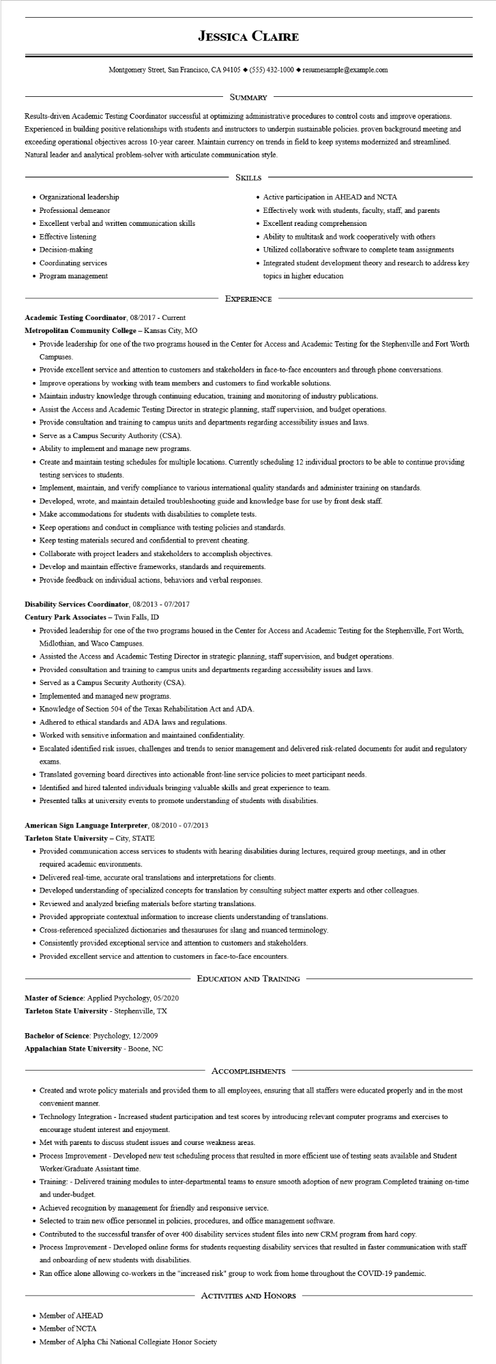

**JESSICA CLAIRE**

Montgomery Street, San Francisco, CA 94105 ♦ (555) 432-1000 resumesample@example.com

SUMMARY

Results-driven Academic Testing Coordinator successful at optimizing administrative procedures to control costs and improve operations. Experienced in building positive relationships with students and instructors to underpin sustainable policies. proven background meeting and exceeding operational objectives across 10-year career. Maintain currency on trends in field to keep systems modernized and streamlined. Natural leader and analytical problem-solver with articulate communication style.

• Organizational leadership

• Professional demeanor

• Excellent verbal and written communication skills

• Effective listening

• Decision-making

• Coordinating services

• Program management

SKILLS

• Active participation in AHEAD and NCTA

• Effectively work with students, faculty, staff, and parents

• Excellent reading comprehension

• Ability to multitask and work cooperatively with others

• Utilized collaborative software to complete team assignments

• Integrated student development theory and research to address key topics in higher education

EXPERIENCE

**Academic Testing Coordinator, 08/2017 - Current**

Metropolitan Community College - Kansas City, MO

• Provide leadership for one of the two programs housed in the Center for Access and Academic Testing for the Stephenville and Fort Worth Campuses.

• Provide excellent service and attention to customers and stakeholders in face-to-face encounters and through phone conversations.

• Improve operations by working with team members and customers to find workable solutions.

• Maintain industry knowledge through continuing education, training and monitoring of industry publications.

• Assist the Access and Academic Testing Director in strategic planning, staff supervision, and budget operations.

• Provide consultation and training to campus units and departments regarding accessibility issues and laws.

• Serve as a Campus Security Authority (CSA).

• Ability to implement and manage new programs.

• Create and maintain testing schedules for multiple locations. Currently scheduling 12 individual proctors to be able to continue providing testing services to students.

• Implement, maintain, and verify compliance to various international quality standards and administer training on standards.

• Developed, wrote, and maintain detailed troubleshooting guide and knowledge base for use by front desk staff.

• Make accommodations for students with disabilities to complete tests.

• Keep operations and conduct in compliance with testing policies and standards.

• Keep testing materials secured and confidential to prevent cheating.

• Collaborate with project leaders and stakeholders to accomplish objectives.

• Develop and maintain effective frameworks, standards and requirements.

• Provide feedback on individual actions, behaviors and verbal responses.

**Disability Services Coordinator, 08/2013 - 07/2017**

**Century Park Associates - Twin Falls, ID**

• Provided leadership for one of the two programs housed in the Center for Access and Academic Testing for the Stephenville, Fort Worth, Midlothian, and Waco Campuses.

• Assisted the Access and Academic Testing Director in strategic planning, staff supervision, and budget operations.

• Provided consultation and training to campus units and departments regarding accessibility issues and laws.

• Served as a Campus Security Authority (CSA).

• Implemented and managed new programs.

• Knowledge of Section 504 of the Texas Rehabilitation Act and ADA.

• Adhered to ethical standards and ADA laws and regulations.

• Worked with sensitive information and maintained confidentiality.

• Escalated identified risk issues, challenges and trends to senior management and delivered risk-related documents for audit and regulatory

exams.

• Translated governing board directives into actionable front-line service policies to meet participant needs.

• Identified and hired talented individuals bringing valuable skills and great experience to team.

• Presented talks at university events to promote understanding of students with disabilities.

**American Sign Language Interpreter, 08/2010 - 07/2013**

**Tarleton State University - City, STATE**

• Provided communication access services to students with hearing disabilities during lectures, required group meetings, and in other required academic environments.

• Delivered real-time, accurate oral translations and interpretations for clients.

• Developed understanding of specialized concepts for translation by consulting subject matter experts and other colleagues.

• Reviewed and analyzed briefing materials before starting translations.

• Provided appropriate contextual information to increase clients understanding of translations.

• Cross-referenced specialized dictionaries and thesauruses for slang and nuanced terminology.

• Consistently provided exceptional service and attention to customers and stakeholders.

• Provided excellent service and attention to customers in face-to-face encounters.

Master of Science: Applied Psychology, 05/2020

Tarleton State University - Stephenville, TX

Bachelor of Science: Psychology, 12/2009

**Appalachian State University - Boone, NC**

EDUCATION AND TRAINING

ACCOMPLISHMENTS

• Created and wrote policy materials and provided them to all employees, ensuring that all staffers were educated properly and in the most convenient manner.

• Technology Integration - Increased student participation and test scores by introducing relevant computer programs and exercises to encourage student interest and enjoyment.

• Met with parents to discuss student issues and course weakness areas.

• Process Improvement - Developed new test scheduling process that resulted in more efficient use of testing seats available and Student Worker/Graduate Assistant time.

• Training: - Delivered training modules to inter-departmental teams to ensure smooth adoption of new program. Completed training on-time and under-budget.

• Achieved recognition by management for friendly and responsive service.

• Selected to train new office personnel in policies, procedures, and office management software.

• Contributed to the successful transfer of over 400 disability services student files into new CRM program from hard copy.

• Process Improvement - Developed online forms for students requesting disability services that resulted in faster communication with staff and onboarding of new students with disabilities.

• Ran office alone allowing co-workers in the "increased risk" group to work from home throughout the COVID-19 pandemic.

• Member of AHEAD

ACTIVITIES AND HONORS

• Member of NCTA

• Member of Alpha Chi National Collegiate Honor Society