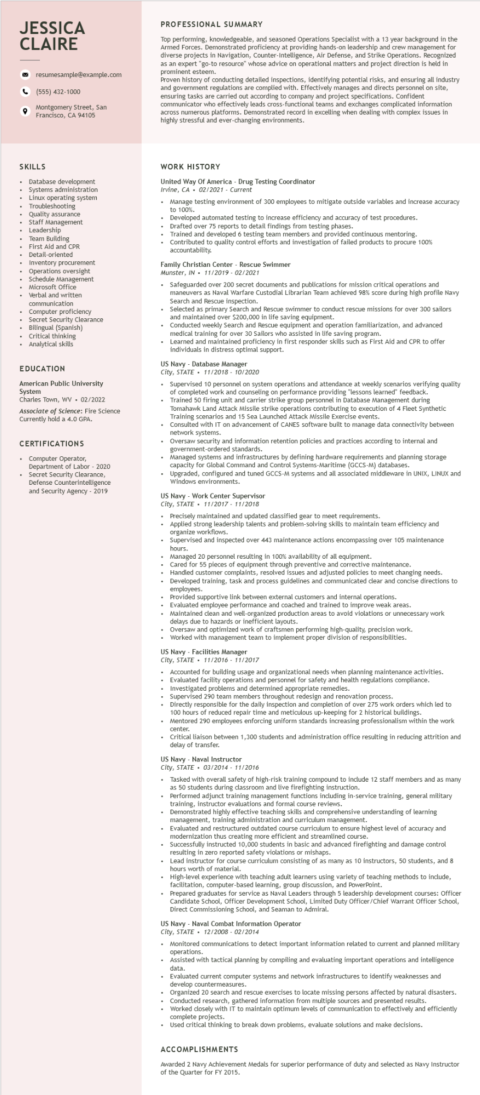

**JESSICA CLAIRE**

9

resumesample@example.com

(555) 432-1000

Montgomery Street, San Francisco, CA 94105

**PROFESSIONAL SUMMARY**

Top performing, knowledgeable, and seasoned Operations Specialist with a 13 year background in the Armed Forces. Demonstrated proficiency at providing hands-on leadership and crew management for diverse projects in Navigation, Counter-Intelligence, Air Defense, and Strike Operations. Recognized as an expert "go-to resource" whose advice on operational matters and project direction is held in prominent esteem.

Proven history of conducting detailed inspections, identifying potential risks, and ensuring all industry and government regulations are complied with. Effectively manages and directs personnel on site, ensuring tasks are carried out according to company and project specifications. Confident communicator who effectively leads cross-functional teams and exchanges complicated information across numerous platforms. Demonstrated record in excelling when dealing with complex issues in highly stressful and ever-changing environments.

**SKILLS**

• Database development Systems administration

• Linux operating system

Troubleshooting

• Quality assurance • Staff Management Leadersm Leadership

Team Building

First Aid and CPR Detail-oriented Inventory procurement Operations oversight Schedule Management Microsoft Office Verbal and written communication

Computer proficiency

Secret Security Clearance

Bilingual (Spanish)

Critical thinking

Analytical skills

EDUCATION

American Public University System

Charles Town, WV. 02/2022

Associate of Science: Fire Science Currently hold a 4.0 GPA.

CERTIFICATIONS

.

Computer Operator,

Department of Labor - 2020

• Secret Security Clearance, Defense Counterintelligence and Security Agency - 2019

**WORK HISTORY**

**United Way Of America - Drug Testing Coordinator**

Irvine, CA 02/2021 - Current

• Manage testing environment of 300 employees to mitigate outside variables and increase accuracy

to 100%.

Developed automated testing to increase efficiency and accuracy of test procedures.

Drafted over 75 reports to detail findings from testing phases.

Trained and developed 6 testing team members and provided continuous mentoring.

Contributed to quality control efforts and investigation of failed products to procure 100% accountability.

Family Christian Center - Rescue Swimmer

Munster, IN. 11/2019-02/2021

• Safeguarded over 200 secret documents and publications for mission critical operations and maneuvers as Naval Warfare Custodial Librarian Team achieved 98% score during high profile Navy Search and Rescue inspection.

• Selected as primary Search and Rescue swimmer to conduct rescue missions for over 300 sailors and maintained over $200,000 in life saving equipment.

• Conducted weekly Search and Rescue equipment and operation familiarization, and advanced medical training for over 30 Sailors who assisted in life saving program.

.

Learned and maintained proficiency in first responder skills such as First Aid and CPR to offer individuals in distress optimal support.

**US Navy - Database Manager**

*City, STATE 11/2018 10/2020*

Supervised 10 personnel on system operations and attendance at weekly scenarios verifying quality of completed work and counseling on performance providing "lessons learned" feedback. Trained 50 firing unit and carrier strike group personnel in atabase Management during Tomahawk Land Attack Missile strike operations contributing to execution of 4 Fleet Synthetic Training scenarios and 15 Sea Launched Attack Missile Exercise events.

Consulted with IT on advancement of CANES software built to manage data connectivity between network systems.

Oversaw security and information retention policies and practices according to internal and government-ordered standards.

Managed systems and infrastructures by defining hardware requirements and planning storage capacity for Global Command and Control Systems-Maritime (GCCS-M) databases.

Upgraded, configured and tuned GCCS-M systems and all associated middleware in UNIX, LINUX and Windows environments.

**US Navy - Work Center Supervisor**

*City, STATE 11/2017 11/2018*

Precisely maintained and updated classified gear to meet requirements.

Applied strong leadership talents and problem-solving skills to maintain team efficiency and organize workflows.

Supervised and inspected over 443 maintenance actions encompassing over 105 maintenance

hours.

Managed 20 personnel resulting in 100% availability of all equipment.

Cared for 55 pieces of equipment through preventive and corrective maintenance.

Handled customer complaints, resolved issues and adjusted policies to meet changing needs.

Developed training, task and process guidelines and communicated clear and concise directions to employees.

Provided supportive link between external customers and internal operations.

Evaluated employee performance and coached and trained to improve weak areas.

• Maintained clean and well-organized production areas to avoid violations or unnecessary work delays due to hazards or inefficient layouts.

Oversaw and optimized work of craftsmen performing high-quality, precision work.

Worked with management team to implement proper division of responsibilities.

US Navy - Facilities Manager

*City, STATE 11/2016 11/2017*

Accounted for building usage and organizational needs when planning maintenance activities. Evaluated facility operations and personnel for safety and health regulations compliance.

• Investigated problems and determined appropriate remedies. Supervised 290 team members throughout redesign and renovation process.

Directly responsible for the daily inspection and completion of over 275 work orders which led to 100 hours of reduced repair time and meticulous up-keeping for 2 historical buildings.

Mentored 290 employees enforcing uniform standards increasing professionalism within the work center.

Critical liaison between 1,300 students and administration office resulting in reducing attrition and delay of transfer.

**US Navy - Naval Instructor**

*City, STATE⚫ 03/2014 - 11/2016*

.

.

Tasked with overall safety of high-risk training compound to include 12 staff members and as many as 50 students during classroom and live firefighting instruction.

Performed adjunct training management functions including in-service training, general military training, instructor evaluations and formal course reviews.

Demonstrated highly effective teaching skills and comprehensive understanding of learning management, training administration and I curriculum

management.

Evaluated and restructured outdated course curriculum to ensure highest level of accuracy and modernization thus creating more efficient and streamlined course.

Successfully instructed 10,000 students in basic and advanced firefighting and damage control resulti resulting in zero reported safety violations mishaps.

Lead instructor for course curriculum consisting of as many as 10 instructors, 50 students, and 8 hours worth of material.

High-level experience with teaching adult learners using variety of teaching methods to include, facilitation, computer-based learning, group discussion, and PowerPoint.

Prepared graduates for service as Naval Leaders through 5 leadership development courses: Officer Candidate School, Officer Development School, Limited Duty Officer/Chief Warrant Officer School, Direct Commissioning School, and Seaman to Admiral.

US Navy Naval Combat Information Operator

*City, STATE 12/2008- 02/2014*

Monitored communications to detect important information related to current and planned military operations.

Assisted with tactical planning by compiling and evaluating important operations and intelligence

data.

Evaluated current computer systems and network infrastructures to identify weaknesses and develop countermeasures.

Organized 20 search and rescue exercises to locate missing persons affected by natural disasters. Conducted research, gathered information from multiple sources and presented results.

Worked closely with IT to maintain optimum levels of communication to effectively and efficiently complete projects.

Used critical thinking to break down problems, evaluate solutions and make decisions.

**ACCOMPLISHMENTS**

Awarded 2 Navy Achievement Medals for superior performance of duty and selected as Navy Instructor of the Quarter for FY 2015.