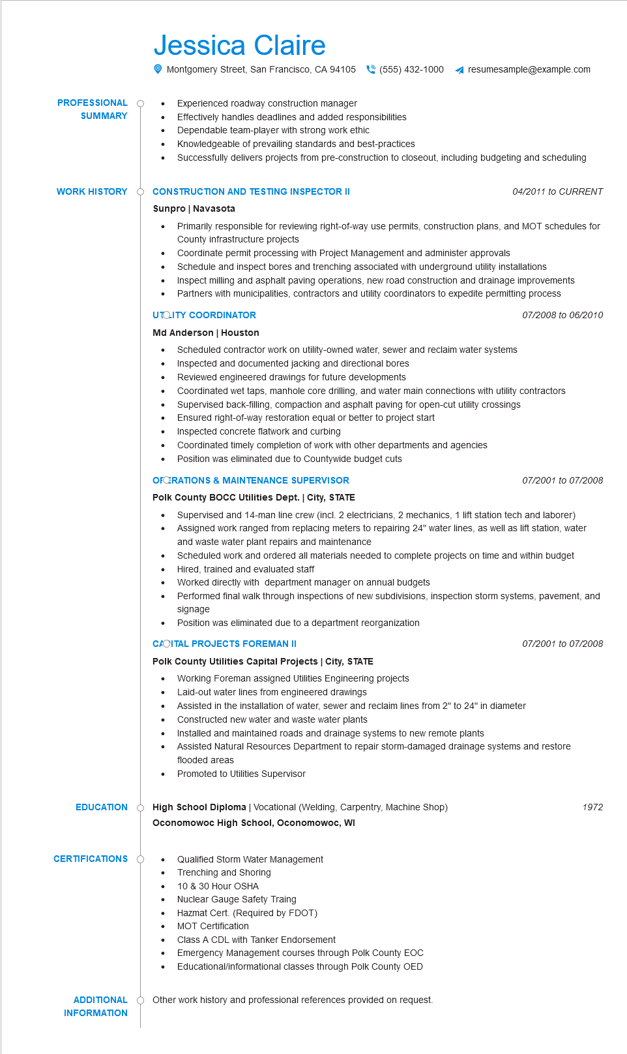

**PROFESSIONAL SUMMARY**

Jessica Claire

Montgomery Street, San Francisco, CA 94105(555) 432-1000 ◄ resumesample@example.com

•

Experienced roadway construction manager

•

Effectively handles deadlines and added responsibilities

Dependable team-player with strong work ethic

Knowledgeable of prevailing standards and best-practices

Successfully delivers projects from pre-construction to closeout, including budgeting and scheduling

**WORK HISTORY CONSTRUCTION AND TESTING INSPECTOR II**

**Sunpro | Navasota**

•

•

*04/2011 to CURRENT*

Primarily responsible for reviewing right-of-way use permits, construction plans, and MOT schedules for County infrastructure projects

Coordinate permit processing with Project Management and administer approvals

·

•

Schedule and inspect bores and trenching associated with underground utility installations

Inspect milling and asphalt paving operations, new road construction and drainage improvements

Partners with municipalities, contractors and utility coordinators to expedite permitting process

07/2008 to 06/2010

**UTOLITY COORDINATOR**

**Md Anderson | Houston**

• Scheduled contractor work on utility-owned water, sewer and reclaim water systems

•

Inspected and documented jacking and directional bores

.

Reviewed engineered drawings for future developments

•

•

Coordinated wet taps, manhole core drilling, and water main connections with utility contractors Supervised back-filling, compaction and asphalt paving for open-cut utility crossings

Ensured right-of-way restoration equal or better to project start

Inspected concrete flatwork and curbing

Coordinated timely completion of work with other departments and agencies

Position was eliminated due to Countywide budget cuts

**OFORATIONS & MAINTENANCE SUPERVISOR**

**Polk County BOCC Utilities Dept. | City, STATE**

07/2001 to 07/2008

•

Supervised and 14-man line crew (incl. 2 electricians, 2 mechanics, 1 lift station tech and laborer) Assigned work ranged from replacing meters to repairing 24" water lines, as well as lift station, water and waste water plant repairs and maintenance

Scheduled work and ordered all materials needed to complete projects on time and within budget Hired, trained and evaluated staff

•

Worked directly with department manager on annual budgets

•

Performed final walk through inspections of new subdivisions, inspection storm systems, pavement, and signage

Position was eliminated due to a department reorganization

**CAOITAL PROJECTS FOREMAN**

**Polk County Utilities Capital Projects | City, STATE**

07/2001 to 07/2008

Working Foreman assigned Utilities Engineering projects

Laid-out water lines from engineered drawings

•

Assisted in the installation of water, sewer and reclaim lines from 2" to 24" in diameter Constructed new water and waste water plants

• Installed and maintained roads and drainage systems to new remote plants

•

Assisted Natural Resources Department to repair storm-damaged drainage systems and restore flooded areas

Promoted to Utilities Supervisor

EDUCATION High School Diploma | Vocational (Welding, Carpentry, Machine Shop)

**Oconomowoc High School, Oconomowoc, WI**

**CERTIFICATIONS**

Qualified Storm Water Management

Trenching and Shoring

•

10 & 30 Hour OSHA

Nuclear Gauge Safety Traing

Hazmat Cert. (Required by FDOT)

•

MOT Certification

•

•

Class A CDL with Tanker Endorsement

Emergency Management courses through Polk County EOC Educational/informational classes through Polk County OED

ADDITIONAL O Other work history and professional references provided on request. INFORMATION

1972