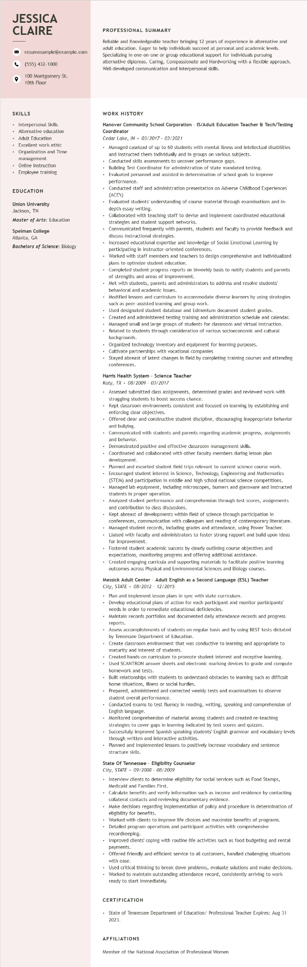

**JESSICA CLAIRE**

resumesample@example.com (555) 432-1000

100 Montgomery St. 10th Floor

PROFESSIONAL SUMMARY

Reliable and Knowledgeable teacher bringing 12 years of experience in alternative and adult education. Eager to help individuals succeed at personal and academic levels. Specializing in one-on-one or group educational support for individuals pursuing alternative diplomas. Caring, Compassionate and Hardworking with a flexible approach. Well-developed communication and interpersonal skills.

**SKILLS**

• Interpersonal Skills

•

Alternative education

• Adult Education

• Excellent work ethic

• Organization and Time management

• Online instruction • Employee training

EDUCATION

Union University

Jackson, TN

Master of Arts: Education

**Spelman College**

Atlanta, GA

**Bachelors of Science: Biology**

WORK HISTORY

**Hanover Community School Corporation - IS/Adult Education Teacher & Tech/Testing Coordinator**

*Cedar Lake, IN 03/2017 - 03/2021*

• Managed caseload of up to 60 students with mental illness and intellectual disabilities

and instructed them individually and in groups on various subjects.

Conducted skills assessments to uncover performance gaps.

Building Test Coordinator for administration of state mandated testing.

Evaluated personnel and assisted in determination of school goals to improve performance.

Conducted staff and administration presentation on Adverse Childhood Experiences (ACE's)

Evaluated students' understanding of course material through examinations and in- depth essay writing.

Collaborated with teaching staff to devise and implement coordinated educational strategies and student support networks.

Communicated frequently with parents, students and faculty to provide feedback and discuss instructional strategies.

Increased educational expertise and knowledge of Social Emotional Learning by participating in instructor-oriented conferences.

Worked with staff members and teachers to design comprehensive and individualized plans to optimize student education.

Completed student progress reports on biweekly basis to notify students and parents of strengths and areas of improvement.

• Met with students, parents and administrators to address and resolve students' behavioral and academic issues.

• Modified lessons and curriculum to accommodate diverse learners by using strategies such as peer-assisted learning and group work.

• Used designated student database and Edmentum document student grades. Created and administered testing training and administration schedule and calendar.

• Managed small and large groups of students for classroom and virtual instruction. Related to students through consideration of various socioeconomic and cultural backgrounds.

• Organized technology inventory and equipment for learning purposes.

.

Cultivate partnerships with vocational companies

• Stayed abreast of latest changes in field by completing training courses and attending conferences.

**Harris Health System - Science Teacher**

*Katy, TX 08/2009 - 03/2017*

• Assessed submitted class assignments, determined grades and reviewed work with struggling students to boost success chance.

• Kept classroom environments consistent and focused on learning by establishing and enforcing clear objectives.

.

.

Offered clear and constructive student discipline, discouraging inappropriate behavior and bullying.

Communicated with students and parents regarding academic progress, assignments and behavior.

Demonstrated positive and effective classroom management skills.

Coordinated and collaborated with other faculty members during lesson plan

development.

Planned and escorted student field trips relevant to current science course work. • Encouraged student interest in Science, Technology, Engineering and Mathematics (STEM) and participation in middle and high school national science competitions. Managed lab equipment, including microscopes, burners and glassware and instructed students in proper operation.

• Analyzed student performance and comprehension through test scores, assignments and contribution to class discussions.

• Kept abreast of developments within field of science through participation in conferences, communication with colleagues and reading of contemporary literature. Managed student records, including grades and attendance, using Power Teacher.

.

• Liaised with faculty and administrators to foster strong rapport and build upon ideas for improvement.

Fostered student academic success by clearly outlining course objectives and expectations, monitoring progress and offering additional assistance.

Created engaging curricula and supporting materials to facilitate positive learning outcomes across Physical and Environmental Sciences and Biology courses.

**Messick Adult Center - Adult English as a Second Language (ESL) Teacher City, STATE**

*08/2012 - 12/2015*

• Plan and implement lesson plans in sync with state curriculum.

• Develop educational plans of action for each participant and monitor participants' needs in order to remediate educational deficiencies.

• Maintain records portfolios and documented daily attendance records and progress reports.

Assess accomplishments of students on regular basis and by using BEST tests dictated by Tennessee Department of Education.

Create classroom environment that was conductive to learning and appropriate to maturity and interest of students.

.

Created hands-on curriculum to promote student interest and receptive learning. Used SCANTRON answer sheets and electronic marking devices to grade and compute homework and tests.

Built relationships with students to understand obstacles to learning such as difficult home situations, illness or social hurdles.

•

Prepared, administered and corrected weekly tests and examinations to observe student overall performance.

Conducted exams to test fluency in reading, writing, speaking and comprehension of English language.

• Monitored comprehension of material among students and created re-teaching strategies to cover gaps in learning indicated by test scores and quizzes.

• Successfully improved Spanish speaking students' English grammar and vocabulary levels through written and interactive activities.

• Planned and implemented lessons to positively increase vocabulary and sentence structure skills.

**State Of Tennessee - Eligibility Counselor**

*City, STATE 09/2008 - 08/2009*

• Interview clients to determine eligibility for social services such as Food Stamps, Medicaid and Families First.

Calculate benefits and verify information such as income and residence by contacting collateral contacts and reviewing documentary evidence.

• Make decisions regarding implementation of policy and procedure in determination of eligibility for benefits.

Worked with clients to improve life choices and maximize benefits of programs.

• Detailed program operations and participant activities with comprehensive recordkeeping.

• Improved clients' coping with routine life activities such as food budgeting and rental payments.

.

Offered friendly and efficient service to all customers, handled challenging situations with ease.

• Used critical thinking to break down problems, evaluate solutions and make decisions.

.

Worked to maintain outstanding attendance record, consistently arriving to work ready to start immediately.

CERTIFICATION

• State of Tennessee Department of Education/ Professional Teacher Expires: Aug 31 2023.

**AFFILIATIONS**

Member of the National Association of Professional Women