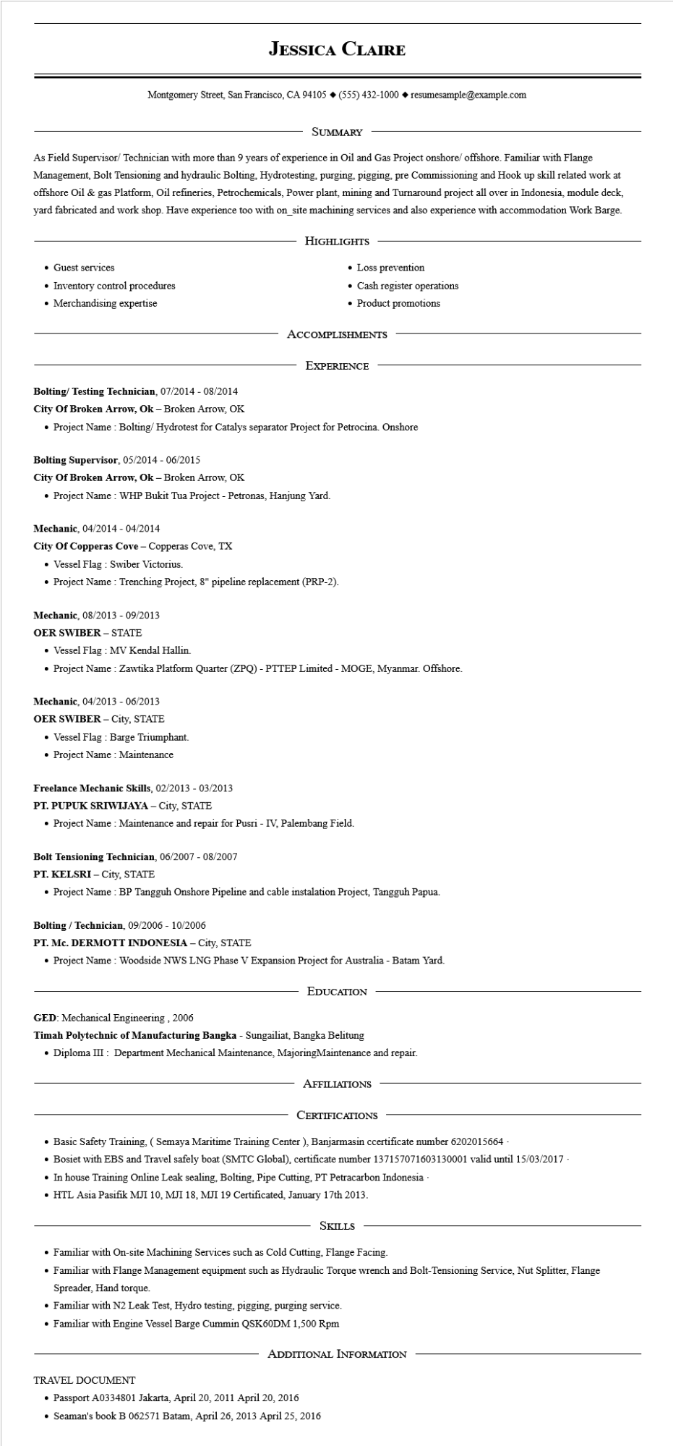

**JESSICA CLAIRE**

Montgomery Street, San Francisco, CA 94105 ♦ (555) 432-1000 resumesample@example.com

SUMMARY

As Field Supervisor/ Technician with more than 9 years of experience in Oil and Gas Project onshore/ offshore. Familiar with Flange Management, Bolt Tensioning and hydraulic Bolting, Hydrotesting, purging, pigging, pre Commissioning and Hook up skill related work at offshore Oil & gas Platform, Oil refineries, Petrochemicals, Power plant, mining and Turnaround project all over in Indonesia, module deck, yard fabricated and work shop. Have experience too with on_site machining services and also experience with accommodation Work Barge.

• Guest services

• Inventory control procedures

• Merchandising expertise

HIGHLIGHTS

• Loss prevention

• Cash register operations

• Product promotions

ACCOMPLISHMENTS

EXPERIENCE

**Bolting/ Testing Technician, 07/2014 - 08/2014**

City of Broken Arrow, Ok - Broken Arrow, OK

• Project Name: Bolting/Hydrotest for Catalys separator Project for Petrocina. Onshore

**Bolting Supervisor, 05/2014 - 06/2015**

**City of Broken Arrow, Ok - Broken Arrow, OK**

• Project Name: WHP Bukit Tua Project - Petronas, Hanjung Yard.

Mechanic, 04/2014 - 04/2014

City of Copperas Cove - Copperas Cove, TX

• Vessel Flag: Swiber Victorius.

• Project Name: Trenching Project, 8" pipeline replacement (PRP-2).

Mechanic, 08/2013 - 09/2013

**OER SWIBER - STATE**

• Vessel Flag: MV Kendal Hallin.

• Project Name: Zawtika Platform Quarter (ZPQ) - PTTEP Limited - MOGE, Myanmar. Offshore.

Mechanic, 04/2013 - 06/2013

OER SWIBER - City, STATE

• Vessel Flag: Barge Triumphant.

• Project Name : Maintenance

**Freelance Mechanic Skills, 02/2013 - 03/2013**

**PT.PUPUK SRIWIJAYA - City, STATE**

• Project Name: Maintenance and repair for Pusri - IV, Palembang Field.

**Bolt Tensioning Technician, 06/2007 - 08/2007**

**PT. KELSRI - City, STATE**

• Project Name: BP Tangguh Onshore Pipeline and cable instalation Project, Tangguh Papua.

**Bolting/Technician, 09/2006 - 10/2006**

**PT. Mc. DERMOTT INDONESIA - City, STATE**

• Project Name: Woodside NWS LNG Phase V Expansion Project for Australia - Batam Yard.

EDUCATION

GED: Mechanical Engineering, 2006

Timah Polytechnic of Manufacturing Bangka - Sungailiat, Bangka Belitung

• Diploma III: Department Mechanical Maintenance, MajoringMaintenance and repair.

AFFILIATIONS

CERTIFICATIONS

• Basic Safety Training, (Semaya Maritime Training Center), Banjarmasin ccertificate number 6202015664 -

• Bosiet with EBS and Travel safely boat (SMTC Global), certificate number 137157071603130001 valid until 15/03/2017 -

• In house Training Online Leak sealing, Bolting, Pipe Cutting, PT Petracarbon Indonesia

• HTL Asia Pasifik MJI 10, MJI 18, MJI 19 Certificated, January 17th 2013.

SKILLS

• Familiar with On-site Machining Services such as Cold Cutting, Flange Facing.

• Familiar with Flange Management equipment such as Hydraulic Torque wrench and Bolt-Tensioning Service, Nut Splitter, Flange Spreader, Hand torque.

Familiar with N2 Leak Test, Hydro testing, pigging, purging service.

• Familiar with Engine Vessel Barge Cummin QSK60DM 1,500 Rpm

ADDITIONAL INFORMATION

TRAVEL DOCUMENT

• Passport A0334801 Jakarta, April 20, 2011 April 20, 2016

• Seaman's book B 062571 Batam, April 26, 2013 April 25, 2016