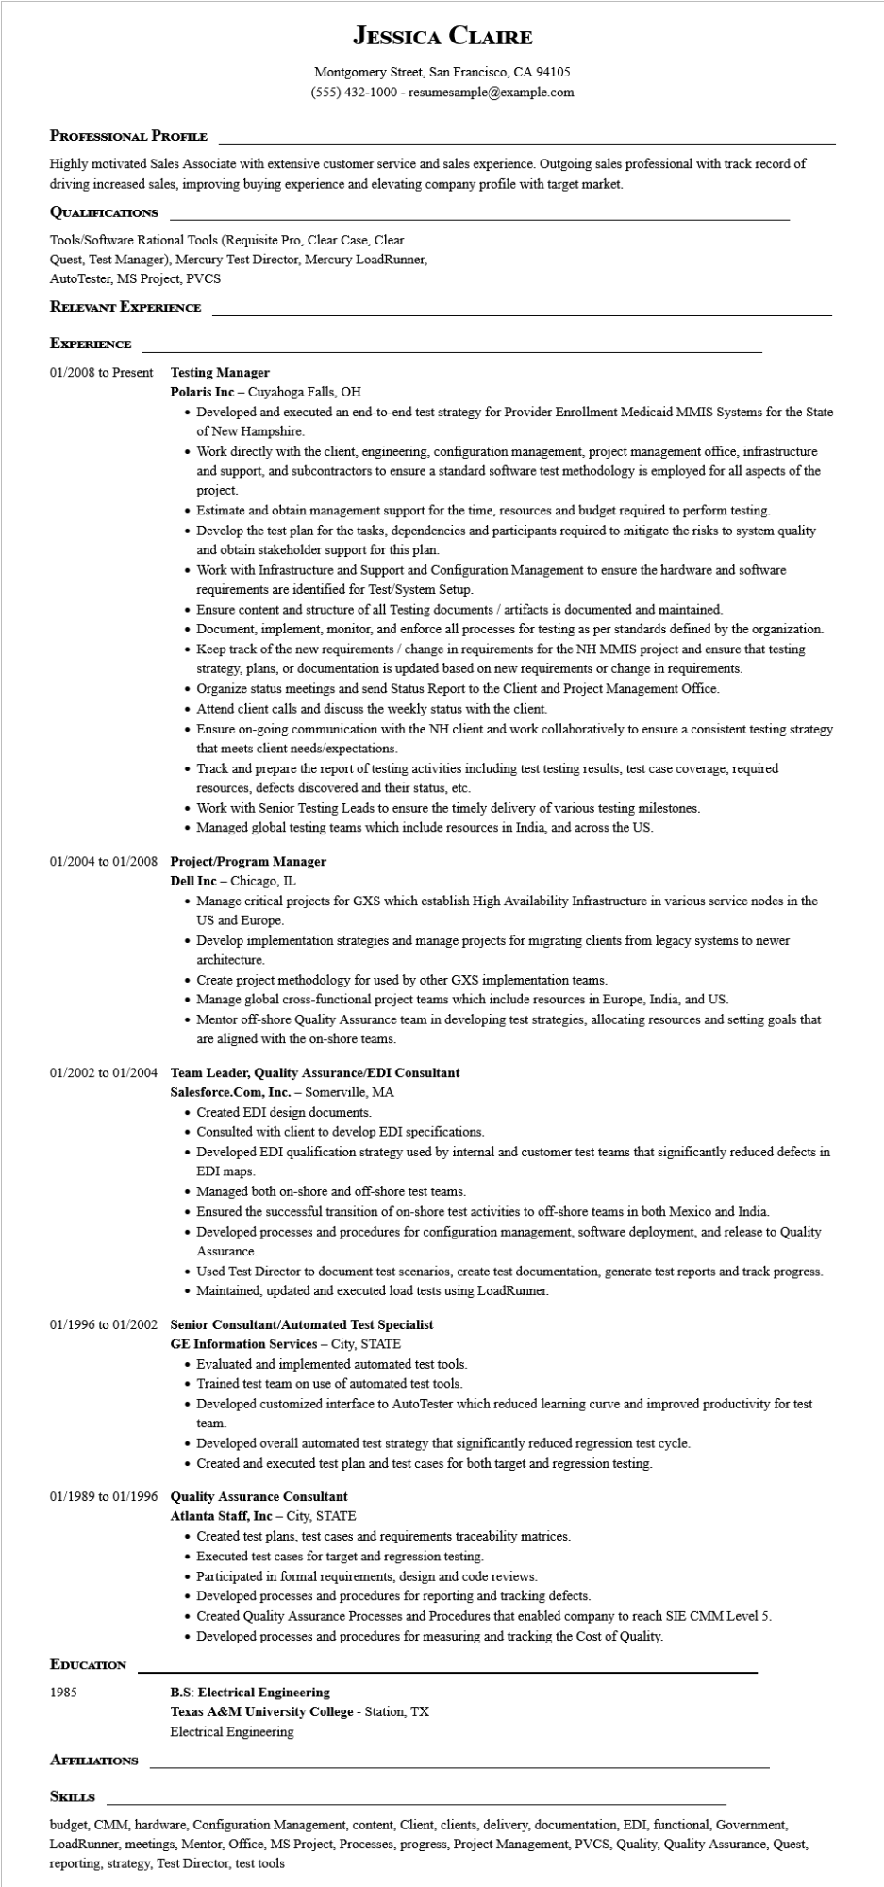

**JESSICA CLAIRE**

Montgomery Street, San Francisco, CA 94105

(555) 432-1000 - resumesample@example.com

**PROFESSIONAL PROFILE**

Highly motivated Sales Associate with extensive customer service and sales experience. Outgoing sales professional with track record of driving increased sales, improving buying experience and elevating company profile with target market.

**QUALIFICATIONS**

Tools/Software Rational Tools (Requisite Pro, Clear Case, Clear

Quest, Test Manager), Mercury Test Director, Mercury LoadRunner,

AutoTester, MS Project, PVCS

**RELEVANT EXPERIENCE**

**EXPERIENCE**

01/2008 to Present

**Testing Manager**

Polaris Inc - Cuyahoga Falls, OH

• Developed and executed an end-to-end test strategy for Provider Enrollment Medicaid MMIS Systems for the State of New Hampshire.

• Work directly with the client, engineering, configuration management, project management office, infrastructure and support, and subcontractors to ensure a standard software test methodology is employed for all aspects of the project.

• Estimate and obtain management support for the time, resources and budget required to perform testing.

• Develop the test plan for the tasks, dependencies and participants required to mitigate the risks to system quality and obtain stakeholder support for this plan.

• Work with Infrastructure and Support and Configuration Management to ensure the hardware and software requirements are identified for Test/System Setup.

• Ensure content and structure of all Testing documents/artifacts is documented and maintained.

• Document, implement, monitor, and enforce all processes for testing as per standards defined by the organization.

• Keep track of the new requirements / change in requirements for the NH MMIS project and ensure that testing strategy, plans, or documentation is updated based on new requirements or change in requirements.

• Organize status meetings and send Status Report to the Client and Project Management Office.

• Attend client calls and discuss the weekly status with the client.

• Ensure on-going communication with the NH client and work collaboratively to ensure that meets client needs/expectations.

consistent testing strategy

• Track and prepare the report of testing activities including test testing results, test case coverage, required resources, defects discovered and their status, etc.

• Work with Senior Testing Leads to ensure the timely delivery of various testing milestones.

• Managed global testing teams which include resources in India, and across the US.

01/2004 to 01/2008 Project/Program Manager

Dell Inc - Chicago, IL

• Manage critical projects for GXS which establish High Availability Infrastructure in various service nodes in the US and Europe.

• Develop implementation strategies and manage projects for migrating clients from legacy systems to newer architecture.

• Create project methodology for used by other GXS implementation teams.

• Manage global cross-functional project teams which include resources in Europe, India, and US.

• Mentor off-shore Quality Assurance team in developing test strategies, allocating resources and setting goals that are aligned with the on-shore teams.

**01/2002 to 01/2004 Team Leader, Quality Assurance/EDI Consultant**

**Salesforce.Com, Inc. - Somerville, MA**

• Created EDI design documents.

• Consulted with client to develop EDI specifications.

• Developed EDI qualification strategy used by internal and customer test teams that significantly reduced defects in EDI maps.

• Managed both on-shore and off-shore test teams.

• Ensured the successful transition of on-shore test activities to off-shore teams in both Mexico and India.

• Developed processes and procedures for configuration management, software deployment, and release to Quality Assurance.

• Used Test Director to document test scenarios, create test documentation, generate test reports and track progress. • Maintained, updated and executed load tests using LoadRunner.

**01/1996 to 01/2002 Senior Consultant/Automated Test Specialist GE Information Services - City, STATE**

• Evaluated and implemented automated test tools.

• Trained test team on use of automated test tools.

• Developed customized interface to Auto Tester which reduced learning curve and improved productivity for test

team.

• Developed overall automated test strategy that significantly reduced regression test cycle.

• Created and executed test plan and test cases for both target and regression testing.

**01/1989 to 01/1996 Quality Assurance Consultant**

**EDUCATION**

1985

**Atlanta Staff, Inc - City, STATE**

• Created test plans, test cases and requirements traceability matrices.

• Executed test cases for target and regression testing.

• Participated in formal requirements, design and code reviews.

• Developed processes and procedures for reporting and tracking defects.

• Created Quality Assurance Processes and Procedures that enabled company to reach SIE CMM Level 5.

• Developed processes and procedures for measuring and tracking the Cost of Quality.

**B.S: Electrical Engineering**

Texas A&M University College - Station, TX

Electrical Engineering

**AFFILIATIONS**

**SKILLS**

budget, CMM, hardware, Configuration Management, content, Client, clients, delivery, documentation, EDI, functional, Government, LoadRunner, meetings, Mentor, Office, MS Project, Processes, progress, Project Management, PVCS, Quality, Quality Assurance, Quest, reporting, strategy, Test Director, test tools