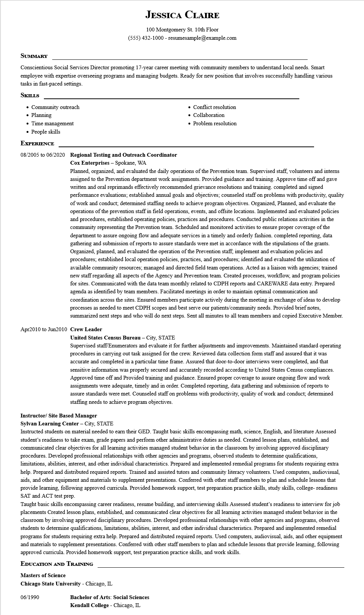

**JESSICA CLAIRE**

100 Montgomery St. 10th Floor (555) 432-1000 - resumesample@example.com

**SUMMARY**

Conscientious Social Services Director promoting 17-year career meeting with community members to understand local needs. Smart employee with expertise overseeing programs and managing budgets. Ready for new position that involves successfully handling various tasks in fast-paced settings.

**SKILLS**

• Community outreach

• Planning

• Time management

• People skills

**EXPERIENCE**

**08/2005 to 06/2020 Regional Testing and Outreach Coordinator Cox Enterprises - Spokane, WA**

• Conflict resolution

• Collaboration

• Problem resolution

Planned, organized, and evaluated the daily operations of the Prevention team. Supervised staff, volunteers and interns assigned to the Prevention department work assignments. Provided guidance and training. Approve time off and gave written and oral reprimands effectively recommended grievance resolutions and training. completed and signed performance evaluations; established annual goals and objectives; counseled staff on problems with productivity, quality of work and conduct; determined staffing needs to achieve program objectives. Organized, Planned, and evaluate the operations of the prevention staff in field operations, events, and offsite locations. Implemented and evaluated policies and procedures, established operating policies, practices and procedures. Conducted public relations activities in the community representing the Prevention team. Scheduled and monitored activities to ensure proper coverage of the department to assure ongoing flow and adequate services in a timely and orderly fashion. completed reporting, data gathering and submission of reports to assure standards were met in accordance with the stipulations of the grants. Organized, planned, and evaluated the operation of the Prevention staff; implement and evaluation policies and procedures; established local operation policies, practices, and procedures; identified and evaluated the utilization of available community resources; managed and directed field team operations. Acted as a liaison with agencies; trained new staff regarding all aspects of the Agency and Prevention team. Created processes, workflow, and program policies for sites. Communicated with the data team monthly related to CDPH reports and CAREWARE data entry. Prepared agenda as identified by team members. Facilitated meetings in order to maintain optimal communication and coordination across the sites. Ensured members participate actively during the meeting in exchange of ideas to develop processes as needed to meet CDPH scopes and best serve our patients/community needs. Provided brief notes, summarized next steps and who will do next steps. Sent all minutes to all team members and copied Executive Member.

**Apr2010 to Jun2010 Crew Leader**

**United States Census Bureau - City, STATE**

Supervised staff/Enumerators and evaluate it for further adjustments and improvements. Maintained standard operating procedures in carrying out task assigned for the crew. Reviewed data collection form staff and assured that it was accurate and completed in a particular time frame. Assured that door-to-door interviews were completed, and that sensitive information was properly secured and accurately recorded according to United States Census compliances. Approved time off and Provided training and guidance. Ensured proper coverage to assure ongoing flow and work assignments were adequate, timely and in order. Completed reporting, data gathering and submission of reports to assure standards were met. Counseled staff on problems with productivity, quality of work and conduct; determined staffing needs to achieve program objectives.

**Instructor/ Site Based Manager**

**Sylvan Learning Center - City, STATE**

Instructed students on material needed to earn their GED. Taught basic skills encompassing math, science, English, and literature Assessed student's readiness to take exam, grade papers and perform other administrative duties as needed. Created lesson plans, established, and communicated clear objectives for all learning activities managed student behavior in the classroom by involving approved disciplinary procedures. Developed professional relationships with other agencies and programs, observed students to determine qualifications, limitations, abilities, interest, and other individual characteristics. Prepared and implemented remedial programs for students requiring extra help. Prepared and distributed required reports. Trained and assisted tutors and community literacy volunteers. Used computers, audiovisual, aids, and other equipment and materials to supplement presentations. Conferred with other staff members to plan and schedule lessons that provide learning, following approved curricula. Provided homework support, test preparation practice skills, study skills, college- readiness SAT and ACT test prep.

Taught basic skills encompassing career readiness, resume building, and interviewing skills Assessed student's readiness to interview for job placements Created lesson plans, established, and communicated clear objectives for all learning activities managed student behavior in the classroom by involving approved disciplinary procedures. Developed professional relationships with other agencies and programs, observed students to determine qualifications, limitations, abilities, interest, and other individual characteristics. Prepared and implemented remedial programs for students requiring extra help. Prepared and distributed required reports. Used computers, audiovisual, aids, and other equipment and materials to supplement presentations. Conferred with other staff members to plan and schedule lessons that provide learning, following approved curricula. Provided homework support, test preparation practice skills, and work skills.

**EDUCATION AND TRAINING**

**Masters of Science**

**Chicago State University - Chicago, IL**

06/1990

**Bachelor of Arts: Social Sciences**

Kendall College - Chicago, IL