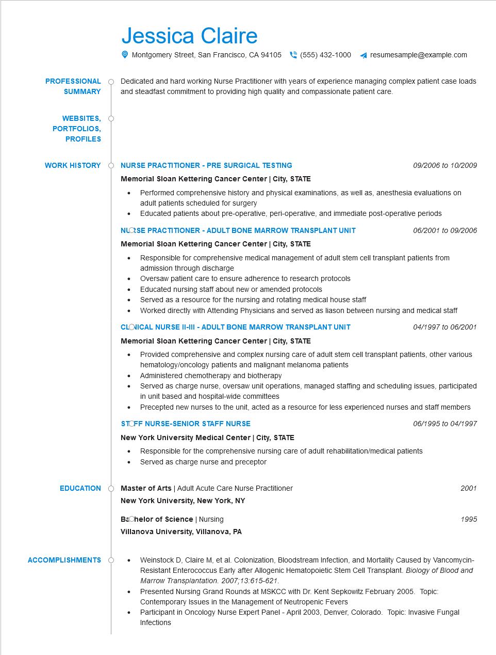

**PROFESSIONAL**

**SUMMARY**

**WEBSITES,**

**PORTFOLIOS,**

**PROFILES**

**WORK HISTORY**

Jessica Claire

Montgomery Street, San Francisco, CA 94105 (555) 432-1000

resumesample@example.com

Dedicated and hard working Nurse Practitioner with years of experience managing complex patient case loads and steadfast commitment to providing high quality and compassionate patient care.

**NURSE PRACTITIONER - PRE SURGICAL TESTING**

*09/2006 to 10/2009*

**Memorial Sloan Kettering Cancer Center | City, STATE**

• Performed comprehensive history and physical examinations, as well as, anesthesia evaluations on adult patients scheduled for surgery

• Educated patients about pre-operative, peri-operative, and immediate post-operative periods NLOSE PRACTITIONER - ADULT BONE MARROW TRANSPLANT UNIT

**Memorial Sloan Kettering Cancer Center | City, STATE**

06/2001 to 09/2006

Responsible for comprehensive medical management of adult stem cell transplant patients from admission through discharge

Oversaw patient care to ensure adherence to research protocols

Educated nursing staff about new or amended protocols

• Served as a resource for the nursing and rotating medical house staff

Worked directly with Attending Physicians and served as liason between nursing and medical staff

**CLOVICAL NURSE II-III - ADULT BONE MARROW TRANSPLANT UNIT**

**Memorial Sloan Kettering Cancer Center | City, STATE**

04/1997 to 06/2001

Provided comprehensive and complex nursing care of adult stem cell transplant patients, other various hematology/oncology patients and malignant melanoma patients

• Administered chemotherapy and biotherapy

Served as charge nurse, oversaw unit operations, managed staffing and scheduling issues, participated in unit based and hospital-wide committees

• Precepted new nurses to the unit, acted as a resource for less experienced nurses and staff members STOFF NURSE-SENIOR STAFF NURSE

**New York University Medical Center | City, STATE**

06/1995 to 04/1997

Responsible for the comprehensive nursing care of adult rehabilitation/medical patients

• Served as charge nurse and preceptor

Master of Arts | Adult Acute Care Nurse Practitioner

**EDUCATION**

**New York University, New York, NY**

**ACCOMPLISHMENTS**

Bachelor of Science | Nursing

**Villanova University, Villanova, PA**

2001

*1995*

•

Weinstock D, Claire M, et al. Colonization, Bloodstream Infection, and Mortality Caused by Vancomycin- Resistant Enterococcus Early after Allogenic Hematopoietic Stem Cell Transplant. Biology of Blood and Marrow Transplantation. 2007;13:615-621.

Presented Nursing Grand Rounds at MSKCC with Dr. Kent Sepkowitz February 2005. Topic: Contemporary Issues in the Management of Neutropenic Fevers

•

Participant in Oncology Nurse Expert Panel - April 2003, Denver, Colorado. Topic: Invasive Fungal Infections