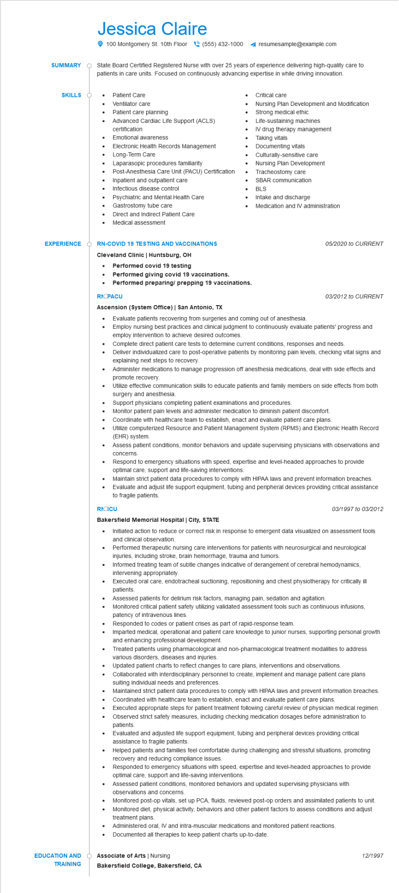

**SUMMARY**

**SKILLS O**

Jessica Claire

100 Montgomery St. 10th Floor (555) 432-1000 ◄ resumesample@example.com

State Board Certified Registered Nurse with over 25 years of experience delivering high-quality care to patients in care units. Focused on continuously advancing expertise in while driving innovation.

Patient Care

• Ventilator care

Critical care

•

Nursing Plan Development and Modification Strong medical ethic

•

Patient care planning

•

Advanced Cardiac Life Support (ACLS) certification

• Emotional awareness

•

Electronic Health Records Management Long-Term Care

Laparasopic procedures familiarity

Post-Anesthesia Care Unit (PACU) Certification

Inpatient and outpatient care

Infectious disease control

•

Psychiatric and Mental Health Care

Gastrostomy tube care

•

Direct and Indirect Patient Care

Medical assessment

•

Life-sustaining machines

IV drug therapy management

Taking vitals

Documenting vitals Culturally-sensitive care Nursing Plan Development Tracheostomy care

SBAR communication BLS

Intake and discharge

Medication and IV administration

**EXPERIENCE**

**RN-COVID 19 TESTING AND VACCINATIONS**

**Cleveland Clinic | Huntsburg, OH**

Performed covid 19 testing

•

**Performed giving covid 19 vaccinations.**

.

**Performed preparing/ prepping 19 vaccinations.**

**RIOPACU**

**Ascension (System Office) | San Antonio, TX**

•

•

Evaluate patients recovering from surgeries and coming out of anesthesia.

*05/2020 to CURRENT*

*03/2012 to CURRENT*

Employ nursing best practices and clinical judgment to continuously evaluate patients' progress and employ intervention to achieve desired outcomes.

Complete direct patient care tests to determine current conditions, responses and needs.

Deliver individualized care to post-operative patients by monitoring pain levels, checking vital signs and explaining next steps to recovery.

Administer medications to manage progression off anesthesia medications, deal with side effects and promote recovery.

Utilize effective communication skills to educate patients and family members on side effects from both surgery and anesthesia.

Support physicians completing patient examinations and procedures.

Monitor patient pain levels and administer medication to diminish patient discomfort.

Coordinate with healthcare team to establish, enact and evaluate patient care plans.

Utilize computerized Resource and Patient Management System (RPMS) and Electronic Health Record (EHR) system.

Assess patient conditions, monitor behaviors and update supervising physicians with observations and concerns.

Respond to emergency situations with speed, expertise and level-headed approaches to provide optimal care, support and life-saving interventions.

Maintain strict patient data procedures to comply with HIPAA laws and prevent information breaches. Evaluate and adjust life support equipment, tubing and peripheral devices providing critical assistance to fragile patients.

RICCU

**Bakersfield Memorial Hospital | City, STATE**

03/1997 to 03/2012

Initiated action to reduce or correct risk in response to emergent data visualized on assessment tools and clinical observation.

Performed therapeutic nursing care interventions for patients with neurosurgical and neurological injuries, including stroke, brain hemorrhage, trauma and tumors.

Informed treating team of subtle changes indicative of derangement of cerebral hemodynamics, intervening appropriately.

Executed oral care, endotracheal suctioning, repositioning and chest physiotherapy for critically ill patients.

Assessed patients for delirium risk factors, managing pain, sedation and agitation.

• Monitored critical patient safety utilizing validated assessment tools such as continuous infusions, patency of intravenous lines.

Responded to codes or patient crises as part of rapid-response team.

Imparted medical, operational and patient care knowledge to junior nurses, supporting personal growth and enhancing professional development.

Treated patients using pharmacological and non-pharmacological treatment modalities to address various disorders, diseases and injuries.

Updated patient charts to reflect changes to care plans, interventions and observations.

Collaborated with interdisciplinary personnel to create, implement and manage patient care plans suiting individual needs and preferences.

•

Maintained strict patient data procedures to comply with HIPAA laws and prevent information breaches. Coordinated with healthcare team to establish, enact and evaluate patient care plans.

•

Executed appropriate steps for patient treatment following careful review of physician medical regimen.

•

Observed strict safety measures, including checking medication dosages before administration to patients.

Evaluated and adjusted life support equipment, tubing and peripheral devices providing critical assistance to fragile patients.

Helped patients and families feel comfortable during challenging and stressful situations, promoting recovery and reducing compliance issues.

Responded to emergency situations with speed, expertise and level-headed approaches to provide optimal care, support and life-saving interventions.

Assessed patient conditions, monitored behaviors and updated supervising physicians with observations and concerns.

•

Monitored post-op vitals, set up PCA, fluids, reviewed post-op orders and assimilated patients to unit. Monitored diet, physical activity, behaviors and other patient factors to assess conditions and adjust treatment plans.

•

Administered oral, IV and intra-muscular medications and monitored patient reactions.

•

Documented all therapies to keep patient charts up-to-date.

**EDUCATION AND**

Associate of Arts | Nursing

12/1997

**TRAINING**

**Bakersfield College, Bakersfield, CA**