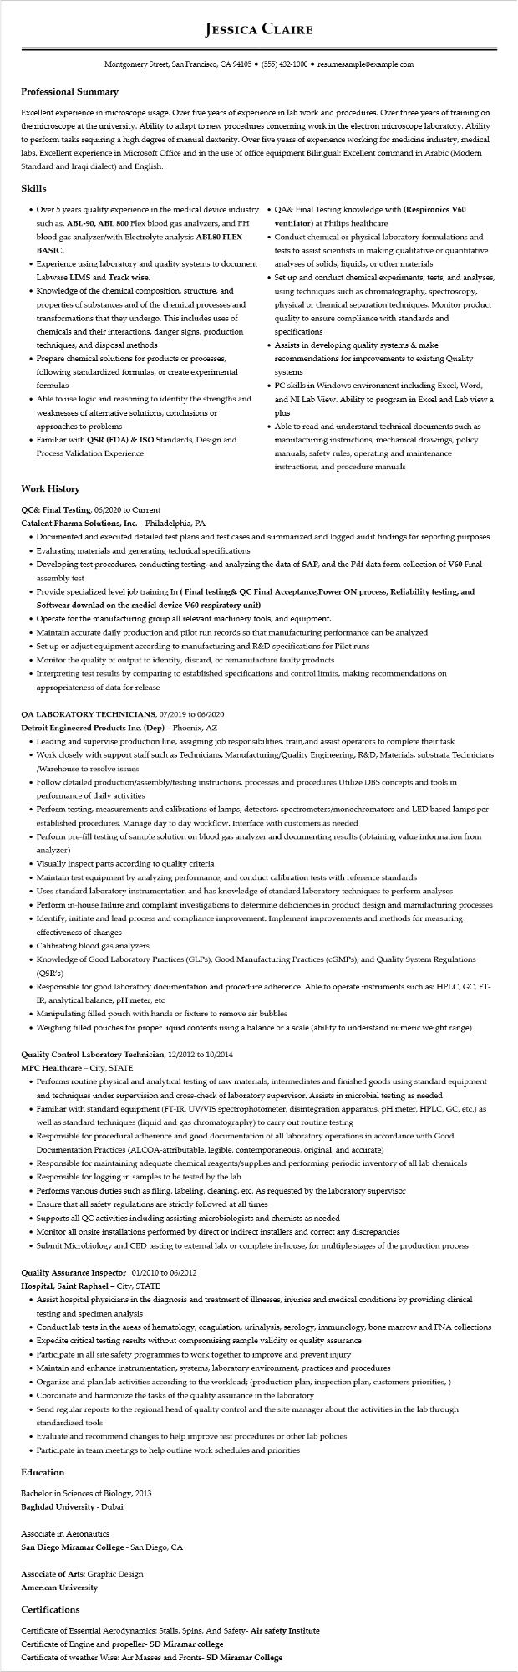

**JESSICA CLAIRE**

Montgomery Street, San Francisco, CA 94105 ⚫ (555) 432-1000⚫ resumesample@example.com

**Professional Summary**

Excellent experience in microscope usage. Over five years of experience in lab work and procedures. Over three years of training on the microscope at the university. Ability to adapt to new procedures concerning work in the electron microscope laboratory. Ability to perform tasks requiring a high degree of manual dexterity. Over five years of experience working for medicine industry, medical labs. Excellent experience in Microsoft Office and in the use of office equipment Bilingual: Excellent command in Arabic (Modern Standard and Iraqi dialect) and English.

**Skills**

• Over 5 years quality experience in the medical device industry⚫ such as, ABL-90, ABL 800 Flex blood gas analyzers, and PH blood gas analyzer/with Electrolyte analysis ABL80 FLEX BASIC.

• Experience using laboratory and quality systems to document

Labware LIMS and Track wise.

• Knowledge of the chemical composition, structure, and properties of substances and of the chemical processes and transformations that they undergo. This includes uses of chemicals and their interactions, danger signs, production techniques, and disposal methods

• Prepare chemical solutions for products or processes, following standardized formulas, or create experimental formulas

• Able to use logic and reasoning to identify the strengths and weaknesses of alternative solutions, conclusions or approaches to problems

• Familiar with QSR (FDA) & ISO Standards, Design and Process Validation Experience

QA& Final Testing knowledge with (Respironics V60 ventilator) at Philips healthcare

• Conduct chemical or physical laboratory formulations and tests to assist scientists in making qualitative or quantitative analyses of solids, liquids, or other materials

• Set up and conduct chemical experiments, tests, and analyses, using techniques such as chromatography, spectroscopy, physical or chemical separation techniques. Monitor product quality to ensure compliance with standards and specifications

• Assists in developing quality systems & make recommendations for improvements to existing Quality

systems

• PC skills in Windows environment including Excel, Word, and NI Lab View. Ability to program in Excel and Lab view a plus

• Able to read and understand technical documents such as manufacturing instructions, mechanical drawings, policy manuals, safety rules, operating and maintenance instructions, and procedure manuals

**Work History**

QC& Final Testing, 06/2020 to Current

**Catalent Pharma Solutions, Inc. - Philadelphia, PA**

• Documented and executed detailed test plans and test cases and summarized and logged audit findings for reporting purposes

• Evaluating materials and generating technical specifications

• Developing test procedures, conducting testing, and analyzing the data of SAP, and the Pdf data form collection of V60 Final assembly test

**• Provide specialized level job training In (Final testing& QC Final Acceptance,Power ON process, Reliability testing, and Softwear downlad on the medicl device V60 respiratory unit)**

• Operate for the manufacturing group all relevant machinery tools, and equipment.

• Maintain accurate daily production and pilot run records so that manufacturing performance can be analyzed

• Set up or adjust equipment according to manufacturing and R&D specifications for Pilot runs

• Monitor the quality of output to identify, discard, or remanufacture faulty products

• Interpreting test results by comparing to established specifications and control limits, making recommendations on appropriateness of data for release

QA LABORATORY TECHNICIANS, 07/2019 to 06/2020

**Detroit Engineered Products Inc. (Dep) – Phoenix, AZ**

• Leading and supervise production line, assigning job responsibilities, train,and assist operators to complete their task

• Work closely with support staff such as Technicians, Manufacturing/Quality Engineering, R&D, Materials, substrata Technicians /Warehouse to resolve issues

• Follow detailed production/assembly/testing instructions, processes and procedures Utilize DBS concepts and tools in performance of daily activities

• Perform testing, measurements and calibrations of lamps, detectors, spectrometers/monochromators and LED based lamps per established procedures. Manage day to day workflow. Interface with customers as needed

• Perform pre-fill testing of sample solution on blood gas analyzer and documenting results (obtaining value information from analyzer)

• Visually inspect parts according to quality criteria

• Maintain test equipment by analyzing performance, and conduct calibration tests with reference standards

• Uses standard laboratory instrumentation and has knowledge of standard laboratory techniques to perform analyses

• Perform in-house failure and complaint investigations to determine deficiencies in product design and manufacturing processes

• Identify, initiate and lead process and compliance improvement. Implement improvements and methods for measuring effectiveness of changes

• Calibrating blood gas analyzers

• Knowledge of Good Laboratory Practices (GLPs), Good Manufacturing Practices (cGMPs), and Quality System Regulations (QSR's)

• Responsible for good laboratory documentation and procedure adherence. Able to operate instruments such as: HPLC, GC, FT- IR, analytical balance, pH meter, etc

• Manipulating filled pouch with hands or fixture to remove air bubbles

• Weighing filled pouches for proper liquid contents using a balance or a scale (ability to understand numeric weight range)

**Quality Control Laboratory Technician, 12/2012 to 10/2014**

**MPC Healthcare - City, STATE**

• Performs routine physical and analytical testing of raw materials, intermediates and finished goods using standard equipment and techniques under supervision and cross-check of laboratory supervisor. Assists in microbial testing as needed

• Familiar with standard equipment (FT-IR, UV/VIS spectrophotometer, disintegration apparatus, pH meter, HPLC, GC, etc.) as well as standard techniques (liquid and gas chromatography) to carry out routine testing

• Responsible for procedural adherence and good documentation of all laboratory operations in accordance with Good Documentation Practices (ALCOA-attributable, legible, contemporaneous, original, and accurate)

• Responsible for maintaining adequate chemical reagents/supplies and performing periodic inventory of all lab chemicals

• Responsible for logging in samples to be tested by the lab

• Performs various duties such as filing, labeling, cleaning, etc. As requested by the laboratory supervisor

• Ensure that all safety regulations are strictly followed at all times

Supports all QC activities including assisting microbiologists and chemists as needed

• Monitor all onsite installations performed by direct or indirect installers and correct any discrepancies

• Submit Microbiology and CBD testing to external lab, or complete in-house, for multiple stages of the production process

**Quality Assurance Inspector, 01/2010 to 06/2012**

**Hospital, Saint Raphael - City, STATE**

• Assist hospital physicians in the diagnosis and treatment of illnesses, injuries and medical conditions by providing clinical testing and specimen analysis

• Conduct lab tests in the areas of hematology, coagulation, urinalysis, serology, immunology, bone marrow and FNA collections

• Expedite critical testing results without compromising sample validity or quality assurance

• Participate in all site safety programmes to work together to improve and prevent injury

• Maintain and enhance instrumentation, systems, laboratory environment, practices and procedures

• Organize and plan lab activities according to the workload; (production plan, inspection plan, customers priorities,)

• Coordinate and harmonize the tasks of the quality assurance in the laboratory

• Send regular reports to the regional head of quality control and the site manager about the activities in the lab through standardized tools

• Evaluate and recommend changes to help improve test procedures or other lab policies

• Participate in team meetings to help outline work schedules and priorities

**Education**

Bachelor in Sciences of Biology, 2013

Baghdad University - Dubai

Associate in Aeronautics

San Diego Miramar College - San Diego, CA

Associate of Arts: Graphic Design

**American University**

Certifications

Certificate of Essential Aerodynamics: Stalls, Spins, And Safety- Air safety Institute

**Certificate of Engine and propeller-SD Miramar college**

Certificate of weather Wise: Air Masses and Fronts- SD Miramar College