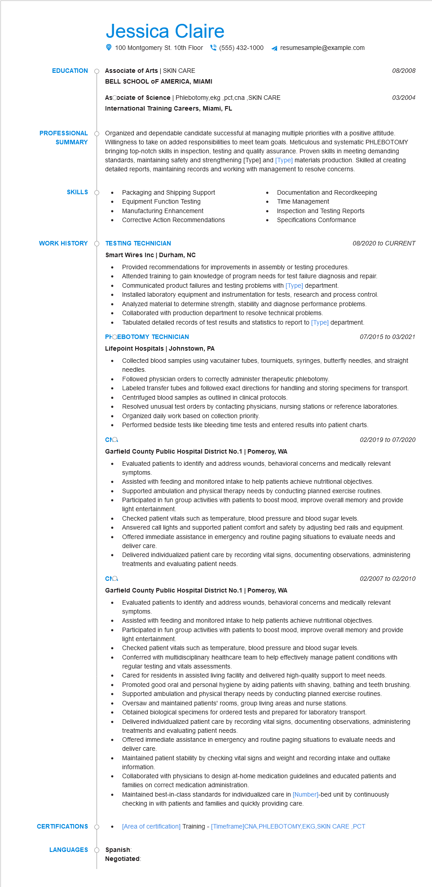

**EDUCATION**

Jessica Claire

100 Montgomery St. 10th Floor (555) 432-1000 resumesample@example.com

**Associate of Arts | SKIN CARE**

**BELL SCHOOL OF AMERICA, MIAMI**

Ascociate of Science | Phlebotomy,ekg,pct,cna,SKIN CARE

International Training Careers, Miami, FL

*08/2008*

*03/2004*

**PROFESSIONAL SUMMARY**

Organized and dependable candidate successful at managing multiple priorities with a positive attitude. Willingness to take on added responsibilities to meet team goals. Meticulous and systematic PHLEBOTOMY bringing top-notch skills in inspection, testing and quality assurance. Proven skills in meeting demanding standards, maintaining safety and strengthening [Type] and [Type] materials production. Skilled at creating detailed reports, maintaining records and working with management to resolve concerns.

**SKILLS**

•

Packaging and Shipping Support

Equipment Function Testing

Manufacturing Enhancement

Corrective Action Recommendations

Documentation and Recordkeeping Time Management

Inspection and Testing Reports Specifications Conformance

**WORK HISTORY**

**TESTING TECHNICIAN**

Smart Wires Inc | Durham, NC

*08/2020 to CURRENT*

• Provided recommendations for improvements in assembly or testing procedures.

•

•

·

Attended training to gain knowledge of program needs for test failure diagnosis and repair. Communicated product failures and testing problems with [Type] department.

Installed laboratory equipment and instrumentation for tests, research and process control.

Analyzed material to determine strength, stability and diagnose performance problems. Collaborated with production department to resolve technical problems.

Tabulated detailed records of test results and statistics to report to [Type] department.

**PHOEBOTOMY TECHNICIAN**

**Lifepoint Hospitals | Johnstown, PA**

07/2015 to 03/2021

• Collected blood samples using vacutainer tubes, tourniquets, syringes, butterfly needles, and straight needles.

•

Followed physician orders to correctly administer therapeutic phlebotomy.

Labeled transfer tubes and followed exact directions for handling and storing specimens for transport. Centrifuged blood samples as outlined in clinical protocols.

•

сла

Resolved unusual test orders by contacting physicians, nursing stations or reference laboratories. Organized daily work based on collection priority.

Performed bedside tests like bleeding time tests and entered results into patient charts.

**Garfield County Public Hospital District No.1 | Pomeroy, WA**

02/2019 to 07/2020

Evaluated patients to identify and address wounds, behavioral concerns and medically relevant symptoms

Assisted with feeding and monitored intake to help patients achieve nutritional objectives.

· Supported ambulation and physical therapy needs by conducting planned exercise routines. Participated in fun group activities with patients to boost mood, improve overall memory and provide light entertainment.

сла

Checked patient vitals such as temperature, blood pressure and blood sugar levels.

Answered call lights and supported patient comfort and safety by adjusting bed rails and equipment. Offered immediate assistance in emergency and routine paging situations to evaluate needs and deliver care.

Delivered individualized patient care by recording vital signs, documenting observations, administering treatments and evaluating patient needs.

**Garfield County Public Hospital District No.1 | Pomeroy, WA**

02/2007 to 02/2010

• Evaluated patients to identify and address wounds, behavioral concerns and medically relevant symptoms.

•

Assisted with feeding and monitored intake to help patients achieve nutritional objectives

Participated in fun group activities with patients to boost mood, improve overall memory and provide light entertainment.

Checked patient vitals such as temperature, blood pressure and blood sugar levels.

Conferred with multidisciplinary healthcare team to help effectively manage patient conditions with regular testing and vitals assessments.

•

• Cared for residents in assisted living facility and delivered high-quality support to meet needs. Promoted good oral and personal hygiene by aiding patients with shaving, bathing and teeth brushing. Supported ambulation and physical therapy needs by conducting planned exercise routines. Oversaw and maintained patients' rooms, group living areas and nurse stations.

Obtained biological specimens for ordered tests and prepared for laboratory transport.

**CERTIFICATIONS**

**LANGUAGES**

•

Delivered individualized patient care by recording vital signs, documenting observations, administering treatments and evaluating patient needs.

Offered immediate assistance in emergency and routine paging situations to evaluate needs and deliver care.

Maintained patient stability by checking vital signs and weight and recording intake and outtake information.

Collaborated with physicians to design at-home medication guidelines and educated patients and families on correct medication administration.

Maintained best-in-class standards for individualized care in [Number]-bed unit by continuously checking in with patients and families and quickly providing care.

[Area of certification] Training - [Timeframe]CNA, PHLEBOTOMY, EKG, SKIN CARE,PCT

**Spanish: Negotiated**