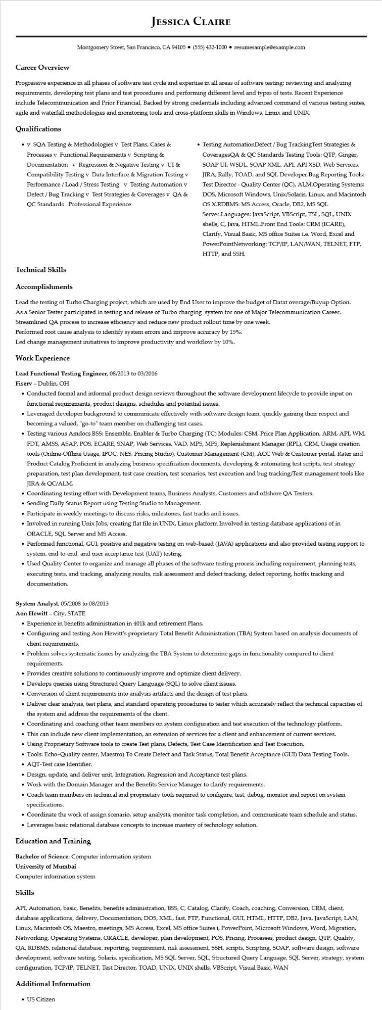

**Career Overview**

**JESSICA CLAIRE**

Montgomery Street, San Francisco, CA 94105 ⚫ (555) 432-1000⚫ resumesample@example.com

Progressive experience in all phases of software test cycle and expertise in all areas of software testing: reviewing and analyzing requirements, developing test plans and test procedures and performing different level and types of tests. Recent Experience include Telecommunication and Prior Financial, Backed by strong credentials including advanced command of various testing suites, agile and waterfall methodologies and monitoring tools and cross-platform skills in Windows, Linux and UNIX.

**Qualifications**

• v SQA Testing & Methodologies v Test Plans, Cases & Processes v Functional Requirements v Scripting & Documentation v Regression & Negative Testing v UI & Compatibility Testing v Data Interface & Migration Testing v Performance / Load / Stress Testing v Testing Automation v Defect / Bug Tracking v Test Strategies & Coverages v QA & QC Standards Professional Experience

• Testing AutomationDefect / Bug TrackingTest Strategies & CoveragesQA & QC Standards Testing Tools: QTP, Ginger, SOAP UI, WSDL, SOAP XML, API, API XSD, Web Services, JIRA, Rally, TOAD, and SQL Developer.Bug Reporting Tools: Test Director - Quality Center (QC), ALM.Operating Systems: DOS, Microsoft Windows, Unix/Solaris, Linux, and Macintosh OS X.RDBMS: MS Access, Oracle, DB2, MS SQL Server.Languages: JavaScript, VBScript, TSL, SQL, UNIX shells, C, Java, HTML.Front End Tools: CRM (ICARE), Clarify, Visual Basic, MS office Suites i.e. Word, Excel and PowerPointNetworking: TCP/IP, LAN/WAN, TELNET, FTP, HTTP, and SSH.

**Technical Skills**

**Accomplishments**

Lead the testing of Turbo Charging project, which are used by End User to improve the budget of Datat overage/Buyup Option. As a Senior Tester participated in testing and release of Turbo charging system for one of Major Telecommunication Career. Streamlined QA process to increase efficiency and reduce new product rollout time by one week.

Performed root cause analysis to identify system errors and improve accuracy by 15%.

Led change management initiatives to improve productivity and workflow by 10%.

**Work Experience**

Lead Functional Testing Engineer, 08/2013 to 03/2016

**Fiserv - Dublin, OH**

• Conducted formal and informal product design reviews throughout the software development lifecycle to provide input on functional requirements, product designs, schedules and potential issues.

• Leveraged developer background to communicate effectively with software design team, quickly gaining their respect and becoming a valued, "go-to" team member on challenging test cases.

• Testing various Amdocs BSS: Ensemble, Enabler & Turbo Charging (TC) Modules: CSM, Price Plan Application, ARM, API, WM, FDT, AMSS, ASAP, POS, ECARE, SNAP, Web Services, VAD, MPS, MFS, Replenishment Manager (RPL), CRM, Usage creation tools (Online-Offline Usage, IPOC, NES, Pricing Studio), Customer Management (CM), ACC Web & Customer portal, Rater and Product Catalog Proficient in analyzing business specification documents, developing & automating test scripts, test strategy preparation, test plan development, test case creation, test scenarios, test execution and bug tracking/Test management tools like JIRA & QC/ALM.

• Coordinating testing effort with Development teams, Business Analysts, Customers and offshore QA Testers.

• Sending Daily Status Report using Testing Studio to Management.

• Participate in weekly meetings to discuss risks, milestones, fast tracks and issues.

• Involved in running Unix Jobs, creating flat file in UNIX, Linux platform Involved in testing database applications of in ORACLE, SQL Server and MS Access.

• Performed functional, GUI, positive and negative testing on web-based (JAVA) applications and also provided testing support to system, end-to-end, and user acceptance test (UAT) testing.

• Used Quality Center to organize and manage all phases of the software testing process including requirement, planning tests, executing tests, and tracking, analyzing results, risk assessment and defect tracking, defect reporting, hotfix tracking and documentation.

**System Analyst, 05/2008 to 08/2013**

Aon Hewitt-City, STATE

• Experience in benefits administration in 401k and retirement Plans.

• Configuring and testing Aon Hewitt's proprietary Total Benefit Administration (TBA) System based on analysis documents of client requirements.

• Problem solves systematic issues by analyzing the TBA System to determine gaps in functionality compared to client requirements.

• Provides creative solutions to continuously improve and optimize client delivery.

• Develops queries using Structured Query Language (SQL) to solve client issues.

• Conversion of client requirements into analysis artifacts and the design of test plans.

• Deliver clear analysis, test plans, and standard operating procedures to tester which accurately reflect the technical capacities of the system and address the requirements of the client.

• Coordinating and coaching other team members on system configuration and test execution of the technology platform.

• This can include new client implementation, an extension of services for a client and enhancement of current services.

• Using Proprietary Software tools to create Test plans, Defects, Test Case Identification and Test Execution.

• Tools: Echo-Quality center, Maestro) To Create Defect and Task Status, Total Benefit Acceptance (GUI) Data Testing Tools. • AQT-Test case Identifier.

• Design, update, and deliver unit, Integration, Regression and Acceptance test plans.

• Work with the Domain Manager and the Benefits Service Manager to clarify requirements.

• Coach team members on technical and proprietary tools required to configure, test, debug, monitor and report on system specifications.

• Coordinate the work of assign scenario, setup analysts, monitor task completion, and communicate team schedule and status.

• Leverages basic relational database concepts to increase mastery of technology solution.

**Education and Training**

Bachelor of Science: Computer information system

University of Mumbai

Computer information system

**Skills**

API, Automation, basic, Benefits, benefits administration, BSS, C, Catalog, Clarify, Coach, coaching, Conversion, CRM, client, database applications, delivery, Documentation, DOS, XML, fast, FTP, Functional, GUI, HTML, HTTP, DB2, Java, JavaScript, LAN, Linux, Macintosh OS, Maestro, meetings, MS Access, Excel, MS office Suites i, PowerPoint, Microsoft Windows, Word, Migration, Networking, Operating Systems, ORACLE, developer, plan development, POS, Pricing, Processes, product design, QTP, Quality, QA, RDBMS, relational database, reporting, requirement, risk assessment, SSH, scripts, Scripting, SOAP, software design, software development, software testing, Solaris, specification, MS SQL Server, SQL, Structured Query Language, SQL Server, strategy, system configuration, TCP/IP, TELNET, Test Director, TOAD, UNIX, UNIX shells, VBScript, Visual Basic, WAN

**Additional Information**

• US Citizen