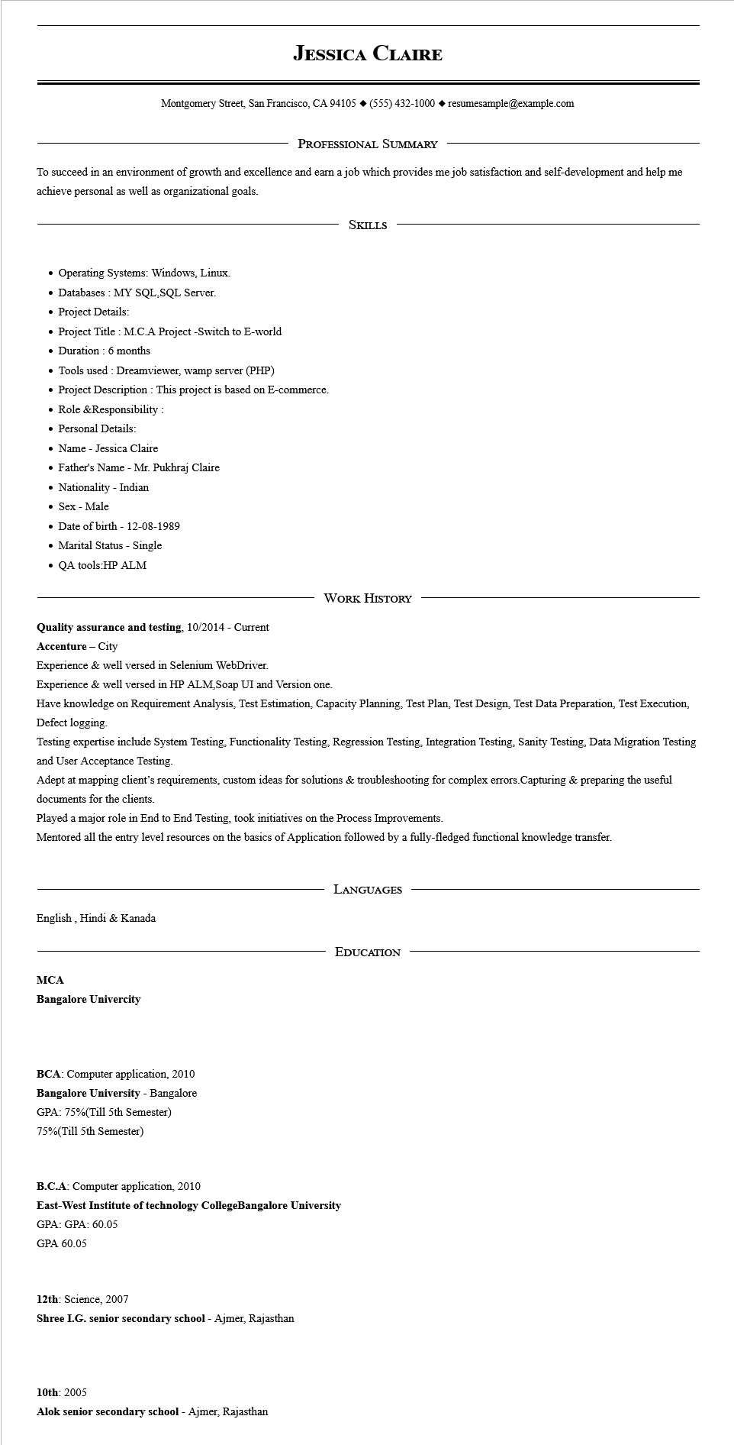

**JESSICA CLAIRE**

Montgomery Street, San Francisco, CA 94105 ♦ (555) 432-1000 resumesample@example.com

PROFESSIONAL SUMMARY

To succeed in an environment of growth and excellence and earn a job which provides me job satisfaction and self-development and help me achieve personal as well as organizational goals.

• Operating Systems: Windows, Linux.

• Databases: MY SQL,SQL Server.

• Project Details:

• Project Title: M.C.A Project -Switch to E-world

⚫ Duration 6 months

• Tools used: Dreamviewer, wamp server (PHP)

• Project Description: This project is based on E-commerce.

• Role & Responsibility:

• Personal Details:

Name Jessica Claire

• Father's Name - Mr. Pukhraj Claire

Nationality Indian

• Sex Male

• Date of birth - 12-08-1989

• Marital Status - Single

• QA tools:HP ALM

SKILLS

WORK HISTORY

**Quality assurance and testing, 10/2014 - Current Accenture - City**

Experience & well versed in Selenium WebDriver.

Experience & well versed in HP ALM,Soap UI and Version one.

Have knowledge on Requirement Analysis, Test Estimation, Capacity Planning, Test Plan, Test Design, Test Data Preparation, Test Execution, Defect logging.

Testing expertise include System Testing, Functionality Testing, Regression Testing, Integration Testing, Sanity Testing, Data Migration Testing and User Acceptance Testing.

Adept at mapping client's requirements, custom ideas for solutions & troubleshooting for complex errors. Capturing & preparing the useful documents for the clients.

Played a major role in End to End Testing, took initiatives on the Process Improvements.

Mentored all the entry level resources on the basics of Application followed by a fully-fledged functional knowledge transfer.

English, Hindi & Kanada

**MCA**

**Bangalore Univercity**

BCA: Computer application, 2010

**Bangalore University - Bangalore**

GPA: 75%(Till 5th Semester)

75% (Till 5th Semester)

**LANGUAGES**

EDUCATION

B.C.A: Computer application, 2010

**East-West Institute of technology CollegeBangalore University**

GPA: GPA: 60.05

GPA 60.05

12th: Science, 2007

Shree I.G. senior secondary school - Ajmer, Rajasthan

10th: 2005

**Alok senior secondary school - Ajmer, Rajasthan**