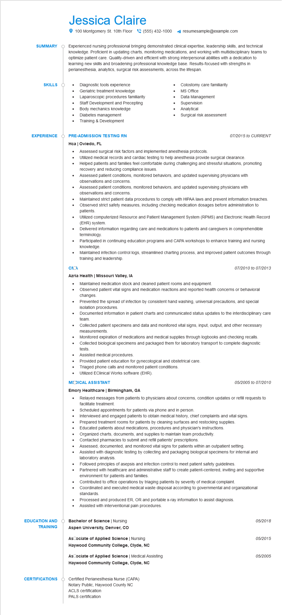

**SUMMARY**

Jessica Claire

100 Montgomery St. 10th Floor (555) 432-1000

resumesample@example.com

Experienced nursing professional bringing demonstrated clinical expertise, leadership skills, and technical knowledge. Proficient in updating charts, monitoring medications, and working with multidisciplinary teams to optimize patient care. Quality-driven and efficient with strong interpersonal abilities with a dedication to learning new skills and broadening professional knowledge base. Results-focused with strengths in perianesthesia, analytics, surgical risk assessments, across the lifespan.

•

•

Diagnostic tools experience Geriatric treatment knowledge

Laparoscopic procedures familiarity Staff Development and Precepting

Body mechanics knowledge

Diabetes management

Training & Development

•

Colostomy care familiarity

MS Office

Data Management

Supervision

Analytical

Surgical risk assessment

**SKILLS**

•

**EXPERIENCE**

**PRE-ADMISSION TESTING RN**

Hca | Oviedo, FL

• Assessed surgical risk factors and implemented anesthesia protocols.

07/2015 to CURRENT

•

Utilized medical records and cardiac testing to help anesthesia provide surgical clearance.

•

Helped patients and families feel comfortable during challenging and stressful situations, promoting recovery and reducing compliance issues.

•

•

•

СЛА

Assessed patient conditions, monitored behaviors, and updated supervising physicians with observations and concerns.

Assessed patient conditions, monitored behaviors, and updated supervising physicians with observations and concerns.

Maintained strict patient data procedures to comply with HIPAA laws and prevent information breaches. Observed strict safety measures, including checking medication dosages before administration to patients.

Utilized computerized Resource and Patient Management System (RPMS) and Electronic Health Record (EHR) system.

Delivered information regarding care and medications to patients and caregivers in comprehendible terminology.

Participated in continuing education programs and CAPA workshops to enhance training and nursing knowledge

Maintained infection control logs, streamlined charting process, and improved patient outcomes through training and leadership.

**Azria Health | Missouri Valley, IA**

•

Maintained medication stock and cleaned patient rooms and equipment.

07/2010 to 07/2013

Observed patient vital signs and medication reactions and reported health concerns or behavioral changes.

• Prevented the spread of infection by consistent hand washing, universal precautions, and special isolation procedures.

Documented information in patient charts and communicated status updates to the interdisciplinary care team.

• Collected patient specimens and data and monitored vital signs, input, output, and other necessary measurements.

•

•

Monitored expiration of medications and medical supplies through logbooks and checking recalls. Collected biological specimens and packaged them for laboratory transport to complete diagnostic tests.

•

Assisted medical procedures.

Provided patient education for gynecological and obstetrical care.

• Triaged phone calls and monitored patient conditions.

Utilized EClinical Works software (EHR).

**MODICAL ASSISTANT**

**Emory Healthcare | Birmingham, GA**

05/2005 to 07/2010

•

Relayed messages from patients to physicians about concerns, condition updates or refill requests to facilitate treatment.

Scheduled appointments for patients via phone and in person.

•

Interviewed and engaged patients to obtain medical history, chief complaints and vital signs. Prepared treatment rooms for patients by cleaning surfaces and restocking supplies.

Educated patients about medications, procedures and physician's instructions.

Organized charts, documents, and supplies to maintain team productivity.

•

Contacted pharmacies to submit and refill patients' prescriptions.

Assessed, documented, and monitored vital signs for patients within an outpatient setting.

•

Assisted with diagnostic testing by collecting and packaging biological specimens for internal and laboratory analysis.

Followed principles of asepsis and infection control to meet patient safety guidelines.

Partnered with healthcare and administrative staff to create patient-centered, inviting and supportive environment for patients and families.

•

Contributed to office operations by triaging patients by severity of medical complaint. Coordinated and executed medical waste disposal according to governmental and organizational standards.

Processed and produced ER, OR and portable x-ray information to assist diagnosis.

Assisted with interventional pain procedures.

**EDUCATION AND TRAINING**

Bachelor of Science | Nursing

*05/2018*

**Aspen University, Denver, CO**

**AsCociate of Applied Science | Nursing**

05/2015

**Haywood Community College, Clyde, NC**

**AsCociate of Applied Science | Medical Assisting**

*05/2005*

**Haywood Community College, Clyde, NC**

**CERTIFICATIONS**

Certified Perianesthesia Nurse (CAPA)

Notary Public, Haywood County NC

ACLS certification

PALS certification