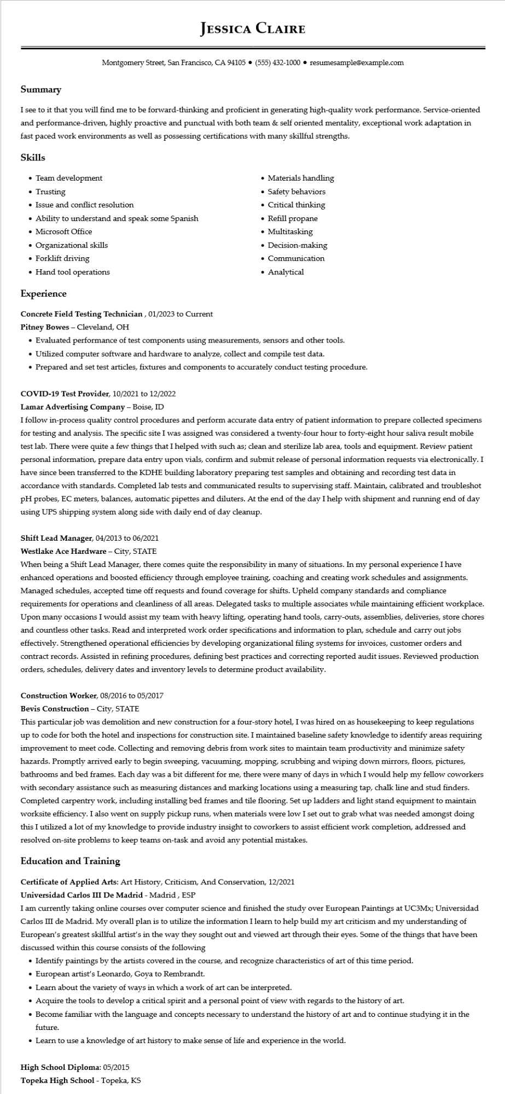

**JESSICA CLAIRE**

Montgomery Street, San Francisco, CA 94105 ⚫ (555) 432-1000⚫ resumesample@example.com

Summary

I see to it that you will find me to be forward-thinking and proficient in generating high-quality work performance. Service-oriented and performance-driven, highly proactive and punctual with both team & self oriented mentality, exceptional work adaptation in fast paced work environments as well as possessing certifications with many skillful strengths.

**Skills**

• Team development

• Trusting

• Issue and conflict resolution

• Ability to understand and speak some Spanish

• Microsoft Office

• Organizational skills

• Forklift driving

• Hand tool operations

**Experience**

Concrete Field Testing Technician, 01/2023 to Current

Pitney Bowes - Cleveland, OH

• Materials handling

• Safety behaviors

• Critical thinking

• Refill propane

• Multitasking

• Decision-making

• Communication

• Analytical

• Evaluated performance of test components using measurements, sensors and other tools.

• Utilized computer software and hardware to analyze, collect and compile test data.

• Prepared and set test articles, fixtures and components to accurately conduct testing procedure.

COVID-19 Test Provider, 10/2021 to 12/2022

**Lamar Advertising Company - Boise, ID**

I follow in-process quality control procedures and perform accurate data entry of patient information to prepare collected specimens for testing and analysis. The specific site I was assigned was considered a twenty-four hour to forty-eight hour saliva result mobile test lab. There were quite a few things that I helped with such as; clean and sterilize lab area, tools and equipment. Review patient personal information, prepare data entry upon vials, confirm and submit release of personal information requests via electronically. I have since been transferred to the KDHE building laboratory preparing test samples and obtaining and recording test data in accordance with standards. Completed lab tests and communicated results to supervising staff. Maintain, calibrated and troubleshot pH probes, EC meters, balances, automatic pipettes and diluters. At the end of the day I help with shipment and running end of day using UPS shipping system along side with daily end of day cleanup.

Shift Lead Manager, 04/2013 to 06/2021

**Westlake Ace Hardware - City, STATE**

When being a Shift Lead Manager, there comes quite the responsibility in many of situations. In my personal experience I have enhanced operations and boosted efficiency through employee training, coaching and creating work schedules and assignments. Managed schedules, accepted time off requests and found coverage for shifts. Upheld company standards and compliance requirements for operations and cleanliness of all areas. Delegated tasks to multiple associates while maintaining efficient workplace. Upon many occasions I would assist my team with heavy lifting, operating hand tools, carry-outs, assemblies, deliveries, store chores and countless other tasks. Read and interpreted work order specifications and information to plan, schedule and carry out jobs effectively. Strengthened operational efficiencies by developing organizational filing systems for invoices, customer orders and contract records. Assisted in refining procedures, defining best practices and correcting reported audit issues. Reviewed production orders, schedules, delivery dates and inventory levels to determine product availability.

Construction Worker, 08/2016 to 05/2017

Bevis Construction - City, STATE

This particular job was demolition and new construction for a four-story hotel, I was hired on as housekeeping to keep regulations up to code for both the hotel and inspections for construction site. I maintained baseline safety knowledge to identify areas requiring improvement to meet code. Collecting and removing debris from work sites to maintain team productivity and minimize safety hazards. Promptly arrived early to begin sweeping, vacuuming, mopping, scrubbing and wiping down mirrors, floors, pictures, bathrooms and bed frames. Each day was a bit different for me, there were many of days in which I would help my fellow coworkers with secondary assistance such as measuring distances and marking locations using a measuring tap, chalk line and stud finders. Completed carpentry work, including installing bed frames and tile flooring. Set up ladders and light stand equipment to maintain worksite efficiency. I also went on supply pickup runs, when materials were low I set out to grab what was needed amongst doing this I utilized a lot of my knowledge to provide industry insight to coworkers to assist efficient work completion, addressed and resolved on-site problems to keep teams on-task and avoid any potential mistakes.

**Education and Training**

Certificate of Applied Arts: Art History, Criticism, And Conservation, 12/2021

**Universidad Carlos III De Madrid - Madrid, ESP**

I am currently taking online courses over computer science and finished the study over European Paintings at UC3Mx; Universidad Carlos III de Madrid. My overall plan is to utilize the information I learn to help build my art criticism and my understanding of European's greatest skillful artist's in the way they sought out and viewed art through their eyes. Some of the things that have been discussed within this course consists of the following

• Identify paintings by the artists covered in the course, and recognize characteristics of art of this time period.

• European artist's Leonardo, Goya to Rembrandt.

• Learn about the variety of ways in which a work of art can be interpreted.

• Acquire the tools to develop a critical spirit and a personal point of view with regards to the history of art.

• Become familiar with the language and concepts necessary to understand the history of art and to continue studying it in the future.

• Learn to use a knowledge of art history to make sense of life and experience in the world.

**High School Diploma: 05/2015**

**Topeka High School - Topeka, KS**