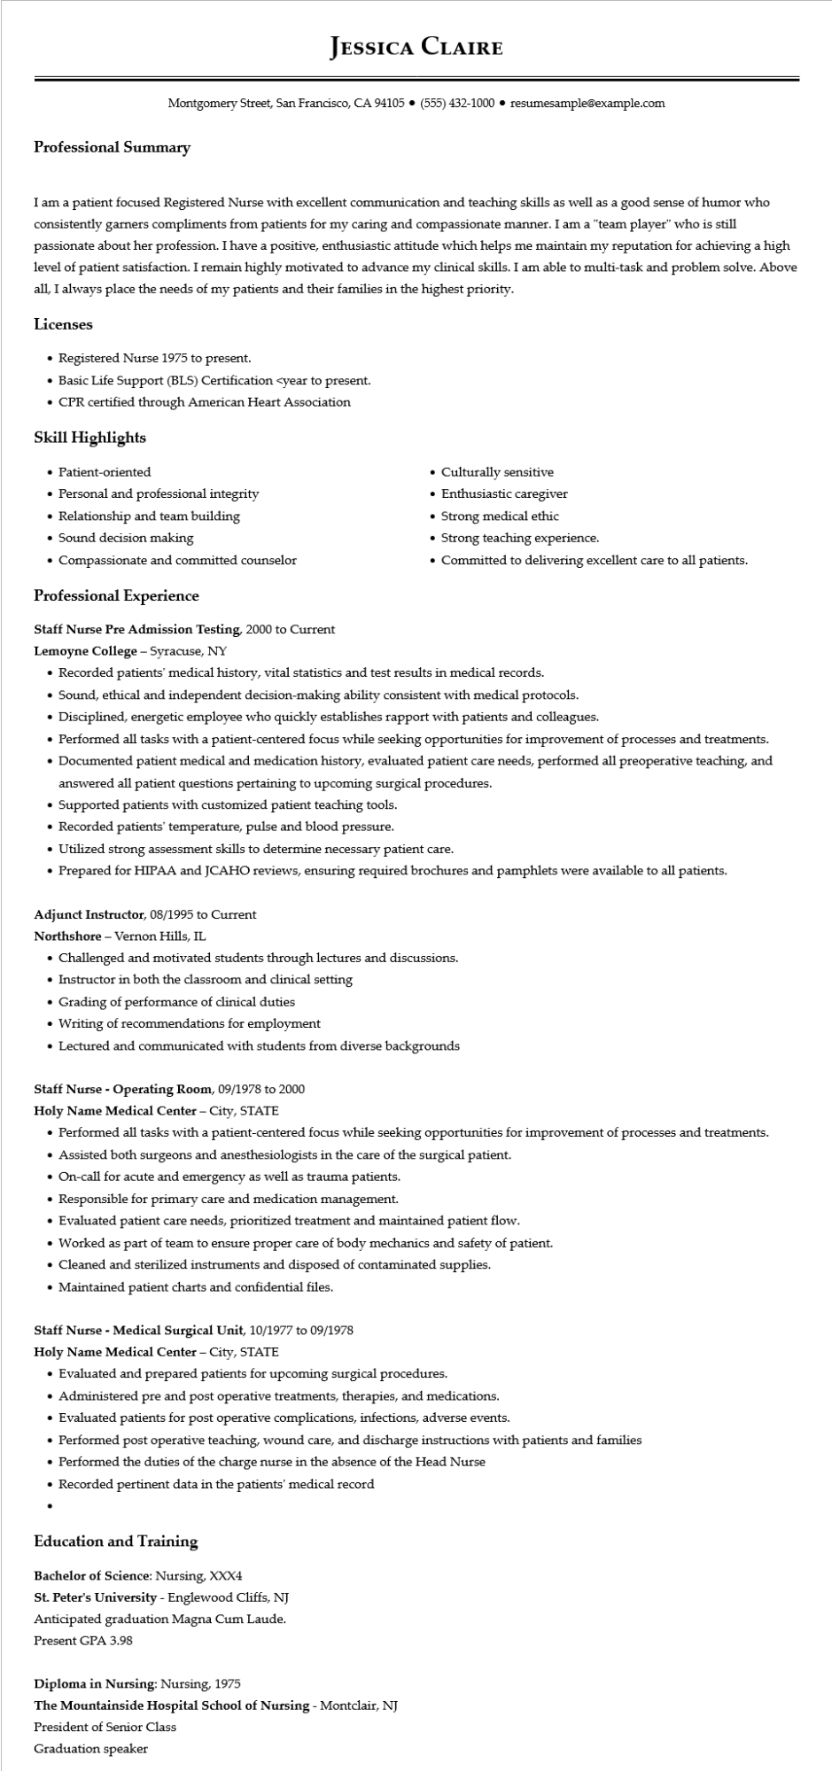

**JESSICA CLAIRE**

Montgomery Street, San Francisco, CA 94105 ⚫ (555) 432-1000⚫ resumesample@example.com

**Professional Summary**

I am a patient focused Registered Nurse with excellent communication and teaching skills as well as a good sense of humor who consistently garners compliments from patients for my caring and compassionate manner. I am a "team player" who is still passionate about her profession. I have a positive, enthusiastic attitude which helps me maintain my reputation for achieving a high level of patient satisfaction. I remain highly motivated to advance my clinical skills. I am able to multi-task and problem solve. Above all, I always place the needs of my patients and their families in the highest priority.

**Licenses**

• Registered Nurse 1975 to present.

• Basic Life Support (BLS) Certification <year to present.

• CPR certified through American Heart Association

**Skill Highlights**

• Patient-oriented

• Personal and professional integrity

• Relationship and team building

• Sound decision making

• Compassionate and committed counselor

**Professional Experience**

**Staff Nurse Pre Admission Testing, 2000 to Current**

**Lemoyne College - Syracuse, NY**

• Culturally sensitive

• Enthusiastic caregiver

• Strong medical ethic

• Strong teaching experience.

• Committed to delivering excellent care to all patients.

• Recorded patients' medical history, vital statistics and test results in medical records.

• Sound, ethical and independent decision-making ability consistent with medical protocols.

• Disciplined, energetic employee who quickly establishes rapport with patients and colleagues.

• Performed all tasks with a patient-centered focus while seeking opportunities for improvement of processes and treatments.

• Documented patient medical and medication history, evaluated patient care needs, performed all preoperative teaching, and answered all patient questions pertaining to upcoming surgical procedures.

• Supported patients with customized patient teaching tools.

• Recorded patients' temperature, pulse and blood pressure.

• Utilized strong assessment skills to determine necessary patient care.

• Prepared for HIPAA and JCAHO reviews, ensuring required brochures and pamphlets were available to all patients.

Adjunct Instructor, 08/1995 to Current

Northshore - Vernon Hills, IL

• Challenged and motivated students through lectures and discussions.

• Instructor in both the classroom and clinical setting

• Grading of performance of clinical duties

• Writing of recommendations for employment

• Lectured and communicated with students from diverse backgrounds

**Staff Nurse - Operating Room, 09/1978 to 2000**

Holy Name Medical Center - City, STATE

• Performed all tasks with a patient-centered focus while seeking opportunities for improvement of processes and treatments.

• Assisted both surgeons and anesthesiologists in the care of the surgical patient.

• On-call for acute and emergency as well as trauma patients.

• Responsible for primary care and medication management.

• Evaluated patient care needs, prioritized treatment and maintained patient flow.

• Worked as part of team to ensure proper care of body mechanics and safety of patient.

• Cleaned and sterilized instruments and disposed of contaminated supplies.

• Maintained patient charts and confidential files.

Staff Nurse - Medical Surgical Unit, 10/1977 to 09/1978

Holy Name Medical Center - City, STATE

• Evaluated and prepared patients for upcoming surgical procedures.

• Administered pre and post operative treatments, therapies, and medications.

• Evaluated patients for post operative complications, infections, adverse events.

• Performed post operative teaching, wound care, and discharge instructions with patients and families

• Performed the duties of the charge nurse in the absence of the Head Nurse

• Recorded pertinent data in the patients' medical record

**Education and Training**

Bachelor of Science: Nursing, XXX4

**St. Peter's University - Englewood Cliffs, NJ**

Anticipated graduation Magna Cum Laude.

Present GPA 3.98

Diploma in Nursing: Nursing, 1975

**The Mountainside Hospital School of Nursing - Montclair, NJ**

President of Senior Class

Graduation speaker