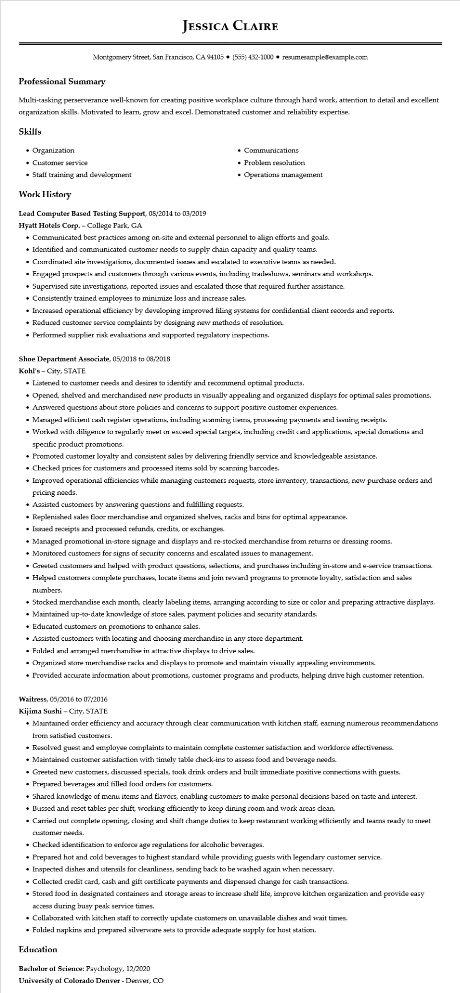

**JESSICA CLAIRE**

Montgomery Street, San Francisco, CA 94105 ⚫ (555) 432-1000⚫ resumesample@example.com

**Professional Summary**

Multi-tasking perserverance well-known for creating positive workplace culture through hard work, attention to detail and excellent organization skills. Motivated to learn, grow and excel. Demonstrated customer and reliability expertise.

Skills

• Organization

• Customer service

• Staff training and development

**Work History**

**Lead Computer Based Testing Support, 08/2014 to 03/2019**

**Hyatt Hotels Corp. - College Park, GA**

• Communications

• Problem resolution

•

Operations management

• Communicated best practices among on-site and external personnel to align efforts and goals.

• Identified and communicated customer needs to supply chain capacity and quality teams.

• Coordinated site investigations, documented issues and escalated to executive teams as needed.

• Engaged prospects and customers through various events, including tradeshows, seminars and workshops.

•

Supervised site investigations, reported issues and escalated those that required further assistance.

• Consistently trained employees to minimize loss and increase sales.

• Increased operational efficiency by developing improved filing systems for confidential client records and reports.

• Reduced customer service complaints by designing new methods of resolution.

• Performed supplier risk evaluations and supported regulatory inspections.

Shoe Department Associate, 05/2018 to 08/2018

**Kohl's - City, STATE**

• Listened to customer needs and desires to identify and recommend optimal products.

• Opened, shelved and merchandised new products in visually appealing and organized displays for optimal sales promotions.

• Answered questions about store policies and concerns to support positive customer experiences.

• Managed efficient cash register operations, including scanning items, processing payments and issuing receipts.

• Worked with diligence to regularly meet or exceed special targets, including credit card applications, special donations and specific product promotions.

• Promoted customer loyalty and consistent sales by delivering friendly service and knowledgeable assistance.

• Checked prices for customers and processed items sold by scanning barcodes.

• Improved operational efficiencies while managing customers requests, store inventory, transactions, new purchase orders and pricing needs.

• Assisted customers by answering questions and fulfilling requests.

• Replenished sales floor merchandise and organized shelves, racks and bins for optimal appearance.

• Issued receipts and processed refunds, credits, or exchanges.

• Managed promotional in-store signage and displays and re-stocked merchandise from returns or dressing rooms.

• Monitored customers for signs of security concerns and escalated issues to management.

• Greeted customers and helped with product questions, selections, and purchases including in-store and e-service transactions.

• Helped customers complete purchases, locate items and join reward programs to promote loyalty, satisfaction and sales numbers.

• Stocked merchandise each month, clearly labeling items, arranging according to size or color and preparing attractive displays.

• Maintained up-to-date knowledge of store sales, payment policies and security standards.

• Educated customers on promotions to enhance sales.

• Assisted customers with locating and choosing merchandise in any store department.

• Folded and arranged merchandise in attractive displays to drive sales.

• Organized store merchandise racks and displays to promote and maintain visually appealing environments.

• Provided accurate information about promotions, customer programs and products, helping drive high customer retention.

Waitress, 05/2016 to 07/2016

**Kijima Sushi - City, STATE**

• Maintained order efficiency and accuracy through clear communication with kitchen staff, earning numerous recommendations from satisfied customers.

• Resolved guest and employee complaints to maintain complete customer satisfaction and workforce effectiveness.

• Maintained customer satisfaction with timely table check-ins to assess food and beverage needs.

• Greeted new customers, discussed specials, took drink orders and built immediate positive connections with guests.

• Prepared beverages and filled food orders for customers.

• Shared knowledge of menu items and flavors, enabling customers to make personal decisions based on taste and interest.

• Bussed and reset tables per shift, working efficiently to keep dining room and work areas clean.

• Carried out complete opening, closing and shift change duties to keep restaurant working efficiently and teams ready to meet customer needs.

• Checked identification to enforce age regulations for alcoholic beverages.

• Prepared hot and cold beverages to highest standard while providing guests with legendary customer service.

• Inspected dishes and utensils for cleanliness, sending back to be washed again when necessary.

• Collected credit card, cash and gift certificate payments and dispensed change for cash transactions.

• Stored food in designated containers and storage areas to increase shelf life, improve kitchen organization and provide easy access during busy peak service times.

• Collaborated with kitchen staff to correctly update customers on unavailable dishes and wait times.

• Folded napkins and prepared silverware sets to provide adequate supply for host station.

**Education**

Bachelor of Science: Psychology, 12/2020

University of Colorado Denver - Denver, CO