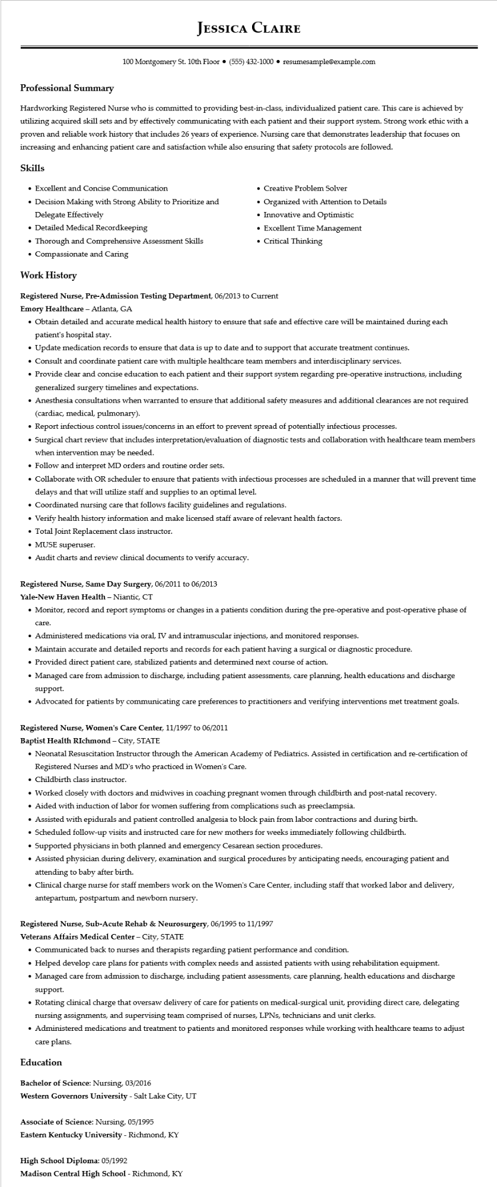

**Professional Summary**

**JESSICA CLAIRE**

100 Montgomery St. 10th Floor⚫ (555) 432-1000⚫ resumesample@example.com

Hardworking Registered Nurse who is committed to providing best-in-class, individualized patient care. This care is achieved by utilizing acquired skill sets and by effectively communicating with each patient and their support system. Strong work ethic with a proven and reliable work history that includes 26 years of experience. Nursing care that demonstrates leadership that focuses on increasing and enhancing patient care and satisfaction while also ensuring that safety protocols are followed.

**Skills**

• Excellent and Concise Communication

• Decision Making with Strong Ability to Prioritize and Delegate Effectively

• Detailed Medical Recordkeeping

• Thorough and Comprehensive Assessment Skills

• Compassionate and Caring

**Work History**

• Creative Problem Solver

Organized with Attention to Details

• Innovative and Optimistic

• Excellent Time Management

• Critical Thinking

Registered Nurse, Pre-Admission Testing Department, 06/2013 to Current

Emory Healthcare - Atlanta, GA

• Obtain detailed and accurate medical health history to ensure that safe and effective care will be maintained during each patient's hospital stay.

• Update medication records to ensure that data is up to date and to support that accurate treatment continues.

• Consult and coordinate patient care with multiple healthcare team members and interdisciplinary services.

• Provide clear and concise education to each patient and their support system regarding pre-operative instructions, including generalized surgery timelines and expectations.

• Anesthesia consultations when warranted to ensure that additional safety measures and additional clearances are not required (cardiac, medical, pulmonary).

• Report infectious control issues/concerns in an effort to prevent spread of potentially infectious processes.

• Surgical chart review that includes interpretation/evaluation of diagnostic tests and collaboration with healthcare team members when intervention may be needed.

• Follow and interpret MD orders and routine order sets.

• Collaborate with OR scheduler to ensure that patients with infectious processes are scheduled in a manner that will prevent time delays and that will utilize staff and supplies to an optimal level.

• Coordinated nursing care that follows facility guidelines and regulations.

• Verify health history information and make licensed staff aware of relevant health factors.

• Total Joint Replacement class instructor.

• MUSE superuser.

• Audit charts and review clinical documents to verify accuracy.

**Registered Nurse, Same Day Surgery, 06/2011 to 06/2013**

Yale-New Haven Health - Niantic, CT

• Monitor, record and report symptoms or changes in a patients condition during the pre-operative and post-operative phase of

care.

• Administered medications via oral, IV and intramuscular injections, and monitored responses.

• Maintain accurate and detailed reports and records for each patient having a surgical or diagnostic procedure.

• Provided direct patient care, stabilized patients and determined next course of action.

• Managed care from admission to discharge, including patient assessments, care planning, health educations and discharge support.

• Advocated for patients by communicating care preferences to practitioners and verifying interventions met treatment goals.

**Registered Nurse, Women's Care Center, 11/1997 to 06/2011**

Baptist Health Richmond - City, STATE

• Neonatal Resuscitation Instructor through the American Academy of Pediatrics. Assisted in certification and re-certification of Registered Nurses and MD's who practiced in Women's Care.

• Childbirth class instructor.

• Worked closely with doctors and midwives in coaching pregnant women through childbirth and post-natal recovery.

• Aided with induction of labor for women suffering from complications such as preeclampsia.

• Assisted with epidurals and patient controlled analgesia to block pain from labor contractions and during birth.

• Scheduled follow-up visits and instructed care for new mothers for weeks immediately following childbirth.

• Supported physicians in both planned and emergency Cesarean section procedures.

• Assisted physician during delivery, examination and surgical procedures by anticipating needs, encouraging patient and attending to baby after birth.

• Clinical charge nurse for staff members work on the Women's Care Center, including staff that worked labor and delivery, antepartum, postpartum and newborn nursery.

**Registered Nurse, Sub-Acute Rehab & Neurosurgery, 06/1995 to 11/1997**

Veterans Affairs Medical Center - City, STATE

• Communicated back to nurses and therapists regarding patient performance and condition.

• Helped develop care plans for patients with complex needs and assisted patients with using rehabilitation equipment.

• Managed care from admission to discharge, including patient assessments, care planning, health educations and discharge support.

• Rotating clinical charge that oversaw delivery of care for patients on medical-surgical unit, providing direct care, delegating nursing assignments, and supervising team comprised of nurses, LPNs, technicians and unit clerks.

• Administered medications and treatment to patients and monitored responses while working with healthcare teams to adjust care plans.

**Education**

Bachelor of Science: Nursing, 03/2016

**Western Governors University - Salt Lake City, UT**

Associate of Science: Nursing, 05/1995

Eastern Kentucky University - Richmond, KY

**High School Diploma: 05/1992**

**Madison Central High School - Richmond, KY**