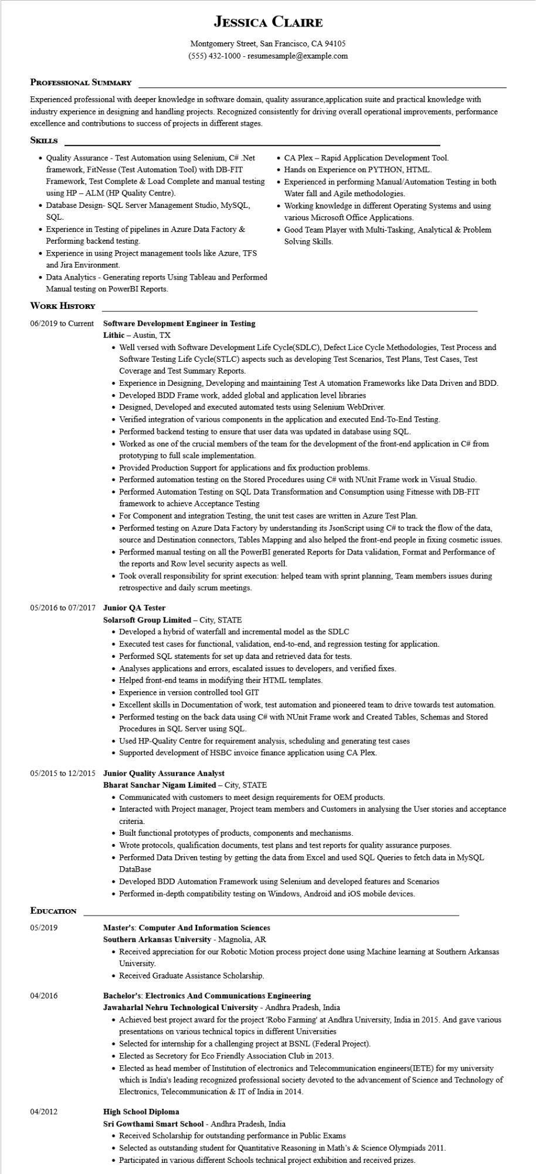

**JESSICA CLAIRE**

Montgomery Street, San Francisco, CA 94105

(555) 432-1000 - resumesample@example.com

**PROFESSIONAL SUMMARY**

Experienced professional with deeper knowledge in software domain, quality assurance,application suite and practical knowledge with industry experience in designing and handling projects. Recognized consistently for driving overall operational improvements, performance excellence and contributions to success of projects in different stages.

**SKILLS**

• Quality Assurance - Test Automation using Selenium, C# .Net framework, FitNesse (Test Automation Tool) with DB-FIT Framework, Test Complete & Load Complete and manual testing using HP - ALM (HP Quality Centre).

• Database Design- SQL Server Management Studio, MySQL, SQL.

• Experience in Testing of pipelines in Azure Data Factory & Performing backend testing.

• Experience in using Project management tools like Azure, TFS and Jira Environment.

• Data Analytics - Generating reports Using Tableau and Performed Manual testing on PowerBI Reports.

**WORK HISTORY**

**06/2019 to Current Software Development Engineer in Testing Lithic - Austin, TX**

• CA Plex - Rapid Application Development Tool.

• Hands on Experience on PYTHON, HTML.

• Experienced in performing Manual/Automation Testing in both Water fall and Agile methodologies.

• Working knowledge in different Operating Systems and using various Microsoft Office Applications.

• Good Team Player with Multi-Tasking, Analytical & Problem Solving Skills.

• Well versed with Software Development Life Cycle(SDLC), Defect Lice Cycle Methodologies, Test Process and Software Testing Life Cycle(STLC) aspects such as developing Test Scenarios, Test Plans, Test Cases, Test Coverage and Test Summary Reports.

• Experience in Designing, Developing and maintaining Test Automation Frameworks like Data Driven and BDD.

• Developed BDD Frame work, added global and application level libraries

• Designed, Developed and executed automated tests using Selenium WebDriver.

• Verified integration of various components in the application and executed End-To-End Testing.

• Performed backend testing to ensure that user data was updated in database using SQL.

• Worked as one of the crucial members of the team for the development of the front-end application in C# from prototyping to full scale implementation.

• Provided Production Support for applications and fix production problems.

• Performed automation testing on the Stored Procedures using C# with NUnit Frame work in Visual Studio.

• Performed Automation Testing on SQL Data Transformation and Consumption using Fitnesse with DB-FIT framework to achieve Acceptance Testing

• For Component and integration Testing, the unit test cases are written in Azure Test Plan.

• Performed testing on Azure Data Factory by understanding its JsonScript using C# to track the flow of the data, source and Destination connectors, Tables Mapping and also helped the front-end people in fixing cosmetic issues.

• Performed manual testing on all the PowerBI generated Reports for Data validation, Format and Performance of the reports and Row level security aspects as well.

• Took overall responsibility for sprint execution: helped team with sprint planning. Team members issues during retrospective and daily scrum meetings.

**05/2016 to 07/2017 Junior QA Tester**

Solarsoft Group Limited - City, STATE

• Developed a hybrid of waterfall and incremental model as the SDLC

• Executed test cases for functional, validation, end-to-end, and regression testing for application.

• Performed SQL statements for set up data and retrieved data for tests.

• Analyses applications and errors, escalated issues to developers, and verified fixes.

• Helped front-end teams in modifying their HTML templates.

• Experience in version controlled tool GIT

• Excellent skills in Documentation of work, test automation and pioneered team to drive towards test automation.

• Performed testing on the back data using C# with NUnit Frame work and Created Tables, Schemas and Stored Procedures in SQL Server using SQL.

• Used HP-Quality Centre for requirement analysis, scheduling and generating test cases

• Supported development of HSBC invoice finance application using CA Plex.

**05/2015 to 12/2015 Junior Quality Assurance Analyst**

**EDUCATION**

05/2019

04/2016

04/2012

**Bharat Sanchar Nigam Limited - City, STATE**

• Communicated with customers to meet design requirements for OEM products.

• Interacted with Project manager, Project team members and Customers in analysing the User stories and acceptance criteria.

• Built functional prototypes of products, components and mechanisms.

• Wrote protocols, qualification documents, test plans and test reports for quality assurance purposes.

• Performed Data Driven testing by getting the data from Excel and used SQL Queries to fetch data in MySQL DataBase

• Developed BDD Automation Framework using Selenium and developed features and Scenarios

• Performed in-depth compatibility testing on Windows, Android and iOS mobile devices.

**Master's: Computer And Information Sciences**

**Southern Arkansas University - Magnolia, AR**

• Received appreciation for our Robotic Motion process project done using Machine learning at Southern Arkansas University.

• Received Graduate Assistance Scholarship.

**Bachelor's: Electronics And Communications Engineering**

**Jawaharlal Nehru Technological University - Andhra Pradesh, India**

• Achieved best project award for the project 'Robo Farming' at Andhra University, India in 2015. And gave various presentations on various technical topics in different Universities

• Selected for internship for a challenging project at BSNL (Federal Project).

• Elected as Secretory for Eco Friendly Association Club in 2013.

• Elected as head member of Institution of electronics and Telecommunication engineers(IETE) for my university which is India's leading recognized professional society devoted to the advancement of Science and Technology of Electronics, Telecommunication & IT of India in 2014.

**High School Diploma**

Sri Gowthami Smart School - Andhra Pradesh, India

• Received Scholarship for outstanding performance in Public Exams

• Selected as outstanding student for Quantitative Reasoning in Math's & Science Olympiads 2011.

• Participated in various different Schools technical project exhibition and received prizes.