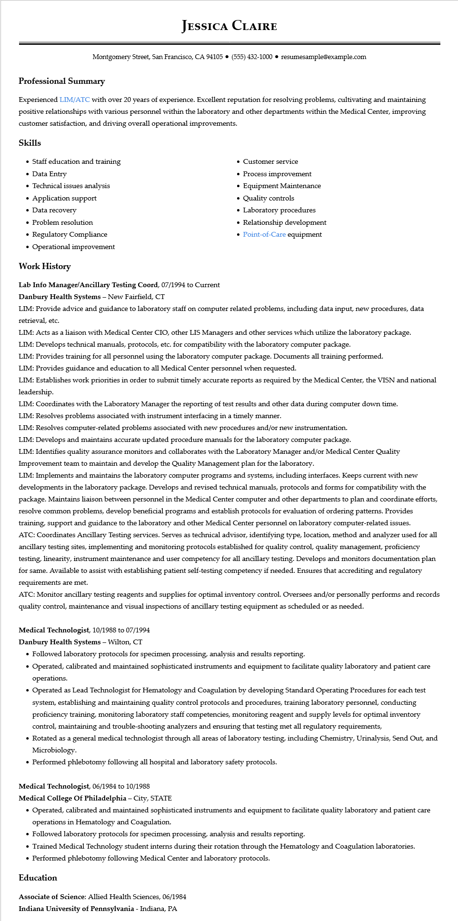

**JESSICA CLAIRE**

Montgomery Street, San Francisco, CA 94105 ⚫ (555) 432-1000⚫ resumesample@example.com

**Professional Summary**

Experienced LIM/ATC with over 20 years of experience. Excellent reputation for resolving problems, cultivating and maintaining positive relationships with various personnel within the laboratory and other departments within the Medical Center, improving customer satisfaction, and driving overall operational improvements.

**Skills**

• Staff education and training

• Data Entry

• Technical issues analysis

• Application support

• Data recovery

• Problem resolution

• Regulatory Compliance

• Customer service

• Process improvement

• Equipment Maintenance • Quality controls

• Laboratory procedures

• Relationship development

• Point-of-Care equipment

•

Operational improvement

**Work History**

**Lab Info Manager/Ancillary Testing Coord, 07/1994 to Current**

**Danbury Health Systems - New Fairfield, CT**

LIM: Provide advice and guidance to laboratory staff on computer related problems, including data input, new procedures, data retrieval, etc.

LIM: Acts as a liaison with Medical Center CIO, other LIS Managers and other services which utilize the laboratory package. LIM: Develops technical manuals, protocols, etc. for compatibility with the laboratory computer package.

LIM: Provides training for all personnel using the laboratory computer package. Documents all training performed.

LIM: Provides guidance and education to all Medical Center personnel when requested.

LIM: Establishes work priorities in order to submit timely accurate reports as required by the Medical Center, the VISN and national leadership.

LIM: Coordinates with the Laboratory Manager the reporting of test results and other data during computer down time. LIM: Resolves problems associated with instrument interfacing in a timely manner.

LIM: Resolves computer-related problems associated with new procedures and/or new instrumentation.

LIM: Develops and maintains accurate updated procedure manuals for the laboratory computer package.

LIM: Identifies quality assurance monitors and collaborates with the Laboratory Manager and/or Medical Center Quality Improvement team to maintain and develop the Quality Management plan for the laboratory.

LIM: Implements and maintains the laboratory computer programs and systems, including interfaces. Keeps current with new developments in the laboratory package. Develops and revised technical manuals, protocols and forms for compatibility with the package. Maintains liaison between personnel in the Medical Center computer and other departments to plan and coordinate efforts, resolve common problems, develop beneficial programs and establish protocols for evaluation of ordering patterns. Provides training, support and guidance to the laboratory and other Medical Center personnel on laboratory computer-related issues. ATC: Coordinates Ancillary Testing services. Serves as technical advisor, identifying type, location, method and analyzer used for all ancillary testing sites, implementing and monitoring protocols established for quality control, quality management, proficiency testing, linearity, instrument maintenance and user competency for all ancillary testing. Develops and monitors documentation plan for same. Available to assist with establishing patient self-testing competency if needed. Ensures that accrediting and regulatory requirements are met.

ATC: Monitor ancillary testing reagents and supplies for optimal inventory control. Oversees and/or personally performs and records quality control, maintenance and visual inspections of ancillary testing equipment as scheduled or as needed.

Medical Technologist, 10/1988 to 07/1994

**Danbury Health Systems - Wilton, CT**

• Followed laboratory protocols for specimen processing, analysis and results reporting.

• Operated, calibrated and maintained sophisticated instruments and equipment to facilitate quality laboratory and patient care operations.

• Operated as Lead Technologist for Hematology and Coagulation by developing Standard Operating Procedures for each test system, establishing and maintaining quality control protocols and procedures, training laboratory personnel, conducting proficiency training, monitoring laboratory staff competencies, monitoring reagent and supply levels for optimal inventory control, maintaining and trouble-shooting analyzers and ensuring that testing met all regulatory requirements,

• Rotated as a general medical technologist through all areas of laboratory testing, including Chemistry, Urinalysis, Send Out, and Microbiology.

• Performed phlebotomy following all hospital and laboratory safety protocols.

Medical Technologist, 06/1984 to 10/1988

Medical College Of Philadelphia - City, STATE

• Operated, calibrated and maintained sophisticated instruments and equipment to facilitate quality laboratory and patient care operations in Hematology and Coagulation.

• Followed laboratory protocols for specimen processing, analysis and results reporting.

• Trained Medical Technology student interns during their rotation through the Hematology and Coagulation laboratories.

• Performed phlebotomy following Medical Center and laboratory protocols.

**Education**

Associate of Science: Allied Health Sciences, 06/1984

**Indiana University of Pennsylvania - Indiana, PA**