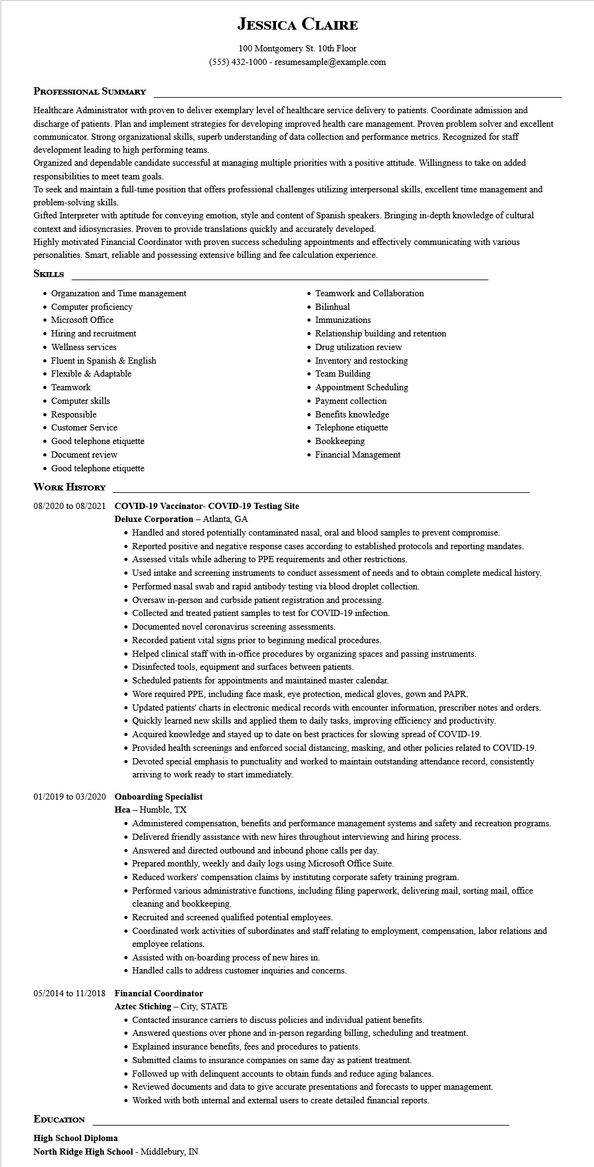

**JESSICA CLAIRE**

100 Montgomery St. 10th Floor

(555) 432-1000 - resumesample@example.com

**PROFESSIONAL SUMMARY**

Healthcare Administrator with proven to deliver exemplary level of healthcare service delivery to patients. Coordinate admission and discharge of patients. Plan and implement strategies for developing improved health care management. Proven problem solver and excellent communicator. Strong organizational skills, superb understanding of data collection and performance metrics. Recognized for staff development leading to high performing teams.

Organized and dependable candidate successful at managing multiple priorities with a positive attitude. Willingness to take on added responsibilities to meet team goals.

To seek and maintain a full-time position that offers professional challenges utilizing interpersonal skills, excellent time management and problem-solving skills.

Gifted Interpreter with aptitude for conveying emotion, style and content of Spanish speakers. Bringing in-depth knowledge of cultural context and idiosyncrasies. Proven to provide translations quickly and accurately developed.

Highly motivated Financial Coordinator with proven success scheduling appointments and effectively communicating with various personalities. Smart, reliable and possessing extensive billing and fee calculation experience.

**SKILLS**

• Organization and Time management

• Computer proficiency

• Microsoft Office

• Hiring and recruitment

• Wellness services

• Fluent in Spanish & English

• Flexible & Adaptable

• Teamwork

• Computer skills

• Responsible

• Customer Service

• Good telephone etiquette

• Document review

• Good telephone etiquette

**WORK HISTORY**

**08/2020 to 08/2021 COVID-19 Vaccinator- COVID-19 Testing Site Deluxe Corporation – Atlanta, GA**

• Teamwork and Collaboration

• Bilinhual

• Immunizations

• Relationship building and retention

• Drug utilization review

• Inventory and restocking

• Team Building

Appointment Scheduling Payment collection

• Benefits knowledge

• Telephone etiquette

• Bookkeeping

• Financial Management

• Handled and stored potentially contaminated nasal, oral and blood samples to prevent compromise.

• Reported positive and negative response cases according to established protocols and reporting mandates.

• Assessed vitals while adhering to PPE requirements and other restrictions.

• Used intake and screening instruments to conduct assessment of needs and to obtain complete medical history.

• Performed nasal swab and rapid antibody testing via blood droplet collection.

• Oversaw in-person and curbside patient registration and processing.

• Collected and treated patient samples to test for COVID-19 infection.

• Documented novel coronavirus screening assessments.

• Recorded patient vital signs prior to beginning medical procedures.

• Helped clinical staff with in-office procedures by organizing spaces and passing instruments.

• Disinfected tools, equipment and surfaces between patients.

• Scheduled patients for appointments and maintained master calendar.

• Wore required PPE, including face mask, eye protection, medical gloves, gown and PAPR.

• Updated patients' charts in electronic medical records with encounter information, prescriber notes and orders.

• Quickly learned new skills and applied them to daily tasks, improving efficiency and productivity.

• Acquired knowledge and stayed up to date on best practices for slowing spread of COVID-19.

• Provided health screenings and enforced social distancing, masking, and other policies related to COVID-19.

• Devoted special emphasis to punctuality and worked to maintain outstanding attendance record, consistently arriving to work ready to start immediately.

**01/2019 to 03/2020 Onboarding Specialist**

Hca - Humble, TX

• Administered compensation, benefits and performance management systems and safety and recreation programs.

• Delivered friendly assistance with new hires throughout interviewing and hiring process.

• Answered and directed outbound and inbound phone calls per day.

• Prepared monthly, weekly and daily logs using Microsoft Office Suite.

• Reduced workers' compensation claims by instituting corporate safety training program.

• Performed various administrative functions, including filing paperwork, delivering mail, sorting mail, office cleaning and bookkeeping.

• Recruited and screened qualified potential employees.

• Coordinated work activities of subordinates and staff relating to employment, compensation, labor relations and employee relations.

• Assisted with on-boarding process of new hires in.

• Handled calls to address customer inquiries and concerns.

**05/2014 to 11/2018 Financial Coordinator**

**Aztec Stiching - City, STATE**

• Contacted insurance carriers to discuss policies and individual patient benefits.

• Answered questions over phone and in-person regarding billing, scheduling and treatment.

• Explained insurance benefits, fees and procedures to patients.

• Submitted claims to insurance companies on same day as patient treatment.

• Followed up with delinquent accounts to obtain funds and reduce aging balances.

• Reviewed documents and data to give accurate presentations and forecasts to upper management.

• Worked with both internal and external users to create detailed financial reports.

**EDUCATION**

High School Diploma

North Ridge High School - Middlebury, IN