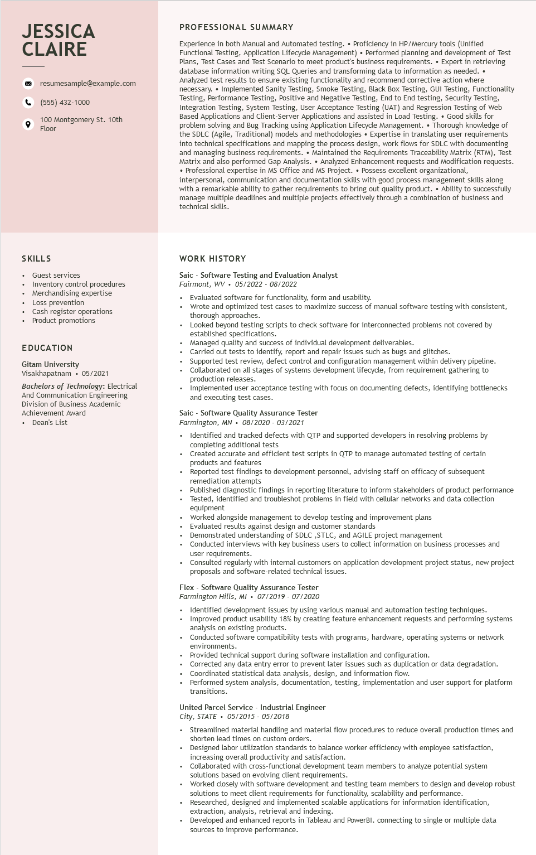

**JESSICA CLAIRE**

resumesample@example.com (555) 432-1000

100 Montgomery St. 10th Floor

PROFESSIONAL SUMMARY

Experience in both Manual and Automated testing. • Proficiency in HP/Mercury tools (Unified Functional Testing, Application Lifecycle Management) • Performed planning and development of Test Plans, Test Cases and Test Scenario to meet product's business requirements.⚫ Expert in retrieving database information writing SQL Queries and transforming data information as needed. ⚫ Analyzed test results to ensure existing functionality and recommend corrective action where necessary.⚫ Implemented Sanity Testing, Smoke Testing, Black Box Testing, GUI Testing, Functionality Testing, Performance Testing, Positive and Negative Testing, End to End testing, Security Testing, Integration Testing, System Testing, User Acceptance Testing (UAT) and Regression Testing of Web Based Applications and Client-Server Applications and assisted in Load Testing. • Good skills for problem solving and Bug Tracking using Application Lifecycle Management. Thorough knowledge of the SDLC (Agile, Traditional) models and methodologies. Expertise in translating user user requirements into technical specifications and mapping the process design, work flows for SDLC with with documenting and managing business requirements. Maintained the Requirements Traceability Matrix (RTM), Test Matrix and also performed Gap Analysis. • Analyzed Enhancement requests and Modification requests. • Professional expertise in MS Office and MS Project. • Possess excellent organizational, interpersonal, communication and documentation skills with good process management skills along with a remarkable ability to gather requirements to bring out quality product. • Ability to successfully manage multiple deadlines and multiple projects effectively through a combination of business and technical skills.

SKILLS

• Guest services

• Inventory control procedures

• Merchandising expertise

• Loss prevention

•

Cash register operations Product promotions

EDUCATION

Gitam University Visakhapatnam • 05/2021

Bachelors of Technology: Electrical And Communication Engineering Division of Business Academic Achievement Award

• Dean's List

WORK HISTORY

Saic Software Testing and Evaluation Analyst Fairmont, WV 05/2022 - 08/2022

Evaluated software for functionality, form and usability.

Wrote and optimized test cases to maximize success of manual software testing with consistent, thorough approaches.

Looked beyond testing scripts to check software for interconnected problems not covered by established specifications.

Managed quality and success of individual development deliverables.

Carried out tests to identify, report and repair issues such as bugs and glitches.

Supported test review, defect control and configuration management within delivery pipeline. Collaborated on all stages of systems development lifecycle, from requirement gathering to production releases.

Implemented user acceptance testing with focus on documenting defects, identifying bottlenecks and executing test cases.

Saic - Software Quality Assurance Tester

Farmington, MN 08/2020 03/2021

.

Identified and tracked defects with QTP and supported developers in resolving problems by completing additional tests

Created accurate and efficient test scripts in QTP to manage automated testing of certain products and features

Reported test findings to development personnel, advising staff on efficacy of subsequent remediation attempts

Published diagnostic findings in reporting literature to inform stakeholders of product performance Tested, identified and troubleshot problems in field with cellular networks and data collection equipment

Worked alongside management to develop testing and improvement plans

Evaluated results against design and customer standards

Demonstrated understanding of SDLC,STLC, and AGILE project management

Conducted interviews with key business users to collect information on business processes and user requirements.

Consulted regularly with internal customers on application development project status, new project proposals and software-related technical issues.

Flex - Software Quality Assurance Tester

*Farmington Hills, MI 07/2019-07/2020*

Identified development issues by using various manual and automation testing techniques. Improved product usability 18% by creating feature enhancement requests and performing systems analysis on existing products.

Conducted software compatibility tests with programs, hardware, operating systems or network environments.

Provided technical support during software installation and configuration.

Corrected any data entry error to prevent later issues such as duplication or data degradation. Coordinated statistical data analysis, design, and information flow.

Performed system analysis, documentation, testing, implementation and user support for platform transitions.

United Parcel Service Industrial Engineer

*City, STATE⚫ 05/2015 05/2018*

.

Streamlined material handling and material flow procedures to reduce overall production times and shorten lead times on custom orders.

Designed labor utilization standards to balance worker efficiency with employee satisfaction, increasing overall productivity and satisfaction.

Collaborated with cross-functional development team members to analyze potential system solutions based on evolving client requirements.

Worked closely with software development and testing team members to design and develop robust solutions to meet client requirements for functionality, scalability and performance.

Researched, designed and implemented scalable applications for information identification, extraction, analysis, retrieval and indexing.

Developed and enhanced reports in Tableau and PowerBI. connecting to single or multiple data sources to improve performance.