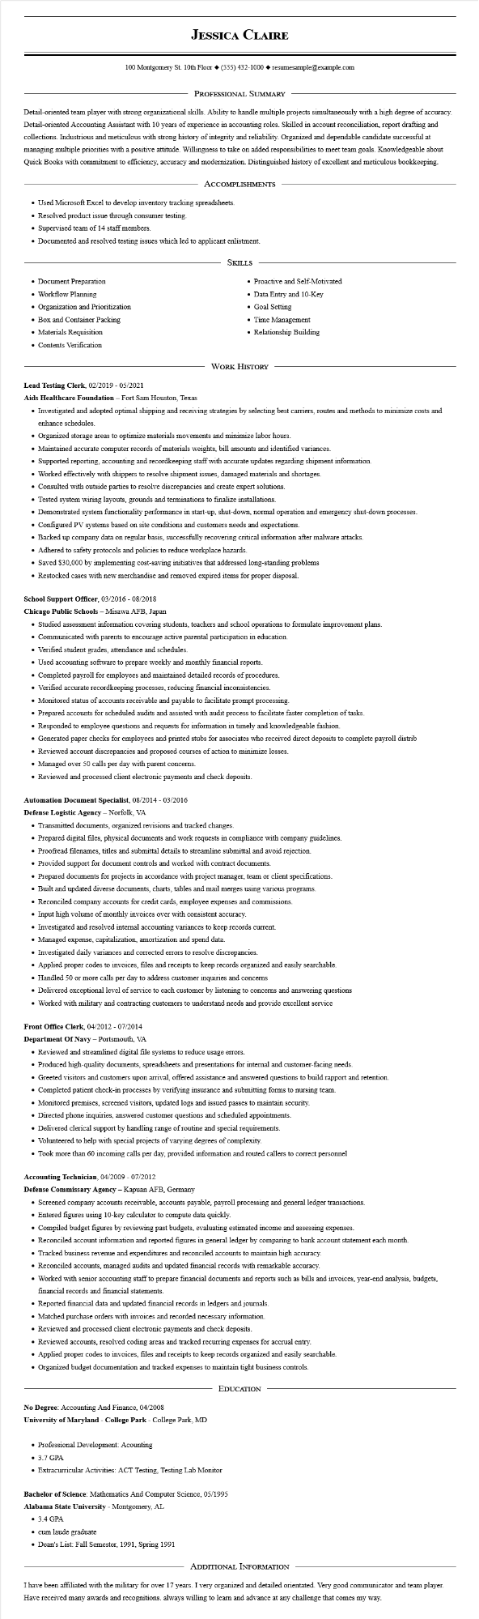

**JESSICA CLAIRE**

100 Montgomery St. 10th Floor (555) 432-1000◆ resumesample@example.com

PROFESSIONAL SUMMARY

Detail-oriented team player with strong organizational skills. Ability to handle multiple projects simultaneously with a high degree of accuracy. Detail-oriented Accounting Assistant with 10 years of experience in accounting roles. Skilled in account reconciliation, report drafting and collections. Industrious and meticulous with strong history of integrity and reliability. Organized and dependable candidate successful at managing multiple priorities with a positive attitude. Willingness to take on added responsibilities to meet team goals. Knowledgeable about Quick Books with commitment to efficiency, accuracy and modernization. Distinguished history of excellent and meticulous bookkeeping.

ACCOMPLISHMENTS

• Used Microsoft Excel to develop inventory tracking spreadsheets.

• Resolved product issue through consumer testing.

• Supervised team of 14 staff members.

• Documented and resolved testing issues which led to applicant enlistment.

• Document Preparation

• Workflow Planning

• Organization and Prioritization.

• Box and Container Packing

• Materials Requisition

• Contents Verification

SKILLS

• Proactive and Self-Motivated

• Data Entry and 10-Key

• Goal Setting

• Time Management

• Relationship Building

WORK HISTORY

Lead Testing Clerk, 02/2019 - 05/2021

Aids Healthcare Foundation - Fort Sam Houston, Texas

• Investigated and adopted optimal shipping and receiving strategies by selecting best carriers, routes and methods to minimize costs and enhance schedules.

• Organized storage areas to optimize materials movements and minimize labor hours.

• Maintained accurate computer records of materials weights, bill amounts and identified variances.

• Supported reporting, accounting and recordkeeping staff with accurate updates regarding shipment information.

• Worked effectively with shippers to resolve shipment issues, damaged materials and shortages.

• Consulted with outside parties to resolve discrepancies and create expert solutions.

• Tested system wiring layouts, grounds and terminations to finalize installations.

• Demonstrated system functionality performance in start-up, shut-down, normal operation and emergency shut-down processes.

• Configured PV systems based on site conditions and customers needs and expectations.

• Backed up company data on regular basis, successfully recovering critical information after malware attacks.

• Adhered to safety protocols and policies to reduce workplace hazards.

• Saved $30,000 by implementing cost-saving initiatives that addressed long-standing problems

• Restocked cases with new merchandise and removed expired items for proper disposal.

School Support Officer, 03/2016 - 08/2018

**Chicago Public Schools - Misawa AFB, Japan**

• Studied assessment information covering students, teachers and school operations to formulate improvement plans.

• Communicated with parents to encourage active parental participation in education.

• Verified student grades, attendance and schedules.

• Used accounting software to prepare weekly and monthly financial reports.

• Completed payroll for employees and maintained detailed records of procedures.

• Verified accurate recordkeeping processes, reducing financial inconsistencies.

• Monitored status of accounts receivable and payable to facilitate prompt processing.

• Prepared accounts for scheduled audits and assisted with audit process to facilitate faster completion of tasks.

• Responded to employee questions and requests for information in timely and knowledgeable fashion.

• Generated paper checks for employees and printed stubs for associates who received direct deposits to complete payroll distrib

• Reviewed account discrepancies and proposed courses of action to minimize losses.

• Managed over 50 calls per day with parent concerns.

• Reviewed and processed client electronic payments and check deposits.

**Automation Document Specialist, 08/2014 - 03/2016**

**Defense Logistic Agency - Norfolk, VA**

• Transmitted documents, organized revisions and tracked changes.

• Prepared digital files, physical documents and work requests in compliance with company guidelines.

• Proofread filenames, titles and submittal details to streamline submittal and avoid rejection.

• Provided support for document controls and worked with contract documents.

• Prepared documents for projects in accordance with project manager, team or client specifications.

• Built and updated diverse documents, charts, tables and mail merges using various programs.

• Reconciled company accounts for credit cards, employee expenses and commissions.

• Input high volume of monthly invoices over with consistent accuracy.

• Investigated and resolved internal accounting variances to keep records current.

• Managed expense, capitalization, amortization and spend data.

• Investigated daily variances and corrected errors to resolve discrepancies.

• Applied proper codes to invoices, files and receipts to keep records organized and easily searchable.

• Handled 50 or more calls per day to address customer inquiries and concerns

• Delivered exceptional level of service to each customer by listening to concerns and answering questions

• Worked with military and contracting customers to understand needs and provide excellent service

Front Office Clerk, 04/2012 - 07/2014

Department Of Navy - Portsmouth, VA

• Reviewed and streamlined digital file systems to reduce usage errors.

• Produced high-quality documents, spreadsheets and presentations for internal and customer-facing needs.

• Greeted visitors and customers upon arrival, offered assistance and answered questions to build rapport and retention.

• Completed patient check-in processes by verifying insurance and submitting forms to nursing team.

• Monitored premises, screened visitors, updated logs and issued passes to maintain security.

• Directed phone inquiries, answered customer questions and scheduled appointments.

• Delivered clerical support by handling range of routine and special requirements.

• Volunteered to help with special projects of varying degrees of complexity.

• Took more than 60 incoming calls per day, provided information and routed callers to correct personnel

**Accounting Technician, 04/2009 - 07/2012**

Defense Commissary Agency - Kapuan AFB, Germany

• Screened company accounts receivable, accounts payable, payroll processing and general ledger transactions.

• Entered figures using 10-key calculator to compute data quickly.

• Compiled budget figures by reviewing past budgets, evaluating estimated income and assessing expenses.

• Reconciled account information and reported figures in general ledger by comparing to bank account statement each month.

• Tracked business revenue and expenditures and reconciled accounts to maintain high accuracy.

• Reconciled accounts, managed audits and updated financial records with remarkable accuracy.

• Worked with senior accounting staff to prepare financial documents and reports such as bills and invoices, year-end analysis, budgets, financial records and financial statements.

• Reported financial data and updated financial records in ledgers and journals.

• Matched purchase orders with invoices and recorded necessary information.

• Reviewed and processed client electronic payments and check deposits.

• Reviewed accounts, resolved coding areas and tracked recurring expenses for accrual entry.

• Applied proper codes to invoices, files and receipts to keep records organized and easily searchable.

• Organized budget documentation and tracked expenses to maintain tight business controls.

No Degree: Accounting And Finance, 04/2008

EDUCATION

**University of Maryland - College Park - College Park, MD**

• Professional Development: Acounting

• 3.7 GPA

• Extracurricular Activities: ACT Testing, Testing Lab Monitor

Bachelor of Science: Mathematics And Computer Science, 05/1995

**Alabama State University - Montgomery, AL**

• 3.4 GPA

⚫ cum laude graduate

• Dean's List: Fall Semester, 1991, Spring 1991

ADDITIONAL INFORMATION

I have been affiliated with the military for over 17 years. I very organized and detailed orientated. Very good communicator and team player.

Have received many awards and recognitions. always willing to learn and advance at any challenge that comes my way.