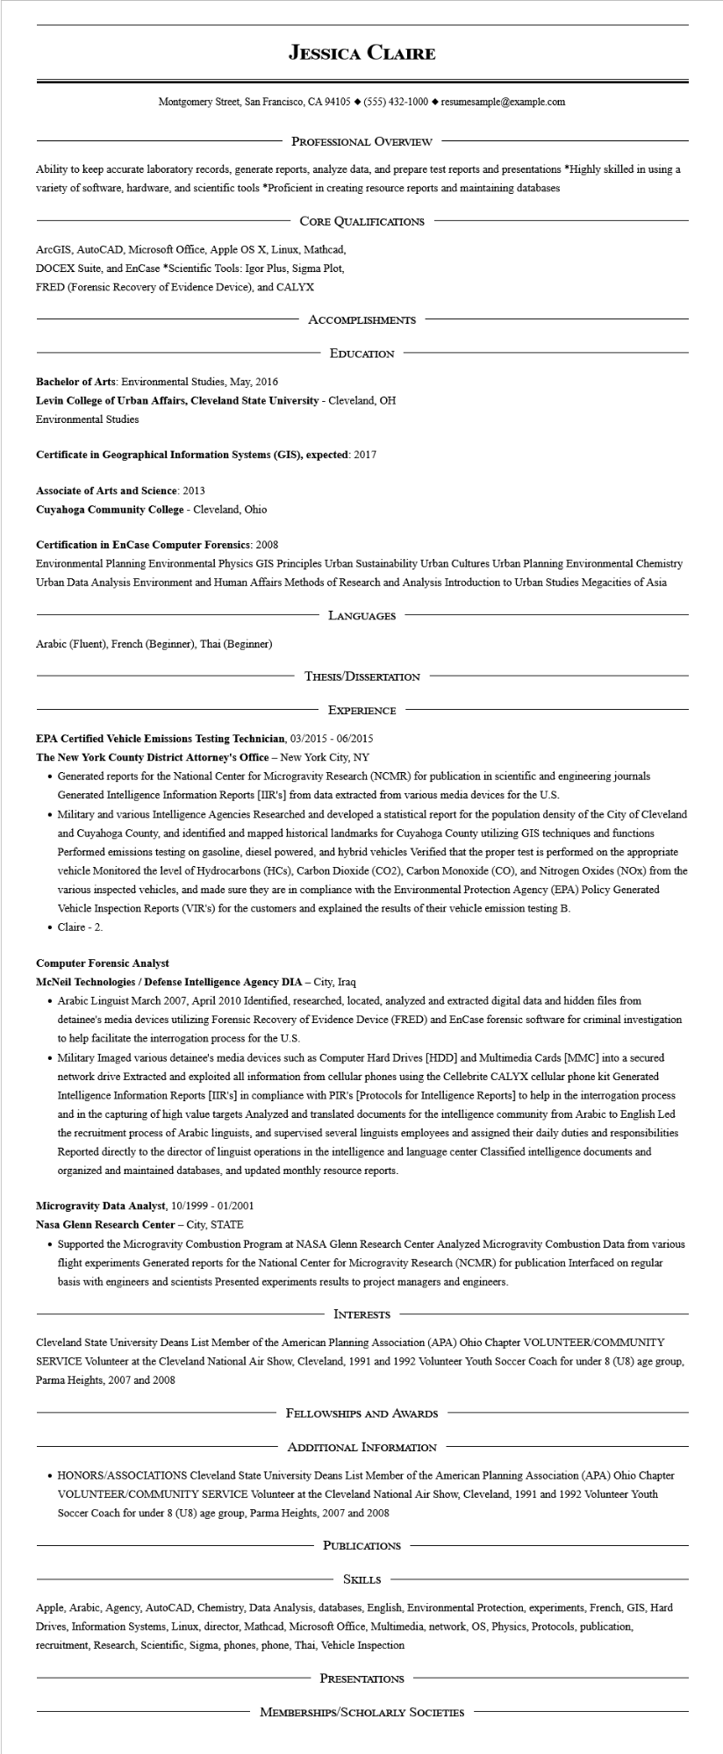

**JESSICA CLAIRE**

Montgomery Street, San Francisco, CA 94105 ♦ (555) 432-1000 resumesample@example.com

PROFESSIONAL OVERVIEW

Ability to keep accurate laboratory records, generate reports, analyze data, and prepare test reports and presentations *Highly skilled in using a variety of software, hardware, and scientific tools *Proficient in creating resource reports and maintaining databases

CORE QUALIFICATIONS

ArcGIS, AutoCAD, Microsoft Office, Apple OS X, Linux, Mathcad, DOCEX Suite, and EnCase *Scientific Tools: Igor Plus, Sigma Plot, FRED (Forensic Recovery of Evidence Device), and CALYX

ACCOMPLISHMENTS

EDUCATION

Bachelor of Arts: Environmental Studies, May, 2016

**Levin College of Urban Affairs, Cleveland State University - Cleveland, OH Environmental Studies**

**Certificate in Geographical Information Systems (GIS), expected: 2017**

**Associate of Arts and Science: 2013**

**Cuyahoga Community College - Cleveland, Ohio**

**Certification in EnCase Computer Forensics: 2008**

Environmental Planning Environmental Physics GIS Principles Urban Sustainability Urban Cultures Urban Planning Environmental Chemistry Urban Data Analysis Environment and Human Affairs Methods of Research and Analysis Introduction to Urban Studies Megacities of Asia

LANGUAGES

Arabic (Fluent), French (Beginner), Thai (Beginner)

THESIS/DISSERTATION

EXPERIENCE

**EPA Certified Vehicle Emissions Testing Technician, 03/2015 - 06/2015**

**The New York County District Attorney's Office - New York City, NY**

• Generated reports for the National Center for Microgravity Research (NCMR) for publication in scientific and engineering journals Generated Intelligence Information Reports [IIR's] from data extracted from various media devices for the U.S.

• Military and various Intelligence Agencies Researched and developed a statistical report for the population density of the City of Cleveland and Cuyahoga County, and identified and mapped historical landmarks for Cuyahoga County utilizing GIS techniques and functions Performed emissions testing on gasoline, diesel powered, and hybrid vehicles Verified that the proper test is performed on the appropriate vehicle Monitored the level of Hydrocarbons (HCs), Carbon Dioxide (CO2), Carbon Monoxide (CO), and Nitrogen Oxides (NOx) from the various inspected vehicles, and made sure they are in compliance with the Environmental Protection Agency (EPA) Policy Generated Vehicle Inspection Reports (VIR's) for the customers and explained the results of their vehicle emission testing B. • Claire - 2.

**Computer Forensic Analyst**

**McNeil Technologies / Defense Intelligence Agency DIA - City, Iraq**

• Arabic Linguist March 2007, April 2010 Identified, researched, located, analyzed and extracted digital data and hidden files from detainee's media devices utilizing Forensic Recovery of Evidence Device (FRED) and EnCase forensic software for criminal investigation to help facilitate the interrogation process for the U.S.

• Military Imaged various detainee's media devices such as Computer Hard Drives [HDD] and Multimedia Cards [MMC] into a secured network drive Extracted and exploited all information from cellular phones using the Cellebrite CALYX cellular phone kit Generated Intelligence Information Reports [IIR's] in compliance with PIR's [Protocols for Intelligence Reports] to help in the interrogation process and in the capturing of high value targets Analyzed and translated documents for the intelligence community from Arabic to English Led the recruitment process of Arabic linguists, and supervised several linguists employees and assigned their daily duties and responsibilities Reported directly to the director of linguist operations in the intelligence and language center Classified intelligence documents and organized and maintained databases, and updated monthly resource reports.

**Microgravity Data Analyst, 10/1999 - 01/2001**

**Nasa Glenn Research Center - City, STATE**

• Supported the Microgravity Combustion Program at NASA Glenn Research Center Analyzed Microgravity Combustion Data from various flight experiments Generated reports for the National Center for Microgravity Research (NCMR) for publication Interfaced on regular basis with engineers and scientists Presented experiments results to project managers and engineers.

INTERESTS

Cleveland State University Deans List Member of the American Planning Association (APA) Ohio Chapter VOLUNTEER/COMMUNITY SERVICE Volunteer at the Cleveland National Air Show, Cleveland, 1991 and 1992 Volunteer Youth Soccer Coach for under 8 (U8) age group, Parma Heights, 2007 and 2008

FELLOWSHIPS AND AWARDS

ADDITIONAL INFORMATION

• HONORS/ASSOCIATIONS Cleveland State University Deans List Member of the American Planning Association (APA) Ohio Chapter VOLUNTEER/COMMUNITY SERVICE Volunteer at the Cleveland National Air Show, Cleveland, 1991 and 1992 Volunteer Youth Soccer Coach for under 8 (U8) age group, Parma Heights, 2007 and 2008

PUBLICATIONS

SKILLS

Apple, Arabic, Agency, AutoCAD, Chemistry, Data Analysis, databases, English, Environmental Protection, experiments, French, GIS, Hard Drives, Information Systems, Linux, director, Mathcad, Microsoft Office, Multimedia, network, OS, Physics, Protocols, publication, recruitment, Research, Scientific, Sigma, phones, phone, Thai, Vehicle Inspection

PRESENTATIONS

MEMBERSHIPS/SCHOLARLY SOCIETIES