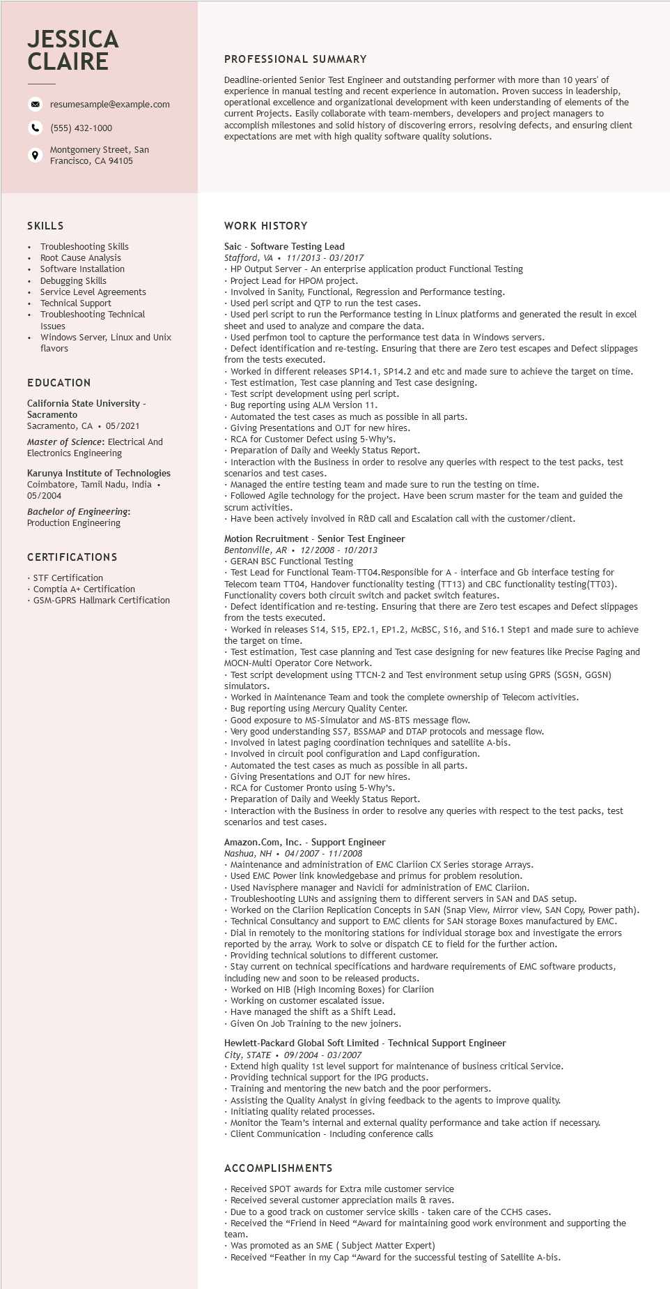

**JESSICA CLAIRE**

9

resumesample@example.com

(555) 432-1000

Montgomery Street, San Francisco, CA 94105

**PROFESSIONAL SUMMARY**

Deadline-oriented Senior Test Engineer and outstanding performer with more than 10 years' of experience in manual testing and recent experience in automation. Proven success in leadership, operational excellence and organizational development with keen understanding of elements of the current Projects. Easily collaborate with team-members, developers and project managers to accomplish milestones and solid history of discovering errors, resolving defects, and ensuring client expectations are met with high quality software quality solutions.

SKILLS

Troubleshooting Skills

Root Cause Analysis

Software Installation

Debugging Skills

Service Level Agreements

Technical Support

Troubleshooting Technical

Issues

Windows Server, Linux and Unix flavors

EDUCATION

California State University - Sacramento

Sacramento, CA ⚫ 05/2021

Master of Science: Electrical And Electronics Engineering

Karunya Institute of Technologies Coimbatore, Tamil Nadu, India • 05/2004

Bachelor of Engineering:

Production Engineering

CERTIFICATIONS

• STF Certification

Comptia A+ Certification

• GSM-GPRS Hallmark Certification

**WORK HISTORY**

Saic Software Testing Lead

*Stafford, VA 11/2013 - 03/2017*

• HP Output Server - An enterprise application product Functional Testing

• Project Lead for HPOM project.

• Involved in Sanity, Functional, Regression and Performance testing.

Used perl script and QTP to run the test cases.

Used perl scri

Used perl script to run the Performance testing in Linux platforms and generated the result in excel sheet and used to analyze and compare the data.

Used perfmon tool to capture the performance test data in Windows servers.

Defect identification and re-testing. Ensuring that there are Zero test escapes and Defect slippages from the tests executed.

• Worked in different releases SP14.1, SP14.2 and etc and made sure to achieve the target on time. Test estimation, Test case planning and Test case designing.

Test script development using perl script.

Rest script developm

Bug reporting using ALM Version 11.

Bug report

using

Automated the test cases as much as possible in all parts.

Giving Presentations and OJT for new hires.

RCA for Customer Defect using 5-Why's.

Preparation of Daily and Weekly Status Report.

• Interaction with the Business in order to resolve any queries with respect to the test packs, test scenarios and test cases.

• Managed the entire testing team and made sure to run the testing on time.

• Followed Agile technology for the project. Have been scrum master for the team and guided the scrum activities.

• Have been actively involved in R&D call and Escalation call with the customer/client.

Motion Recruitment - Senior Test Engineer

Bentonville, AR 12/2008 10/2013

GERAN BSC Functional Testing

• Test Lead for Functional Team-TT04. Responsible for A - interface and Gb interface testing for Telecom team TT04, Handover functionality testing (TT13) and CBC functionality testing (TT03). Functionality covers both circuit switch and packet switch features.

Defect identification and re-testing. Ensuring that there are Zero test escapes and Defect slippages from the tests executed.

• Worked in releases S14, S15, EP2.1, EP1.2, McBSC, S16, and $16.1 Step1 and made sure to achieve the target on time.

• Test estimation, Test case planning and Test case designing for new features like Precise Paging and MOCN-Multi Operator Core Network.

• Test script development using TTCN-2 and Test environment setup using GPRS (SGSN, GGSN) simulators.

• Worked in Maintenance Team and took the complete ownership of Telecom activities.

Bug

reporting using Mercury Quality Center.

• Good exposure to MS-Simulator and MS-BTS message flow.

• Very good understanding SS7, BSSMAP and DTAP protocols and message flow.

• Involved in latest paging coordination techniques and satellite A-bis.

. Involved in circuit t pool configuration and Lapd configuration.

Automated the test cases as much as possible in all parts.

Giving Presentations and OJT for new hires.

• RCA for Customer Pronto using 5-Why's.

•Preparation of Daily and Weekly Status Report.

• Interaction with the Business in order to resolve any queries with respect to the test packs, test scenarios and test cases.

Amazon.com, Inc. Support Engineer

Nashua, NH • 04/2007 - 11/2008

• Maintenance and administration of EMC Clariion CX Series storage Arrays.

• Used EMC Power link knowledgebase and primus for problem resolution.

• Used Navisphere manager and Navicli for administration of EMC Clariion.

• Troubleshooting LUNs and assigning them to different servers in SAN and DAS setup.

• Worked on the Clariion Replication Concepts in SAN (Snap View, Mirror view, SAN Copy, Power path).

• Technical Consultancy and support to EMC clients for SAN storage Boxes manufactured by EMC.

.Dial in in remotely to

to the monitoring stations for individual storage box and investigate the errors

reported by the array. Work to solve or dispatch CE to field for the further action.

Providing technical solutions to different customer.

Stay current on technical specifications and hardware requirements of EMC software products, including new and soon to be released products.

• Worked on HIB (High Incoming Boxes) for Clariion

• Working on customer escalated issue.

• Have managed the shift as a Shift Lead.

. Given On Job Training to the new joiners.

Hewlett-Packard Global Soft Limited Technical Support Engineer

*City, STATE⚫ 09/2004 - 03/2007*

• Extend high quality 1st level support for maintenance of business critical Service.

•Providing technical support for the IPG products.

Training and mentoring the new batch and the poor performers.

• Assisting the Quality Analyst in giving feedback to the agents to improve quality.

Initiating quality related processes.

• Monitor the Team's internal and external quality performance and take action if necessary.

• Client Communication - Including conference calls

ACCOMPLISHMENTS

• Received SPOT awards for Extra mile customer service

• Received several customer appreciation mails & raves.

• Due to a good track on customer service skills - taken care of the CCHS cases.

• Received the "Friend in Need "Award for maintaining good work environment and supporting the

team.

• Was promoted as an SME (Subject Matter Expert)

• Received "Feather in my Cap "Award for the successful testing of Satellite A-bis.