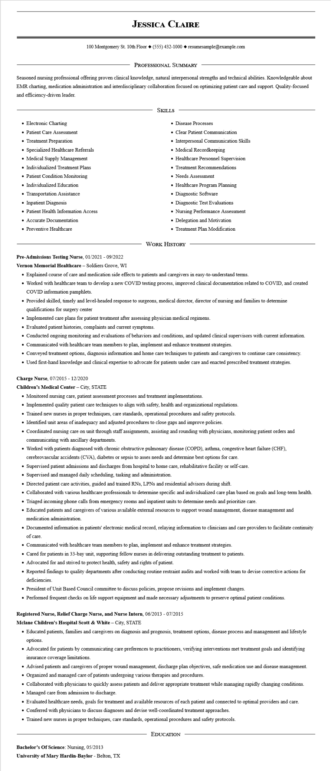

**JESSICA CLAIRE**

100 Montgomery St. 10th Floor (555) 432-1000◆ resumesample@example.com

PROFESSIONAL SUMMARY

Seasoned nursing professional offering proven clinical knowledge, natural interpersonal strengths and technical abilities. Knowledgeable about EMR charting, medication administration and interdisciplinary collaboration focused on optimizing patient care and support. Quality-focused and efficiency-driven leader.

• Electronic Charting

• Patient Care Assessment

• Treatment Preparation

• Specialized Healthcare Referrals

• Medical Supply Management

• Individualized Treatment Plans

• Patient Condition Monitoring Individualized Education

• Transportation Assistance

• Inpatient Diagnosis

• Patient Health Information Access

• Accurate Documentation

• Preventive Healthcare

SKILLS

• Disease Processes

• Clear Patient Communication

• Interpersonal Communication Skills

• Medical Recordkeeping

• Healthcare Personnel Supervision

• Treatment Recommendations

• Needs Assessment

• Healthcare Program Planning

• Diagnostic Software

• Diagnostic Test Evaluations

• Nursing Performance Assessment

• Delegation and Motivation

• Treatment Plan Modification

WORK HISTORY

**Pre-Admissions Testing Nurse, 01/2021 - 09/2022**

**Vernon Memorial Healthcare - Soldiers Grove, WI**

• Explained course of care and medication side effects to patients and caregivers in easy-to-understand terms.

• Worked with healthcare team to develop a new COVID testing process, improved clinical documentation related to COVID, and created COVID information pamphlets.

• Provided skilled, timely and level-headed response to surgeons, medical director, director of nursing and families to determine qualifications for surgery center

• Implemented care plans for patient treatment after assessing physician medical regimens.

• Evaluated patient histories, complaints and current symptoms.

• Conducted ongoing monitoring and evaluations of behaviors and conditions, and updated clinical supervisors with current information.

• Communicated with healthcare team members to plan, implement and enhance treatment strategies.

• Conveyed treatment options, diagnosis information and home care techniques to patients and caregivers to continue care consistency.

• Used first-hand knowledge and clinical expertise to advocate for patients under care and enacted prescribed treatment strategies.

**Charge Nurse, 07/2015 - 12/2020**

**Children's Medical Center - City, STATE**

• Monitored nursing care, patient assessment processes and treatment implementations.

• Implemented quality patient care techniques to align with safety, health and organizational regulations.

• Trained new nurses in proper techniques, care standards, operational procedures and safety protocols.

• Identified unit areas of inadequacy and adjusted procedures to close gaps and improve policies.

• Coordinated nursing care on unit through staff assignments, assisting and rounding with physicians, monitoring patient orders and communicating with ancillary departments.

• Worked with patients diagnosed with chronic obstructive pulmonary disease (COPD), asthma, congestive heart failure (CHF),

cerebrovascular accidents (CVA), diabetes or sepsis to asses needs and determine best options for care.

• Supervised patient admissions and discharges from hospital to home care, rehabilitative facility or self-care.

• Supervised and managed daily scheduling, tasking and administration.

• Directed patient care activities, guided and trained RNs, LPNs and residential advisors during shift.

• Collaborated with various healthcare professionals to determine specific and individualized care plan based on goals and long-term health.

• Triaged incoming phone calls from emergency rooms and inpatient units to determine needs and prioritize care.

• Educated patients and caregivers of various available external resources to support wound management, disease management and medication administration.

• Documented information in patients' electronic medical record, relaying information to clinicians and care providers to facilitate continuity of care.

• Communicated with healthcare team members to plan, implement and enhance treatment strategies.

• Cared for patients in 33-bay unit, supporting fellow nurses in delivering outstanding treatment to patients.

• Advocated for and strived to protect health, safety and rights of patient.

• Reported findings to quality departments after conducting routine restraint audits and worked with team to devise corrective actions for deficiencies.

• President of Unit Based Council committee to discuss policies, propose revisions and implement changes.

• Performed frequent checks on life support equipment and made necessary adjustments to preserve optimal patient conditions.

**Registered Nurse, Relief Charge Nurse, and Nurse Intern, 06/2013 - 07/2015**

**Mclane Children's Hospital Scott & White - City, STATE**

• Educated patients, families and caregivers on diagnosis and prognosis, treatment options, disease process and management and lifestyle options.

• Advocated for patients by communicating care preferences to practitioners, verifying interventions met treatment goals and identifying insurance coverage limitations.

• Advised patients and caregivers of proper wound management, discharge plan objectives, safe medication use and disease management. • Organized and managed care of patients undergoing various therapies and procedures.

• Collaborated with physicians to quickly assess patients and deliver appropriate treatment while managing rapidly changing conditions. • Managed care from admission to discharge.

• Evaluated healthcare needs, goals for treatment and available resources of each patient and connected to optimal providers and care.

• Conferred with physicians to discuss diagnoses and devise well-coordinated treatment approaches.

• Trained new nurses in proper techniques, care standards, operational procedures and safety protocols.

**Bachelor's of Science: Nursing, 05/2013**

**University of Mary Hardin-Baylor - Belton, TX**

EDUCATION