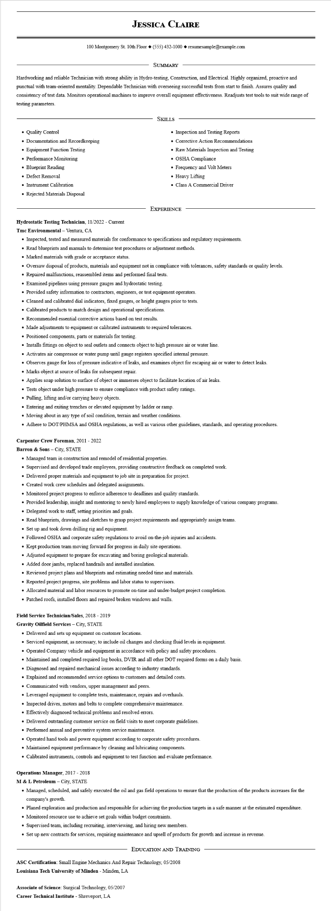

**JESSICA CLAIRE**

100 Montgomery St. 10th Floor (555) 432-1000◆ resumesample@example.com

SUMMARY

Hardworking and reliable Technician with strong ability in Hydro-testing, Construction, and Electrical. Highly organized, proactive and punctual with team-oriented mentality. Dependable Technician with overseeing successful tests from start to finish. Assures quality and consistency of test data. Monitors operational machines to improve overall equipment effectiveness. Readjusts test tools to suit wide range of testing parameters.

• Quality Control

• Documentation and Recordkeeping

• Equipment Function Testing

• Performance Monitoring

• Blueprint Reading

• Defect Removal

• Instrument Calibration

• Rejected Materials Disposal

SKILLS

Inspection and Testing Reports

• Corrective Action Recommendations

• Raw Materials Inspection and Testing

• OSHA Compliance

• Frequency and Volt Meters

• Heavy Lifting

• Class A Commercial Driver

EXPERIENCE

**Hydrostatic Testing Technician, 11/2022 - Current**

**Tmc Environmental - Ventura, CA**

• Inspected, tested and measured materials for conformance to specifications and regulatory requirements.

• Read blueprints and manuals to determine test procedures or adjustment methods.

• Marked materials with grade or acceptance status.

• Oversaw disposal of products, materials and equipment not in compliance with tolerances, safety standards or quality levels.

• Repaired malfunctions, reassembled items and performed final tests.

• Examined pipelines using pressure gauges and hydrostatic testing.

• Provided safety information to contractors, engineers, or test equipment operators.

• Cleaned and calibrated dial indicators, fixed gauges, or height gauges prior to tests.

• Calibrated products to match design and operational specifications.

• Recommended essential corrective actions based on test results.

• Made adjustments to equipment or calibrated instruments to required tolerances.

• Positioned components, parts or materials for testing.

• Installs fittings on object to seal outlets and connects object to high pressure air or water line.

• Activates air compressor or water pump until gauge registers specified internal pressure.

• Observes gauge for loss of pressure indicative of leaks, and examines object for escaping air or water to detect leaks.

• Marks object at source of leaks for subsequent repair.

• Applies soap solution to surface of object or immerses object to facilitate location of air leaks.

• Tests object under high pressure to ensure compliance with product safety ratings.

• Pulling, lifting and/or carrying heavy objects.

• Entering and exiting trenches or elevated equipment by ladder or ramp.

• Moving about in any type of soil condition, terrain and weather conditions.

• Adhere to DOT/PHMSA and OSHA regulations, as well as various other guidelines, standards, and operating procedures.

**Carpenter Crew Foreman, 2011-2022**

**Barron & Sons - City, STATE**

• Managed team in construction and remodel of residential properties.

•

Supervised and developed trade employees, providing constructive feedback on completed work.

• Delivered proper materials and equipment to job site in preparation for project.

• Created work crew schedules and delegated assignments.

• Monitored project progress to enforce adherence to deadlines and quality standards.

• Provided leadership, insight and mentoring to newly hired employees to supply knowledge of various company programs.

• Delegated work to staff, setting priorities and goals.

• Read blueprints, drawings and sketches to grasp project requirements and appropriately assign teams.

• Set up and took down drilling rig and equipment.

• Followed OSHA and corporate safety regulations to avoid on-the-job injuries and accidents.

• Kept production team moving forward for progress in daily site operations.

• Adjusted equipment to prepare for excavating and boring geological materials.

• Added door jambs, replaced handrails and installed insulation.

• Reviewed project plans and blueprints and estimating needed time and materials.

• Reported project progress, site problems and labor status to supervisors.

• Allocated material and labor resources to promote on-time and under-budget project completion.

• Patched roofs, installed floors and repaired broken windows and walls.

**Field Service Technician/Sales, 2018 - 2019**

**Gravity Oilfield Services - City, STATE**

• Delivered and sets up equipment on customer locations.

• Serviced equipment, as necessary, to include oil changes and checking fluid levels in equipment.

• Operated Company vehicle and equipment in accordance with policy and safety procedures.

• Maintained and completed required log books, DVIR and all other DOT required forms on a daily basis.

• Diagnosed and repaired mechanical issues according to industry standards.

• Explained and recommended service options to customers and detailed costs.

• Communicated with vendors, upper management and peers.

• Leveraged equipment to complete tests, maintenance, repairs and overhauls.

• Inspected drives, motors and belts to complete comprehensive maintenance.

• Effectively diagnosed technical problems and resolved errors.

• Delivered outstanding customer service on field visits to meet corporate guidelines.

• Performed annual and preventive system service maintenance.

• Operated hand tools and power equipment according to corporate safety procedures.

• Maintained equipment performance by cleaning and lubricating components.

• Calibrated instruments, controls and equipment to test function and evaluate performance.

**Operations Manager, 2017 - 2018**

M & L Petroleum - City, STATE

• Managed, scheduled, and safely executed the oil and gas field operations to ensure that the production of the products increases for the company's growth.

• Planed exploration and production and responsible for achieving the production targets in a safe manner at the estimated expenditure.

• Monitored resource use to achieve set goals within budget constraints.

• Supervised team, including recruiting, interviewing, and hiring new members.

• Set up new contracts for services, requiring maintenance and upsell of products for growth and increase in revenue.

EDUCATION AND TRAINING

ASC Certification: Small Engine Mechanics And Repair Technology, 05/2008

**Louisiana Tech University of Minden - Minden, LA**

Associate of Science: Surgical Technology, 05/2007

Career Technical Institute - Shreveport, LA