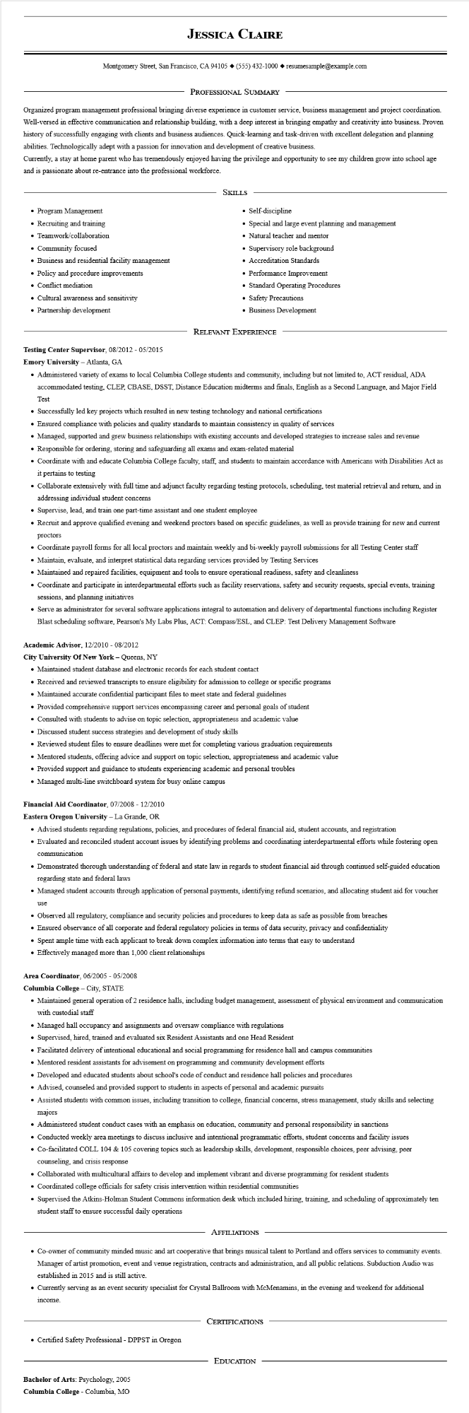

**JESSICA CLAIRE**

Montgomery Street, San Francisco, CA 94105 ♦ (555) 432-1000 resumesample@example.com

PROFESSIONAL SUMMARY

Organized program management professional bringing diverse experience in customer service, business management and project coordination. Well-versed in effective communication and relationship building, with a deep interest in bringing empathy and creativity into business. Proven history of successfully engaging with clients and business audiences. Quick-learning and task-driven with excellent delegation and planning abilities. Technologically adept with a passion for innovation and development of creative business.

Currently, a stay at home parent who has tremendously enjoyed having the privilege and opportunity to see my children grow into school age and is passionate about re-entrance into the professional workforce.

SKILLS

• Self-discipline

• Program Management

• Recruiting and training

• Teamwork/collaboration

• Community focused

• Business and residential facility management

• Policy and procedure improvements

• Conflict mediation

• Cultural awareness and sensitivity

• Partnership development

.

Special and large event planning and management

• Natural teacher and mentor

• Supervisory role background

Accreditation Standards

• Performance Improvement

• Standard Operating Procedures

• Safety Precautions

• Business Development

**Testing Center Supervisor, 08/2012 - 05/2015**

**Emory University - Atlanta, GA**

RELEVANT EXPERIENCE

• Administered variety of exams to local Columbia College students and community, including but not limited to, ACT residual, ADA accommodated testing, CLEP, CBASE, DSST, Distance Education midterms and finals, English as a Second Language, and Major Field

Test

• Successfully led key projects which resulted in new testing technology and national certifications

• Ensured compliance with policies and quality standards to maintain consistency in quality of services

• Managed, supported and grew business relationships with existing accounts and developed strategies to increase sales and revenue

• Responsible for ordering, storing and safeguarding all exams and exam-related material

• Coordinate with and educate Columbia College faculty, staff, and students to maintain accordance with Americans with Disabilities Act as it pertains to testing

• Collaborate extensively with full time and adjunct faculty regarding testing protocols, scheduling, test material retrieval and return, and in addressing individual student concerns

• Supervise, lead, and train one part-time assistant and one student employee

• Recruit and approve qualified evening and weekend proctors based on specific guidelines, as well as provide training for new and current proctors

• Coordinate payroll forms for all local proctors and maintain weekly and bi-weekly payroll submissions for all Testing Center staff

• Maintain, evaluate, and interpret statistical data regarding services provided by Testing Services

• Maintained and repaired facilities, equipment and tools to ensure operational readiness, safety and cleanliness

• Coordinate and participate in interdepartmental efforts such as facility reservations, safety and security requests, special events, training sessions, and planning initiatives

• Serve as administrator for several software applications integral to automation and delivery of departmental functions including Register Blast scheduling software, Pearson's My Labs Plus, ACT: Compass/ESL, and CLEP: Test Delivery Management Software

**Academic Advisor, 12/2010 - 08/2012**

**City University Of New York - Queens, NY**

• Maintained student database and electronic records for each student contact

• Received and reviewed transcripts to ensure eligibility for admission to college or specific programs

• Maintained accurate confidential participant files to meet state and federal guidelines

• Provided comprehensive support services encompassing career and personal goals of student

• Consulted with students to advise on topic selection, appropriateness and academic value

• Discussed student success strategies and development of study skills

• Reviewed student files to ensure deadlines were met for completing various graduation requirements

• Mentored students, offering advice and support on topic selection, appropriateness and academic value

• Provided support and guidance to students experiencing academic and personal troubles

• Managed multi-line switchboard system for busy online campus

**Financial Aid Coordinator, 07/2008 - 12/2010**

**Eastern Oregon University - La Grande, OR**

• Advised students regarding regulations, policies, and procedures of federal financial aid, student accounts, and registration

• Evaluated and reconciled student account issues by identifying problems and coordinating interdepartmental efforts while fostering open communication

• Demonstrated thorough understanding of federal and state law in regards to student financial aid through continued self-guided education regarding state and federal laws

• Managed student accounts through application of personal payments, identifying refund scenarios, and allocating student aid for voucher

use

• Observed all regulatory, compliance and security policies and procedures to keep data as safe as possible from breaches

• Ensured observance of all corporate and federal regulatory policies in terms of data security, privacy and confidentiality

Spent ample time with each applicant to break down complex information into terms that easy to understand

• Effectively managed more than 1,000 client relationships

**Area Coordinator, 06/2005 - 05/2008**

Columbia College - City, STATE

• Maintained general operation of 2 residence halls, including budget management, assessment of physical environment and communication with custodial staff

• Managed hall occupancy and assignments and oversaw compliance with regulations

• Supervised, hired, trained and evaluated six Resident Assistants and one Head Resident

• Facilitated delivery of intentional educational and social programming for residence hall and campus communities

• Mentored resident assistants for advisement on programming and community development efforts

• Developed and educated students about school's code of conduct and residence hall policies and procedures

• Advised, counseled and provided support to students in aspects of personal and academic pursuits

• Assisted students with common issues, including transition to college, financial concerns, stress management, study skills and selecting majors

• Administered student conduct cases with an emphasis on education, community and personal responsibility in sanctions

• Conducted weekly area meetings to discuss inclusive and intentional programmatic efforts, student concerns and facility issues

• Co-facilitated COLL 104 & 105 covering topics such as leadership skills, development, responsible choices, peer advising, peer counseling, and crisis response

• Collaborated with multicultural affairs to develop and implement vibrant and diverse programming for resident students

• Coordinated college officials for safety crisis intervention within residential communities

• Supervised the Atkins-Holman Student Commons information desk which included hiring, training, and scheduling of approximately ten student staff to ensure successful daily operations

AFFILIATIONS

• Co-owner of community minded music and art cooperative that brings musical talent to Portland and offers services to community events. Manager of artist promotion, event and venue registration, contracts and administration, and all public relations. Subduction Audio was established in 2015 and is still active.

• Currently serving as an event security specialist for Crystal Ballroom with McMenamins, in the evening and weekend for additional

income.

⚫ Certified Safety Professional - DPPST in Oregon

Bachelor of Arts: Psychology, 2005

**Columbia College - Columbia, MO**

CERTIFICATIONS

EDUCATION