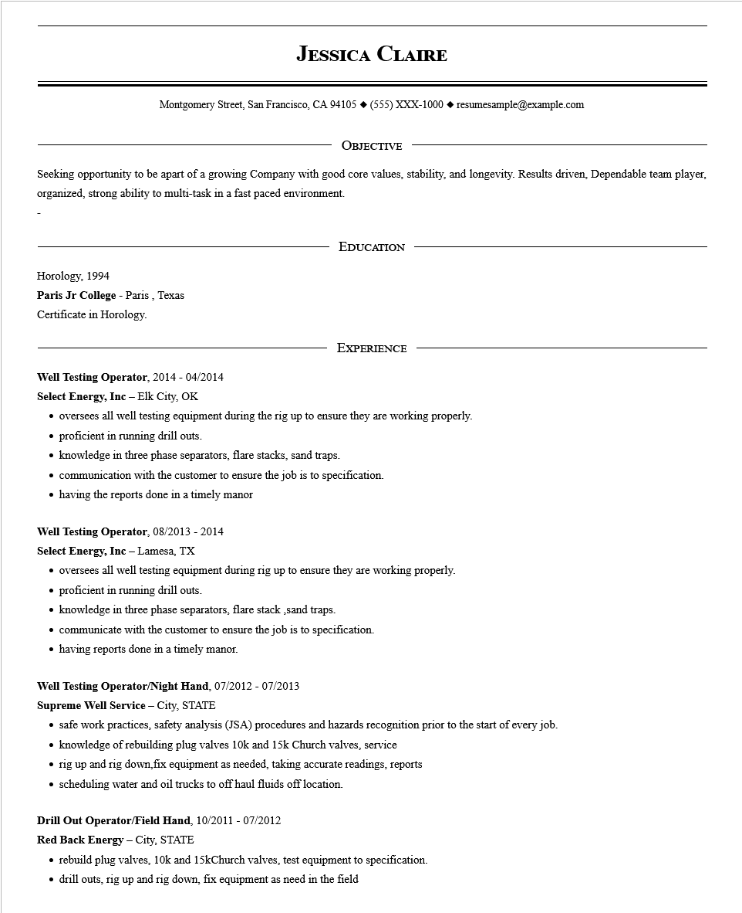

**JESSICA CLAIRE**

Montgomery Street, San Francisco, CA 94105 ♦ (555) XXX-1000◆ resumesample@example.com

OBJECTIVE

Seeking opportunity to be apart of a growing Company with good core values, stability, and longevity. Results driven, Dependable team player, organized, strong ability to multi-task in a fast paced environment.

Horology, 1994

Paris Jr College - Paris, Texas

Certificate in Horology.

EDUCATION

EXPERIENCE

**Well Testing Operator, 2014 - 04/2014**

**Select Energy, Inc - Elk City, OK**

⚫ oversees all well testing equipment during the rig up to ensure they are working properly.

⚫ proficient in running drill outs.

⚫ knowledge in three phase separators, flare stacks, sand traps.

⚫ communication with the customer to ensure the job is to specification.

⚫ having the reports done in a timely manor

**Well Testing Operator, 08/2013 - 2014**

**Select Energy, Inc - Lamesa, TX**

⚫ oversees all well testing equipment during rig up to ensure they are working properly.

⚫ proficient in running drill outs.

⚫ knowledge in three phase separators, flare stack,sand traps.

⚫ communicate with the customer to ensure the job is to specification.

⚫ having reports done in a timely manor.

**Well Testing Operator/Night Hand, 07/2012 - 07/2013**

**Supreme Well Service - City, STATE**

⚫ safe work practices, safety analysis (JSA) procedures and hazards recognition prior to the start of every job.

⚫ knowledge of rebuilding plug valves 10k and 15k Church valves, service

• rig up and rig down,fix equipment as needed, taking accurate readings, reports

• scheduling water and oil trucks to off haul fluids off location.

**Drill Out Operator/Field Hand, 10/2011 - 07/2012**

**Red Back Energy - City, STATE**

⚫ rebuild plug valves, 10k and 15kChurch valves, test equipment to specification.

• drill outs, rig up and rig down, fix equipment as need in the field