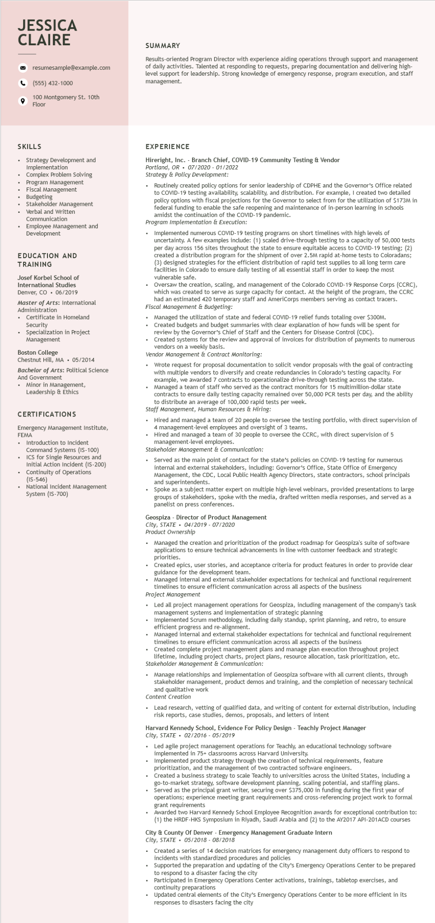

**JESSICA CLAIRE**

resumesample@example.com

(555) 432-1000

100 Montgomery St. 10th Floor

SUMMARY

Results-oriented Program Director with experience aiding operations through support and management of daily activities. Talented at responding to requests, preparing documentation and delivering high- level support for leadership. Strong knowledge of emergency response, program execution, and staff management.

SKILLS

Strategy Development and

Implementation

Complex Problem Solving

Program Management

Fiscal Management

Budgeting

Stakeholder Management Verbal and written Communication

• Employee Management and Development

EDUCATION AND TRAINING

Josef Korbel School of International Studies Denver, CO. 06/2019

Master of Arts: International Administration

• Certificate in Homeland Security

Specialization in Project Management

Boston College

Chestnut Hill, MA⚫ 05/2014

Bachelor of Arts: Political Science

And Government

• Minor in Management, Leadership & Ethics

CERTIFICATIONS

Emergency Management Institute, FEMA

Introduction to Incident Command Systems (IS-100) ICS for Single Resources and Initial Action Incident (IS-200)

⚫ Continuity of Operations

(IS-546)

⚫ National Incident Management System (IS-700)

EXPERIENCE

Hireright, Inc. - Branch Chief, COVID-19 Community Testing & Vendor

Portland, OR 07/2020 - 01/2022

*Strategy & Policy Development:*

• Routinely created policy options for senior leadership of CDPHE and the Governor's Office related to COVID-19 testing availability, scalability, and distribution. For example, I created two detailed policy options with fiscal projections for the Governor to select from for the utilization of $173M in federal funding to enable the safe reopening and maintenance of in-person learning in schools amidst the continuation of the COVID-19 pandemic.

*Program Implementation & Execution:*

Implemented numerous COVID-19 testing programs on short timelines with high levels of uncertainty. A few examples include: (1) scaled drive-through testing to a capacity of 50,000 tests per day across 156 sites throughout the state to ensure equitable access to COVID-19 testing; (2) created a distribution program for the shipment of over 2.5M rapid at-home tests to Coloradans; (3) designed strategies for the efficient distribution of rapid test supplies to all long term care facilities in Colorado to ensure daily testing of all essential staff in order to keep the most vulnerable safe.

Oversaw the creation, scaling, and management of the Colorado COVID-19 Response Corps (CCRC), which was created to serve as surge capacity for contact. At the height of the program, the CCRC had an estimated 420 temporary staff and AmeriCorps members serving as contact tracers. Fiscal Management & Budgeting:

• Managed the utilization of state and federal COVID-19 relief funds totaling over $300M. Created budgets and budget summaries with clear explanation of how funds will be spent for review by the Governor's Chief of Staff and the Centers for Disease Control (CDC).

Created systems for the review and approval of invoices for distribution of payments to numerous vendors on a weekly basis.

*Vendor Management & Contract Monitoring:*

Wrote request for proposal documentation to solicit vendor proposals with the goal of contracting with multiple vendors to diversify and create redundancies in Colorado's testing capacity. For example, we awarded 7 contracts to operationalize drive-through testing across the state.

• Managed a team of staff who served as the contract monitors for 15 multimillion-dollar state contracts to ensure daily testing capacity remained over 50,000 PCR tests per day, and the ability to distribute an average of 100,000 rapid tests per week.

*Staff Management, Human Resources & Hiring:*

.

Hired and managed a team of 20 people to oversee the testing portfolio, with direct supervision of 4 management-level employees and oversight of 3 teams.

Hired and managed a team of 30 people to oversee the CCRC, with direct supervision of 5 management-level employees.

*Stakeholder Management & Communication:*

• Served as the main point of contact for the state's policies on COVID-19 testing for numerous internal and external stakeholders, including: Governor's Office, State Office of Emergency Management, the CDC, Local Public Health Agency Directors, state contractors, school principals and superintendents.

• Spoke as a subject matter expert on multiple high-level webinars, provided presentations to large groups of stakeholders, spoke with the media, drafted written media responses, and served as a panelist on press conferences.

Geospiza - Director of Product Management

*City, STATE 04/2019-07/2020*

Product Ownership

•

Managed the creation and prioritization of the product roadmap for Geospiza's suite of software applications to ensure technical advancements in line with customer feedback and strategic priorities.

Created epics, user stories, and acceptance criteria for product features in order to provide clear guidance for the development team.

• Managed internal and external stakeholder expectations for technical and functional requirement timelines to ensure efficient communication across all aspects of the business

*Project Management*

Led all project management operations for Geospiza, including management of the company's task management systems and implementation of strategic planning

Implemented Scrum methodology, including daily standup, sprint planning, and retro, to ensure efficient progress and re-alignment.

• Managed internal and external stakeholder expectations technical and functional requirement timelines to ensure efficient communication across all aspects of the business

.

Created complete project management plans and manage plan execution throughout project lifetime, including project charts, project plans, resource allocation, task prioritization, etc. Stakeholder Management & Communication:

Manage relationships and implementation of Geospiza software with all current clients, through stakeholder management, product demos and training, and the completion of necessary technical and qualitative work

Content Creation

• Lead research, vetting of qualified data, and writing of content for external distribution, including risk reports, case studies, demos, proposals, and letters of intent

Harvard Kennedy School, Evidence For Policy Design - Teachly Project Manager

*City, STATE 02/2016 - 05/2019*

•

Led agile project management operations for Teachly, an educational technology software implemented in 75+ classrooms across Harvard University.

Implemented product strategy through the creation of technical requirements, feature prioritization, and the management of two contracted software engineers.

Created a business strategy to scale Teachly to universities across the United States, including a go-to-market strategy, software development planning, scaling potential, and staffing plans. Served as the principal grant writer, securing over $375,000 in funding during the first year of operations; experience meeting grant requirements and cross-referencing project work to formal grant requirements

Awarded two Harvard Kennedy School Employee Recognition awards for exceptional contribution to: (1) the HRDF-HKS Symposium in Riyadh, Saudi Arabia and (2) to the AY2017 API-201ACD courses City & County of Denver- Emergency Management Graduate Intern

*City, STATE⚫ 05/2018 - 08/2018*

.

Created a series of 14 decision matrices for emergency management duty officers to respond to incidents with standardized procedures and policies

• Supported the preparation and updating of the City's Emergency Operations Center to be prepared to respond to a disaster facing the city

• Participated in Emergency Operations Center activations, trainings, tabletop exercises, and continuity preparations

Updated central elements of the City's Emergency Operations Center to be more efficient in its responses to disasters facing the city