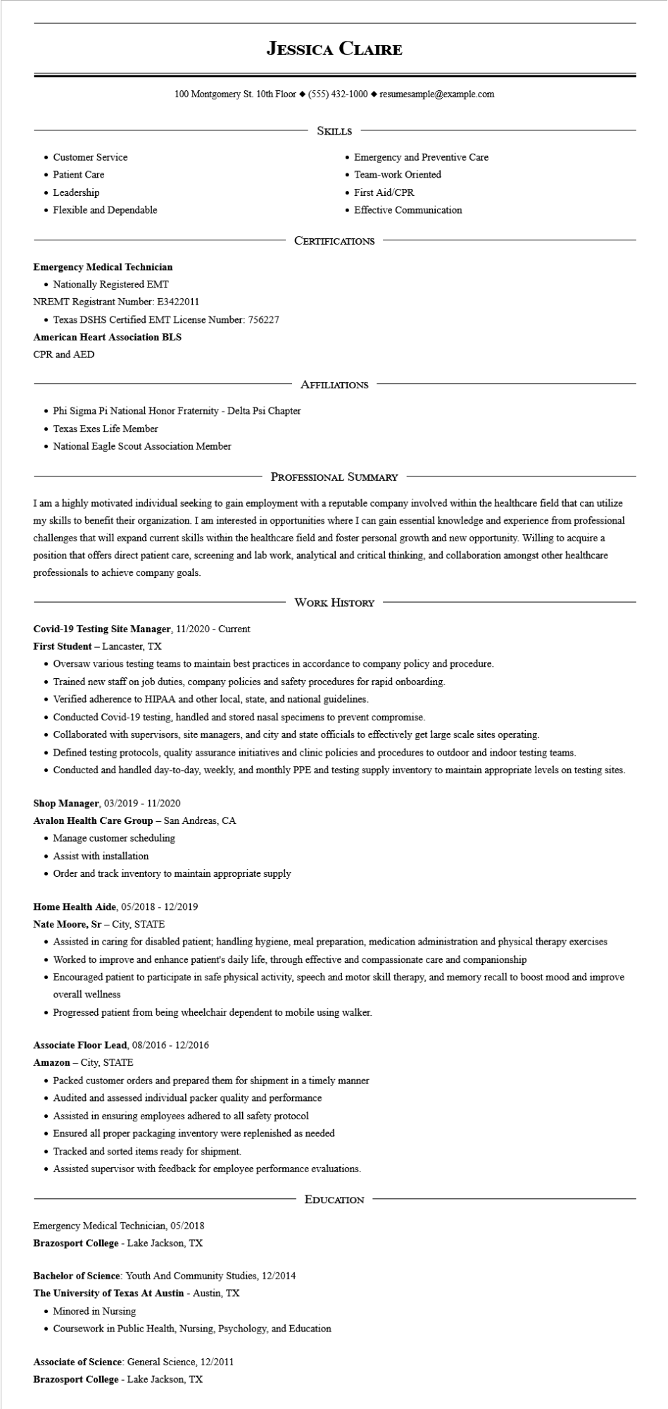

• Customer Service

• Patient Care

• Leadership

• Flexible and Dependable

**JESSICA CLAIRE**

100 Montgomery St. 10th Floor (555) 432-1000◆ resumesample@example.com

SKILLS

• Emergency and Preventive Care

• Team-work Oriented

• First Aid/CPR

• Effective Communication

CERTIFICATIONS

**Emergency Medical Technician**

• Nationally Registered EMT

NREMT Registrant Number: E3422011

• Texas DSHS Certified EMT License Number: 756227

**American Heart Association BLS**

CPR and AED

• Phi Sigma Pi National Honor Fraternity - Delta Psi Chapter

• Texas Exes Life Member

• National Eagle Scout Association Member

AFFILIATIONS

PROFESSIONAL SUMMARY

I am a highly motivated individual seeking to gain employment with a reputable company involved within the healthcare field that can utilize my skills to benefit their organization. I am interested in opportunities where I can gain essential knowledge and experience from professional challenges that will expand current skills within the healthcare field and foster personal growth and new opportunity. Willing to acquire a position that offers direct patient care, screening and lab work, analytical and critical thinking, and collaboration amongst other healthcare professionals to achieve company goals.

WORK HISTORY

**Covid-19 Testing Site Manager, 11/2020 - Current**

First Student - Lancaster, TX

• Oversaw various testing teams to maintain best practices in accordance to company policy and procedure.

• Trained new staff on job duties, company policies and safety procedures for rapid onboarding.

• Verified adherence to HIPAA and other local, state, and national guidelines.

• Conducted Covid-19 testing, handled and stored nasal specimens to prevent compromise.

• Collaborated with supervisors, site managers, and city and state officials to effectively get large scale sites operating.

• Defined testing protocols, quality assurance initiatives and clinic policies and procedures to outdoor and indoor testing teams.

• Conducted and handled day-to-day, weekly, and monthly PPE and testing supply inventory to maintain appropriate levels on testing sites.

Shop Manager, 03/2019 - 11/2020

**Avalon Health Care Group - San Andreas, CA**

• Manage customer scheduling

• Assist with installation

• Order and track inventory to maintain appropriate supply

**Home Health Aide, 05/2018 - 12/2019**

Nate Moore, Sr-City, STATE

• Assisted in caring for disabled patient; handling hygiene, meal preparation, medication administration and physical therapy exercises

• Worked to improve and enhance patient's daily life, through effective and compassionate care and companionship

• Encouraged patient to participate in safe physical activity, speech and motor skill therapy, and memory recall to boost mood and improve overall wellness

• Progressed patient from being wheelchair dependent to mobile using walker.

**Associate Floor Lead, 08/2016 - 12/2016**

**Amazon - City, STATE**

• Packed customer orders and prepared them for shipment in a timely manner

⚫ Audited and assessed individual packer quality and performance

• Assisted in ensuring employees adhered to all safety protocol

• Ensured all proper packaging inventory were replenished as needed

• Tracked and sorted items ready for shipment.

• Assisted supervisor with feedback for employee performance evaluations.

Emergency Medical Technician, 05/2018

EDUCATION

Brazosport College - Lake Jackson, TX

**Bachelor of Science: Youth And Community Studies, 12/2014**

**The University of Texas At Austin - Austin, TX**

• Minored in Nursing

• Coursework in Public Health, Nursing, Psychology, and Education

**Associate of Science: General Science, 12/2011**

**Brazosport College - Lake Jackson, TX**