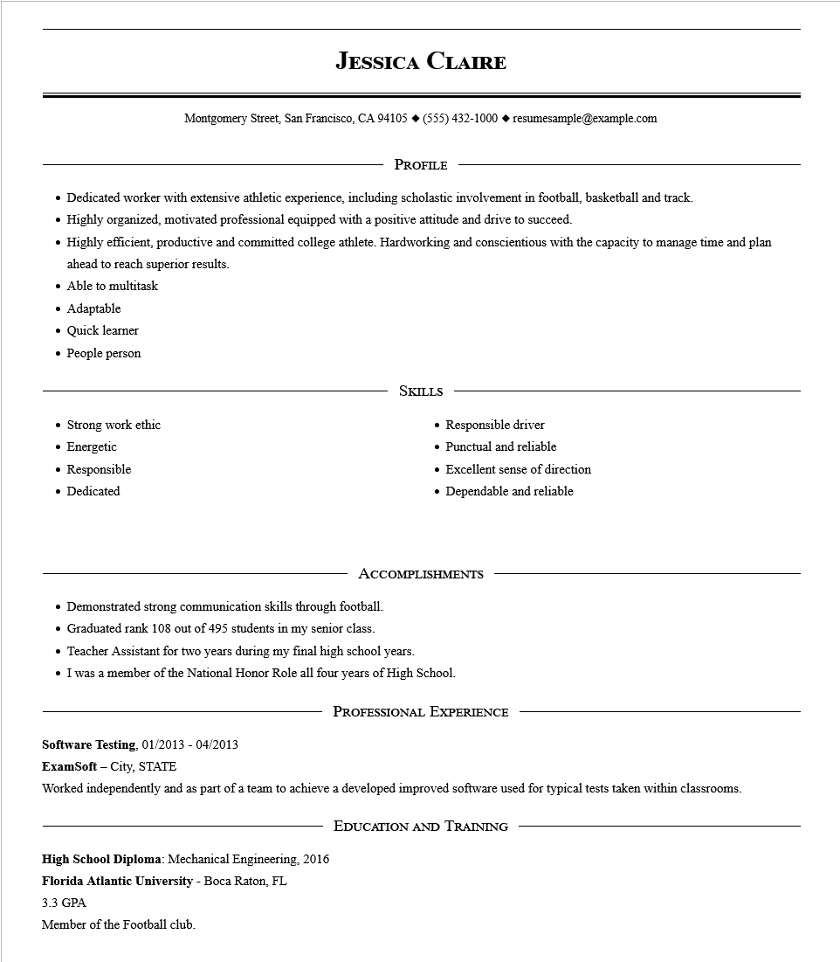

**JESSICA CLAIRE**

Montgomery Street, San Francisco, CA 94105 ♦ (555) 432-1000 resumesample@example.com

PROFILE

• Dedicated worker with extensive athletic experience, including scholastic involvement in football, basketball and track.

•

Highly organized, motivated professional equipped with a positive attitude and drive to succeed.

•

Highly efficient, productive and committed college athlete. Hardworking and conscientious with the capacity to manage time and plan ahead to reach superior results.

• Able to multitask

• Adaptable

• Quick learner

·

People person

• Strong work ethic

.

Energetic

• Responsible

• Dedicated

SKILLS

• Responsible driver

• Punctual and reliable

• Excellent sense of direction

• Dependable and reliable

ACCOMPLISHMENTS

• Demonstrated strong communication skills through football.

• Graduated rank 108 out of 495 students in my senior class.

• Teacher Assistant for two years during my final high school years.

• I was a member of the National Honor Role all four years of High School.

PROFESSIONAL EXPERIENCE

**Software Testing, 01/2013 - 04/2013**

**ExamSoft - City, STATE**

Worked independently and as part of a team to achieve a developed improved software used for typical tests taken within classrooms.

High School Diploma: Mechanical Engineering, 2016

**Florida Atlantic University - Boca Raton, FL**

3.3 GPA

Member of the Football club.

**EDUCATION AND TRAINING**