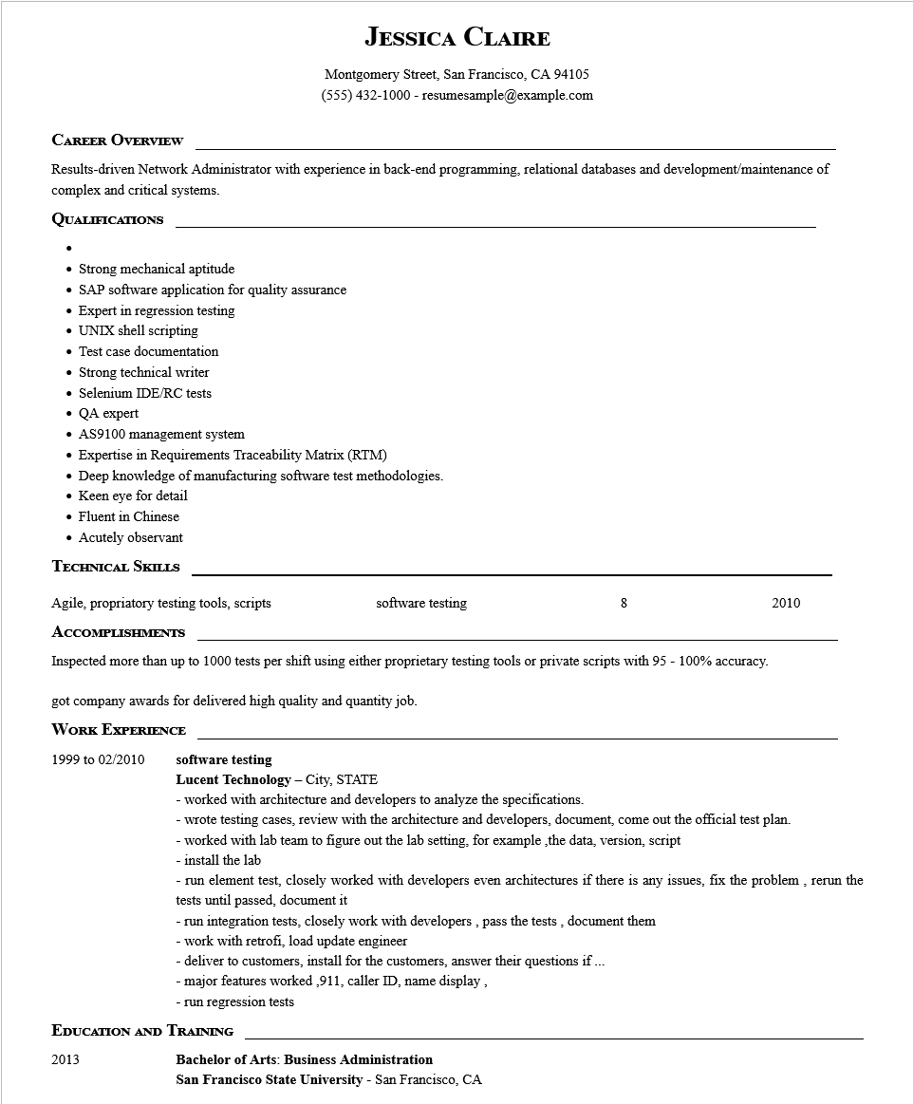

**JESSICA CLAIRE**

Montgomery Street, San Francisco, CA 94105

(555) 432-1000-resumesample@example.com

**CAREER OVERVIEW**

Results-driven Network Administrator with experience in back-end programming, relational databases and development/maintenance of complex and critical systems.

**QUALIFICATIONS**

• Strong mechanical aptitude

• SAP software application for quality assurance

• Expert in regression testing

• UNIX shell scripting

• Test case documentation

• Strong technical writer

• Selenium IDE/RC tests

• QA expert

• AS9100 management system

• Expertise in Requirements Traceability Matrix (RTM)

• Deep knowledge of manufacturing software test methodologies.

• Keen eye for detail

• Fluent in Chinese

• Acutely observant

**TECHNICAL SKILLS**

Agile, propriatory testing tools, scripts

**ACCOMPLISHMENTS**

software testing

8

2010

Inspected more than up to 1000 tests per shift using either proprietary testing tools or private scripts with 95 - 100% accuracy.

got company awards for delivered high quality and quantity job.

WORK EXPERIENCE

1999 to 02/2010

**software testing**

**Lucent Technology - City, STATE**

- worked with architecture and developers to analyze the specifications.

-wrote testing cases, review with the architecture and developers, document, come out the official test plan.

- worked with lab team to figure out the lab setting, for example ̧the data, version, script

- install the lab

- run element test, closely worked with developers even architectures if there is any issues, fix the problem, rerun the tests until passed, document it

- run integration tests, closely work with developers, pass the tests, document them

- work with retrofi, load update engineer

- deliver to customers, install for the customers, answer their questions if ...

- major features worked,911, caller ID, name display,

- run regression tests

**EDUCATION AND TRAINING**

2013

**Bachelor of Arts: Business Administration**

San Francisco State University - San Francisco, CA