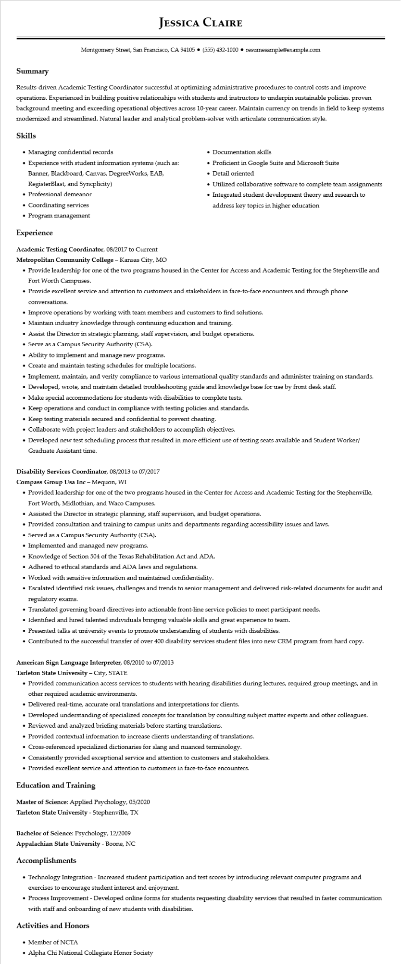

**JESSICA CLAIRE**

Montgomery Street, San Francisco, CA 94105 ⚫ (555) 432-1000⚫ resumesample@example.com

**Summary**

Results-driven Academic Testing Coordinator successful at optimizing administrative procedures to control costs and improve operations. Experienced in building positive relationships with students and instructors to underpin sustainable policies. proven background meeting and exceeding operational objectives across 10-year career. Maintain currency on trends in field to keep systems modernized and streamlined. Natural leader and analytical problem-solver with articulate communication style.

**Skills**

• Managing confidential records

• Experience with student information systems (such as:

Banner, Blackboard, Canvas, DegreeWorks, EAB, RegisterBlast, and Syncplicity)

• Professional demeanor

• Coordinating services

• Documentation skills

• Proficient in Google Suite and Microsoft Suite • Detail oriented

• Utilized collaborative software to complete team assignments

• Integrated student development theory and research to address key topics in higher education

• Program management

**Experience**

**Academic Testing Coordinator, 08/2017 to Current**

**Metropolitan Community College - Kansas City, MO**

• Provide leadership for one of the two programs housed in the Center for Access and Academic Testing for the Stephenville and Fort Worth Campuses.

• Provide excellent service and attention to customers and stakeholders in face-to-face encounters and through phone

conversations.

• Improve operations by working with team members and customers to find solutions.

• Maintain industry knowledge through continuing education and training.

• Assist the Director in strategic planning, staff supervision, and budget operations.

• Serve as a Campus Security Authority (CSA).

• Ability to implement and manage new programs.

• Create and maintain testing schedules for multiple locations.

• Implement, maintain, and verify compliance to various international quality standards and administer training on standards.

• Developed, wrote, and maintain detailed troubleshooting guide and knowledge base for use by front desk staff.

• Make special accommodations for students with disabilities to complete tests.

• Keep operations and conduct in compliance with testing policies and standards.

• Keep testing materials secured and confidential to prevent cheating.

• Collaborate with project leaders and stakeholders to accomplish objectives.

• Developed new test scheduling process that resulted in more efficient use of testing seats available and Student Worker/ Graduate Assistant time.

Disability Services Coordinator, 08/2013 to 07/2017

Compass Group Usa Inc - Mequon, WI

• Provided leadership for one of the two programs housed in the Center for Access and Academic Testing for the Stephenville, Fort Worth, Midlothian, and Waco Campuses.

• Assisted the Director in strategic planning, staff supervision, and budget operations.

• Provided consultation and training to campus units and departments regarding accessibility issues and laws.

• Served as a Campus Security Authority (CSA).

• Implemented and managed new programs.

• Knowledge of Section 504 of the Texas Rehabilitation Act and ADA.

• Adhered to ethical standards and ADA laws and regulations.

• Worked with sensitive information and maintained confidentiality.

• Escalated identified risk issues, challenges and trends to senior management and delivered risk-related documents for audit and regulatory exams.

• Translated governing board directives into actionable front-line service policies to meet participant needs.

• Identified and hired talented individuals bringing valuable skills and great experience to team.

• Presented talks at university events to promote understanding of students with disabilities.

• Contributed to the successful transfer of over 400 disability services student files into new CRM program from hard copy.

**American Sign Language Interpreter, 08/2010 to 07/2013**

Tarleton State University - City, STATE

• Provided communication access services to students with hearing disabilities during lectures, required group meetings, and in other required academic environments.

• Delivered real-time, accurate oral translations and interpretations for clients.

• Developed understanding of specialized concepts for translation by consulting subject matter experts and other colleagues.

• Reviewed and analyzed briefing materials before starting translations.

• Provided contextual information to increase clients understanding of translations.

• Cross-referenced specialized dictionaries for slang and nuanced terminology.

• Consistently provided exceptional service and attention to customers and stakeholders.

• Provided excellent service and attention to customers in face-to-face encounters.

**Education and Training**

Master of Science: Applied Psychology, 05/2020

Tarleton State University - Stephenville, TX

Bachelor of Science: Psychology, 12/2009

Appalachian State University - Boone, NC

**Accomplishments**

• Technology Integration - Increased student participation and test scores by introducing relevant computer programs and exercises to encourage student interest and enjoyment.

• Process Improvement - Developed online forms for students requesting disability services that resulted in faster communication with staff and onboarding of new students with disabilities.

**Activities and Honors**

• Member of NCTA

• Alpha Chi National Collegiate Honor Society