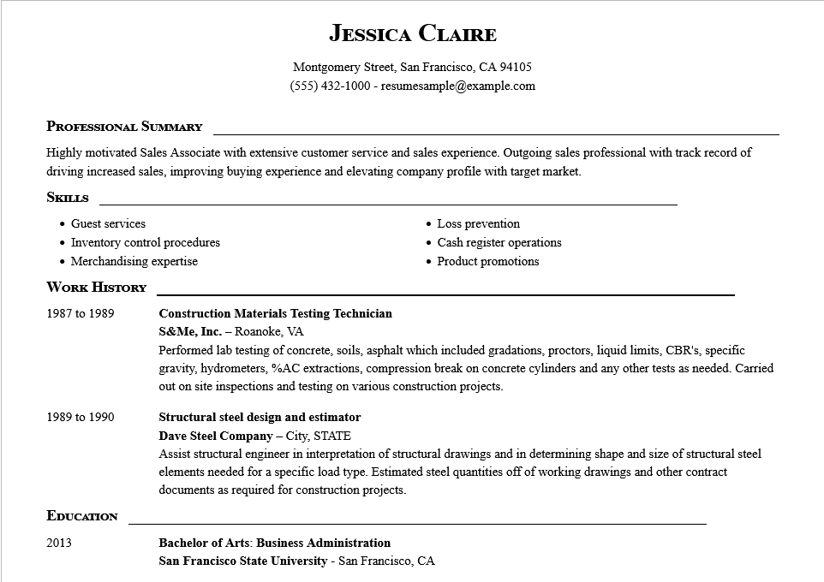

**JESSICA CLAIRE**

Montgomery Street, San Francisco, CA 94105

(555) 432-1000-resumesample@example.com

**PROFESSIONAL SUMMARY**

Highly motivated Sales Associate with extensive customer service and sales experience. Outgoing sales professional with track record of driving increased sales, improving buying experience and elevating company profile with target market.

**SKILLS**

Guest services

• Inventory control procedures

• Merchandising expertise

• Loss prevention

• Cash register operations

• Product promotions

**WORK HISTORY**

1987 to 1989

1989 to 1990

**EDUCATION**

**Construction Materials Testing Technician**

S&Me, Inc. - Roanoke, VA

Performed lab testing of concrete, soils, asphalt which included gradations, proctors, liquid limits, CBR's, specific gravity, hydrometers, %AC extractions, compression break on concrete cylinders and any other tests as needed. Carried out on site inspections and testing on various construction projects.

**Structural steel design and estimator**

**Dave Steel Company - City, STATE**

Assist structural engineer in interpretation of structural drawings and in determining shape and size of structural steel elements needed for a specific load type. Estimated steel quantities off of working drawings and other contract documents as required for construction projects.

2013

**Bachelor of Arts: Business Administration**

San Francisco State University - San Francisco, CA